Enhancing Beverage Production Process Efficiency: A Machine Learning Approach

Michelle M. Moran

A Thesis Submitted in Partial Fulfilment

of the requirements for the

Degree of

Master of Science in Data Analytics

September 2023

Supervisor: Kislay Raj

CCT College Dublin

Assessment Cover Page

|  |  |
| --- | --- |
| Module Title: | Capstone Project |
| Assessment Title: | Enhancing Beverage Production Process Efficiency: A Machine Learning Approach |
| Supervisor Name: | Kislay Raj |
| Student Full Name: | Michelle Moran |
| Student Number: | SBA22220 |
| Assessment Due Date: | Friday, 22 September 2023 |
| Date of Submission: | 22rd September 2023 |

Declaration

By submitting this assessment, I confirm that I have read the CCT policy on Academic Misconduct and understand the implications of submitting work that is not my own or does not appropriately reference material taken from a third party or other source. I declare it to be my own work and that all material from third parties has been appropriately referenced. I further confirm that this work has not previously been submitted for assessment by myself or someone else in CCT College Dublin or any other higher education institution.

Acknowledgements

First and foremost, I express my profound gratitude to my advisor, Kislay Raj, for their continuous guidance, patience, and invaluable insights throughout the course of this research. Their expertise, knowledge, and unwavering support have been instrumental in the completion of this thesis.

I am also thankful to the lecturers and staff of CCT Dublin especially Debora, who provided me with support, advice, and guidance.

Special recognition goes to my colleagues and friends especially Sinead, in my workplace especially interview participants for their collaboration and interesting discussions,

On a personal note, I wish to express my deepest appreciation to my family for their unwavering faith in my abilities and their unconditional love throughout this journey. To my husband James and children Emma and James, your sacrifices, encouragement, and endless belief in me have been my strength.

In conclusion, while this research bears my name, it is the collective effort of everyone mentioned, and more. To all of you, I owe my deepest gratitude.

Abstract

This thesis explores the application of machine learning models to predict downtimes in the beverage production process, particularly focusing on critical instruction steps such as agitation, mucilage addition, and deaeration phases. By analysing production data from various beverage production tanks, each with distinct capacities, the study aimed to determine the most efficacious models for specific production settings. Key findings indicate that model efficacy varies, with tanks like the 22 MT preferring Random Forest Regressors for overall instruction but linear regression for deaeration and gum addition. Similarly, other tanks showcased optimal results with Gradient Boosting Regressors and Linear Regression models. The objective behind these predictions is to enhance production schedules, reduce overruns, and streamline the overall process. This research not only holds implications for the beverage industry but also sets the stage for further exploration into the integration of machine learning in diverse manufacturing settings.

Acknowledgements

First and foremost, I express my profound gratitude to my advisor, Kislay Raj, for their continuous guidance, patience, and invaluable insights throughout the course of this research. Their expertise, knowledge, and unwavering support have been instrumental in the completion of this thesis.

I am also thankful to the lecturers and staff of CCT Dublin, who provided me with support, advice, and guidance.

Special recognition goes to my colleagues and friends in my workplace especially interview participants for their collaboration and interesting discussions,

On a personal note, I wish to express my deepest appreciation to my family for their unwavering faith in my abilities and their unconditional love throughout this journey. To my husband and children, your sacrifices, encouragement, and endless belief in me have been my strength.

In conclusion, while this research bears my name, it is the collective effort of everyone mentioned, and more. To all of you, I owe my deepest gratitude.

List of Contents

1.1. Background and Relevance 1

1.2. Mucilage Containing Beverage Production Process 2

1.2.1. Production Tanks and Instruction Steps 2

1.2.2. Raw Material: Mucilage 2

1.2.3. The Batch Data Collection Process 4

1.2.4. Current Efficiency Measurement 5

1.2.5. Summary 6

1.2.6. Research Overview 6

1.2.6.1. Problem Statement 6

1.2.6.2. Objectives 6

Chapter 2. Literature Review 8

2.1. Introduction 8

2.2. Efficiency Driven Analysis of Batch Data 8

2.3. Traditional Process Optimisation Methods 9

2.4. What is Machine Learning? 10

2.5. Machine Learning for Predictive Analysis 12

2.6. Machine Learning Models Application in Production Process Optimization 13

2.7. Deep Learning via Neural Networks Application in Production Process Optimization 14

2.8. Production Process of Manufacturing Mucilage containing Beverages 16

2.8.1. Process Instruction Steps 17

2.9. Summary 17

Chapter 3. Research Methodology 19

3.1. Primary Research Data Collection 19

3.1.1. Data Collection Through Observation Qualitative Approach 19

3.1.2. Data Collection through in-person Interviews 20

3.2. Secondary Research Data Collection 20

3.3. Research Validity 21

3.4. Research Ethics 21

3.5. Sampling Strategy 22

Chapter 4. Experimental Methodology 23

4.1. Data Collection 23

4.2. Data Pre-processing 24

4.2.1. The Dataset 24

4.2.2. Software, Libraries, Web Applications 26

4.2.3. Data Cleaning 27

4.2.3.1. Handling Missing Values 27

4.2.3.2. Removing Duplicates 27

4.2.3.3. Handling Outliers 27

4.2.3.4. Data Normalization 28

4.3. Exploratory Data Analysis 29

4.4. Application of Machine Learning Models 30

4.4.1. Dataset Split 30

4.4.2. Evaluation Metrics 30

4.4.3. Machine Models 31

4.4.4. Cross Validation 33

4.4.5. Hyperparameter Tuning 33

4.4.6. Conclusion 34

Chapter 5. Results 35

5.1. Introduction 35

5.2. The Primary Data – Interviews 35

5.2.1. Participant no 1: Data Scientist 35

5.2.2. Participant no. 2 Production Manager 36

5.2.3. Participant no.3 Production Operative 36

5.3. The Secondary Data – 37

5.3.1. Exploratory Data Analysis of All Production Tanks 37

5.3.1.1. Univariate Analysis 37

5.3.1.2. Multivariate Analysis 37

5.3.1.3. Correlation Analysis 38

5.3.1.4. Handling Outliers 40

5.3.1.5. Descriptive Statistics 42

5.3.2. Exploratory Data Analysis: Ingredient Addition Phases 43

5.3.2.1. Ingredient Addition: GUM 45

5.3.3. Exploratory Data Analysis: Beverage Production Instruction Steps 45

5.3.4. Production Tanks group Results 47

5.3.5. Production Tank – 22 MT 02 ,03, 04 47

5.3.5.1. Exploratory Data Analysis 47

5.3.5.2. Univariate Analysis 47

5.3.5.3. Model Evaluation for 22 MT. Tanks. 49

5.3.5.4. Model Evaluation for 22 MT. Tanks- Deaeration Instruction Step 51

5.3.5.5. Model Evaluation for 22 MT. Tanks- Agitation Instruction Step 52

5.3.5.6. Model Evaluation for 22 MT. Tanks- Gum Addition Instruction Step 54

5.3.6. Production Tank – 23 MT 02 ,03, 04 55

5.3.6.1. Exploratory Data Analysis 55

5.3.6.2. Univariate Analysis 55

5.3.6.3. Model Evaluation for 23 MT. Tanks 56

5.3.6.4. Model Evaluation for 23 MT. Tanks – Deaeration Phase 58

5.3.6.5. Model Evaluation for 23 MT. Tanks – Agitation phase 59

5.3.6.6. Model Evaluation for 23 MT. Tanks – Gum Addition Phase 61

5.3.7. Production Tank – 25 MT 01 ,02 62

5.3.7.1. Exploratory Data Analysis 62

5.3.7.2. Univariate Analysis 62

5.3.7.3. Model Evaluation for 25 MT 4 Tanks 63

5.3.7.4. Model Evaluation for 25 MT 4 Tanks – Deaeration Phase 64

5.3.7.5. Model Evaluation for 25 MT4. Tanks – Agitation phase 66

5.3.7.1. Model Evaluation for 25 MT4. Tanks – Gum Addition Phase 67

5.3.8. Production Tank – 25 MT 10 -03 ,04 68

5.3.8.1. Exploratory Data Analysis 68

5.3.8.2. Univariate Analysis 68

5.3.8.3. Model Evaluation for 25MT 10 69

5.3.8.4. Model Evaluation for 25 MT10 – Deaeration Phase 71

5.3.8.5. Model Evaluation for 25 MT10 – Agitation Phase 72

5.3.8.6. Model Evaluation for 25 MT10 – Gum Addition Phase 73

5.3.9. Production Tank – 26 MT -01,03 ,04 75

5.3.9.1. Exploratory Data Analysis 75

5.3.9.2. Univariate Analysis 75

5.3.9.3. Model Evaluation for 26 MT Tanks 76

5.3.9.4. Model Evaluation for 26 MT – Deaeration Phase 78

5.3.9.5. Model Evaluation for 26 MT– Agitation Phase 79

5.3.9.6. Model Evaluation for 26 MT– Gum Addition Phase 80

Chapter 6. Discussion 82

6.1. Effectiveness of Machine Learning 82

6.1.1. Exploratory Data Analysis 82

6.1.2. Overview of Beverage Production Downtimes 83

6.1.3. Predictive Models' Performance 83

6.1.3.1. Performance by Instruction Step 84

6.1.3.2. Real-World Applications 85

6.1.3.3. Interpretability and Advantages 85

6.1.3.4. Top Performing Machine Learning Models: Random Forest Regressor (RFG) and Gradient Boosting Regressor (GBR) 85

6.1.4. Limitations 86

6.1.5. Future Recommendations 87

Chapter 7. Conclusion 88

Chapter 8. Appendices 89

8.1. Primary Data: Interview Transcripts 89

8.1.1. Participant 1 Interview- Meeting Script 89

8.1.2. Participant 2 Interview – Meeting Script 100

8.1.3. Participant 3 Interview Meeting Script 140

8.1.4. Consent Form Example 169

8.2. Machine Learning Models and their Hyperparameters 171

8.3. All Machine Model Evaluation Results for all Production Tanks Groups 172

8.3.1. Tank 22 MT 172

8.3.2. Tank 23 MT 174

8.3.3. Tank 25MT 4 176

8.3.4. Tank 25MT 10 178

8.3.5. Tank 26MT 180

8.4. Descriptive Statistics Results for all Production Tanks 182

8.5. Overview of the Phase Overruns per instruction step for all beverages batches produced. 184

8.6. Version Control Details 184

Chapter 9. Reference List 185

List of Tables

Table 1 ProductionDataupdated 1 dataset table 24

Table 2 Production Tank Details 25

Table 3 Production Instruction Step 26

Table 4 Normalization and Machine Learning Models 29

Table 5 An Overview of the Machine Models 32

Table 6 Correlation Table 39

Table 7 Summary Descriptive Statistic: Mean Phase Overrun Values 42

Table 8 List of Common Ingredients used in Mucilage containing Beverages 43

Table 9 List of the Top Instruction Steps with high Phase Overrun s 46

Table 10 22MT Model Evaluation 49

Table 11 Top Performing Machine Model for Tanks 22 MT 49

Table 12 Poor Performing Machine Model for Tanks 22 MT 50

Table 13 22MT Model Evaluation - Deaeration Phase 51

Table 14 Top Performing Machine Model for Tanks 22 MT Deaeration Phase Error! Bookmark not defined.

Table 15 Poor Performing Machine Model for Tanks 22 MT Deaeration Phase 52

Table 16 22 MT Model Evaluation - Agitation Phase 52

Table 17 Top Performing Machine Model for Tanks 22 MT Agitation Phase 53

Table 18 Poor Performing Machine Model for Tanks 22 MT Agitation Phase 53

Table 19 22 MT Model Evaluation: Gum Addition 54

Table 20 Top Performing Machine Model for Tanks 22 MT Gum Addition Phase 54

Table 21 Poor Performing Machine Model for Tanks 22 MT Gum Addition 55

Table 22 23MT Model Evaluation Error! Bookmark not defined.

Table 23 Top Performing Machine Model for Tanks 23 MT 57

Table 24 Poor Performing Machine Model for Tanks 23 MT 58

Table 25 Top Performing Machine Model for Tanks 23 MT Deaeration Phase 58

Table 26 Poor Performing Machine Model for Tanks 23 MT Deaeration Phase 59

Table 27 23MT Model Evaluation - Agitation Phase 59

Table 28 Top Performing Machine Model for Tanks 23 MT Agitation Phase 60

Table 29 Poor Performing Machine Model for Tanks 23 MT Agitation Phase 60

Table 30 23 MT Model Evaluation: Gum Addition 61

Table 31 Top Performing Machine Model for Tanks 23 MT Gum Addition Phase 61

Table 32 Poor Performing Machine Model for Tanks 23 MT Gum Addition 62

Table 33 25 MT4 Model Evaluation 63

Table 34 Top Performing Machine Model for Tanks 25 MT4 63

Table 35 Poor Performing Machine Model for Tanks 25MT4 64

Table 36 25MT4 Model Evaluation 64

Table 37 Top Performing Machine Model for Tanks 25 MT 4 65

Table 38 Poor Performing Machine Model for Tanks 25 MT4 Deaeration Phase 65

Table 39 25 MT4 Model Evaluation 66

Table 40 Top Performing Machine Model for Tanks 25 MT 4- Agitation Phase 66

Table 41 Poor Performing Machine Model for Tanks 25 MT4 Agitation Phase 66

Table 42 25 MT4 Model Evaluation 67

Table 43 Top Performing Machine Model for Tanks 25 MT4 Gum Addition Phase 67

Table 44 Poor Performing Machine Model for Tanks 25 MT4 Gum Addition Phase 68

Table 45 25 MT10 Model Evaluation- Deaeration Phase 71

Table 46 Top Performing Machine Model for Tanks 25 MT10 – Deaeration Phase 71

Table 47 Poor Performing Machine Model for Tanks 26MT 72

Table 48 25 MT10 Model Evaluation- Agitation Phase 72

Table 49 Top Performing Machine Model for Tanks 25 MT10 – Agitation Phase 72

Table 50 Poor Performing Machine Model for Tanks 26MT 73

Table 51 25 MT10 Model Evaluation- Gum Addition Phase 73

Table 52 Top Performing Machine Model for Tanks 25 MT10 – Gum Addition Phase 73

Table 53 Poor Performing Machine Model for Tanks 26MT – Gum Addition Phase 74

Table 54 26 MT Model Evaluation 76

Table 55 Top Performing Machine Model for Tanks 26 MT – 76

Table 56 Poor Performing Machine Model for Tanks 26MT 77

Table 57 26 MT Model Evaluation 78

Table 58 Top Performing Machine Model for Tanks 26 MT – Deaeration Phase 78

Table 59 Poor Performing Machine Model for Tanks 26MT – Deaeration Phase 79

Table 60 26 MT Model Evaluation 79

Table 61 Top Performing Machine Model for Tanks 26 MT – Agitation Phase 79

Table 62 Poor Performing Machine Model for Tanks 26MT – Agitation Phase 80

Table 63 26 MT Model Evaluation 80

Table 64 Top Performing Machine Model for Tanks 26 MT – Gum Addition Phase 81

Table 65 Poor Performing Machine Model for Tanks 26MT – Gum Addition Phase 81

Table 66 Overview of the Top and Poor performing Models for Instruction Step 84

Table 67 Machine Model Result 22 MT 172

Table 68 Machine Model Results 22 MT- Deaeration Phase 172

Table 69 Machine Model Results - Agitation Phase 173

Table 70 Machine Model Results - Gum Addition 173

Table 71 Machine Model Results – 23 MT 174

Table 72 Machine Model Results 23 MT - Deaeration Phase 174

Table 73 Machine Model Results - 23 MT- Agitation Phase 175

Table 74 Machine Model Results for 23MT - Gum Addition Phase 175

Table 75 Machine Model Results 25MT 4 - All Phases 176

Table 76 Machine Model Results 25MT4 - Deaeration Phase 176

Table 77 Machine Model Results 25MT 4 - Agitation Phase 177

Table 78 Machine Model Results - 25MT4 - Gum Addition 177

Table 79 Machine Model Results 25MT10 - All Phases 178

Table 80 Machine Model Results 25MT 10 - Deaeration Phase 178

Table 81 Machine Model Results 25MT10 - Agitation Phase 179

Table 82 Machine Model Results 25MT10 - Gum Addition 180

Table 83 Machine Model Results for 26MT - All Phases 180

Table 84 Machine Model Results 26MT - Deaeration phase 181

Table 85 Machine Model Results 26MT- Agitation Phase 181

Table 86 Machine Model Results 26 MT - Gum Addition Phase 182

List of Figures

Figure 1 Process Production Tank System 3

Figure 2 Sample Batch Process System 4

Figure 3 Schematic Diagram of Production Tank 4

Figure 4 Screenshot of the FactoryTalk Batch View Error! Bookmark not defined.

Figure 5 Types of Machine learning 11

Figure 6 Predictive Quality Approach for a Selected Manufacturing Process 12

Figure 7 Baseline Models used in Predictive Quality Process 13

Figure 8 Flow Diagram of the Machine Learning Process 23

Figure 9 Q-Q plots for the Original and Types of Scaled Data 28

Figure 10 Distribution of Beverage Batches for each Production Tank 37

Figure 11 Distribution of Beverage Materials over Production Tanks 37

Figure 12Comparison of Phase Metrics for Production Tanks 38

Figure 13 Scatterplot of the Phase duration times vs Phase Overrun times 39

Figure 14 Boxplot of the Distribution of Beverage data over All Production Tanks 40

Figure 15 Boxplot of Phase Overrun for each 22MT Tank. 41

Figure 16 Boxplot for Phase Overrun for each 25MT 4 tanks 41

Figure 17 Boxplot for Phase Overrun for each 25MT 10 Tanks 41

Figure 18 Boxplot for Phase Overrun for each 26 MT Tank 42

Figure 19 Mean Overrun Phase values per Production tank. 42

Figure 20 Total Ingredient Addition for Each Production Tank by Phase Overrun 44

Figure 21Total Overrun Phase for each Production Tank by Ingredient 44

Figure 22 Total Phase Overrun times for each Tank by Gum Ingredient ID 45

Figure 23 Total Agitation Phase for each production tank by Phase Start Delay 46

Figure 24Total Phase Deaeration for Each Production Tank by Phase overrun. 47

Figure 25 Comparison of Phase Metrics for Each Material Produced in 22MT tanks. 48

Figure 26 Total Phase Overrun Time for Common Materials in each of the 22 MT Tanks 49

Figure 27 Feature importance for the Random Forest Regressor Model 50

Figure 28 Performance of the Random Forest Model for 22 MT Tanks 50

Figure 29 Performance of the Linear Regression Model for 22 MT Tanks Deaeration Phase 52

Figure 30 Performance of the Linear Regression Model for 22 MT Tanks Deaeration Phase 53

Figure 31 Performance of the Linear Regression Model for 22 MT Tanks Gum Addition Phase 54

Figure 32 Comparison of Phase Metrics for Each Material Produced in 23MT tanks 55

Figure 33 Total Phase Overrun Time for Common Materials in each of the 23 MT Tanks 56

Figure 34 Performance of the Gradient Boosting Regressor Model for 23 MT Tanks 57

Figure 35 23MT Model Evaluation - Deaeration Phase Error! Bookmark not defined.

Figure 36 Performance of the Gradient Booster Model for 23 MT Tanks Deaeration Phase 59

Figure 37 Performance of the Lass Regression Model for 23 MT Tanks Agitation Phase 60

Figure 38 Performance of the Random Forest Model for 23 MT Tanks Gum Addition Phase 61

Figure 39 Comparison of Phase Metrics for Each Material Produced in 25MT 4 tanks 62

Figure 40 Total Phase Overrun Time for Common Materials in each of the 25 MT 4 Tanks 63

Figure 41 Performance of the Random Forest Model for 25 MT4 Tanks 64

Figure 42 Performance of the Random Forest Model for 25 MT4 Tanks Deaeration Phase 65

Figure 43 Performance of the Linear Regression Model for 25 MT4 Tanks Agitation Phase 66

Figure 44 Performance of the Linear Regression Model for 25 MT4 Tanks Agitation Phase 67

Figure 45 Comparison of Phase Metrics for Each Material Produced in 25MT 10 tanks 68

Figure 46 Comparison of Phase Metrics for Each Material Produced in 25MT 10 tanks. 69

Figure 47 25 MT10 Model Evaluation 69

Figure 48 Top Performing Machine Model for Tanks 25 MT10 70

Figure 49 Performance of the Gradient Boosting Regressor Model for 25 MT10 Tanks 70

Figure 50 Performance of the Gradient Boosting Regressor Model for 25 MT10 Tanks 71

Figure 51 Performance of the Gradient Boosting Regressor Model for 25 MT10 Tanks – Agitation phase 73

Figure 52 Performance of the Linear Regression Model for 25 MT10 Tanks – Gum Addition Phase 74

Figure 53 Comparison of Phase Metrics for Each Material Produced in 26MT tanks 75

Figure 54 Comparison of Phase Metrics for Each Material Produced in 26MT tanks. 76

Figure 55 Performance of the Linear Regression Model for 26 MT Tanks 77

Figure 56 Performance of the Linear Regression Model for 26 MT Tanks- Deaeration Phase 78

Figure 57 Performance of the Gradient Boosting Regressor Model for 26 MT Tanks- Agitation Phase 80

Figure 58 Performance of the Gradient Boosting Regressor Model for 26 MT Tanks- Gum Addition Phase 81

Figure 59Descriptive Statistics Results: 22 MT 182

Figure 60 Descriptive Statistics Results : 23MT 183

Figure 61 Descriptive Statistics Results : 25MT 4 183

Figure 62 Descriptive Statistics Results : 25MT 10 183

Figure 63Descriptive Statistic Results : 26MT 183

Figure 64 Phase overrun details for each instruction step in the production process. 184

Introduction

## Background and Relevance

In the modern beverage manufacturing industry, maintaining consistent production efficiency is important. There are challenges in the current production process, especially concerning downtimes in the production of mucilage containing beverage materials across different production tanks systems. This not only disrupts the flow of production but also signifies existing inefficiencies. Downtime can have a significant impact on production schedules, lead times and overall productivity. The total complexity of batch data, paired with its vastness, has made it difficult to derive actionable insights manually, leading to potential overlooked areas of optimization. Furthermore, without predictive mechanisms in place, anticipating these downtimes for better scheduling remains a challenge. This research intends to address these gaps through a comprehensive exploration of production downtimes in the production of mucilage containing beverages, an efficiency-driven analysis using machine learning, and the development of predictive models to enhance scheduling processes.

Production downtime refers to the period when a system is non-operational or fails to execute its primary function. The length of this non-operational phase indicates the time span between the onset of a system malfunction and its inability to perform its intended role. Predicting production downtime serves to pinpoint areas where efficiency can be swiftly enhanced without altering operations, as stated by Kadam et al., 2014. Such predictions empower managers to make sensible choices concerning scheduling, manpower allocation, and production strategizing., (Kadam et al, 2014, Williams et al, 1995)

In contemporary manufacturing settings, vast data from various operational facets—ranging from product assembly and quality control to scheduling and maintenance—are aggregated and archived in database systems. The data volume in such settings escalates at an unparalleled pace. Beyond the sheer magnitude of this data, databases often encapsulate intricate patterns, trends, associations, and dependencies that challenge straightforward interpretation. Data mining emerges as a tool to address this interpretative complexity. (Bastos et al, 2014)

Traditionally, manufacturers depended on historical data and the insights of experts to forecast downtime. However, these methods can be considered subjective and might confine the scope of predictions. In contrast, the integration of machine learning models and big data analytics has significantly improved the precision of downtime forecasts, (Kadam et al, 2014)

## Mucilage Containing Beverage Production Process

### Production Tanks and Instruction Steps

To produce a batch of Mucilage Containing Beverage, it involves on average 27 instruction steps. The production line consists of production tanks divided into systems of varying capacities and each system is denoted as 22, 23, 25 and 26 followed by MT (mobile tank), so in system 22 MT, there is 5 tanks, 1- 5 of capacity 20 tonne. For the purposes of this research, the beverage batch will refer to a mucilage containing batch. These production tanks can have two jobs, one is where batch production occurs and a destination tank where after certain instruction steps, the batch needs to be stored. This type of process can be termed continuous, as the product is an order in volume, (Kang et al, 2020)

The production schedule determines the beverage material batch to be produced, the quantity that is required, and this decides which production tank is to be used. The production process is mixed between automated and manual where some ingredients such as water is added via a tank delivery system and gum ingredient addition is manual and completed by a production operative. Fig 1 hows an example of production tank system. Each instruction step has parameters that are logged on a shopfloor computer system which is a batch data storage database. Instruction steps can be described as a recipe but in this organisation can also be known as phases. Each instruction step is monitored by various metrics, e.g., Phase duration, this the length in minutes of how long each phase takes. There is also target phase times for the duration and flowrate of ingredients, these targets have been determined based on historical batch data. Another important metric is phase overrun times, which is a measure of the difference in phase times between the phase duration and the target duration. It is a form of production downtime.

### Raw Material: Mucilage

The mucilage containing beverage materials are so called because they contain an ingredient called mucilage or otherwise known as gum. The purpose of this ingredient is important to these materials as they add stability to the beverage batch but also is known to aid the enhancement of colour ingredient., (Chung et al, 2016, Benech et al, 2008)). But it’s this gum ingredient’s behaviour in the beverage production process which can impact the production process downtimes measured as either phase start delays which is the measure of the delay in the instruction step or phase overrun, which is the overrun time of the instruction step phase. For the purposes of this study, phase overrun will be the downtime measure for the mucilage containing beverage materials.

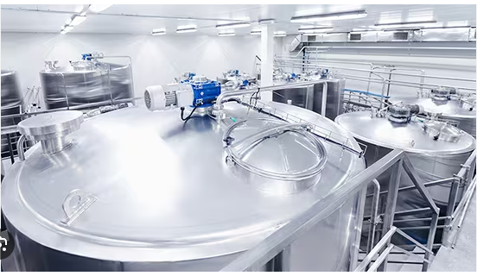

Figure Process Production Tank System

If the Gum addition instruction step overruns, creating downtime, it affects the following production process steps such as the mixing via agitation step, processing via deaeration step and the final texture of the beverage batch. The main reason the gum addition step in the production of beverages materials is problematic is due to length of time it takes to add the gum itself which is manual and to dissolve in the production tanks. After the initial addition, the rest of gum quantity tends to float on its surface, and it takes longer to mix into batch. Agitation of the batch in these production tanks creates gas that needs to be dispersed as it can affect the quality of the product.

The longer the agitation instruction step takes the more gas that is created in the production tank resulting in a longer deaeration step. Deaeration is the process of gas removal from the batch, where the agitators are switched off and the batch is allowed settle. Fig 2 shows an example of a sample batch process system and fig 3 shows the inside of a production tank. The Production tank environment is not complicated but what happens inside these tanks during the production of these batches that can create issues such as downtimes. Agitation involves impellers driven by a drive motor on top of the tanks All these phases are monitored and recorded as phase overrun metric and logged in each batch details on the shopfloor system. This information on the process was shared through the primary data collection through the observation and interview process.

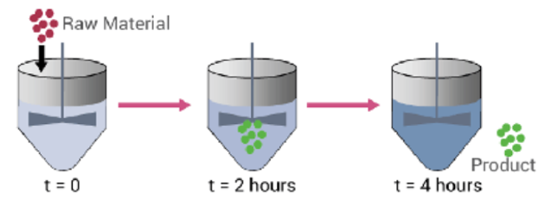

Figure Sample Batch Process System

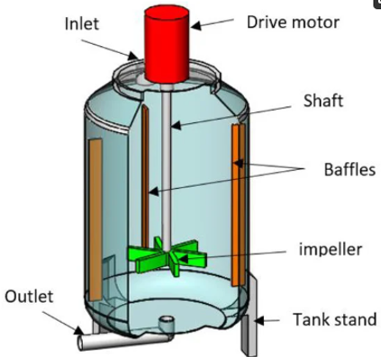

Figure Schematic Diagram of Production Tank

### The Batch Data Collection Process

The current data process from beverage batches production involves collecting data from the various production line operations. The support systems for data collection and storage are FactoryTalk batch software and SQL Server Management Studios.

Data sources can be external and internal. In this research, support for data and information communications come from various industrial information systems which is integrated. and it is stored on the relational database, (Min et al, 2019)

The data for this research was originally stored on the manufacturing shopfloor database system. For each batch produced, each production process time step was recorded. By selecting the production time, we were able to request via SQL query all material batch details that had a deaerating step in their process. Therefore, reducing the amount of data was sent and stored as a CSV file. This data will need to be pre-processed before it can be passed to a machine learning model, (Lee et al ,2019).

The Production batch data in the organisation is acquired from software called FactoryTalk® Batch. It provides a flexible batch control system. It allows you to specify procedures or recipes and enforce their execution in production. The FactoryTalk Batch Server operates FactoryTalk® Batch software, (Rockwell automation, 2006, Kuhar et al m 2015). Figure 4 below shows an example of how this software looks like during a production.

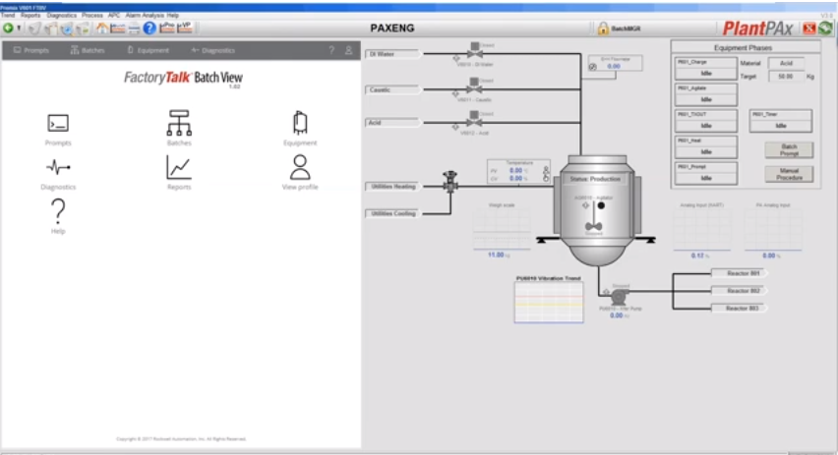

Figure Screenshot of the FactoryTalk Batch View

This FactoryTalk® Batch software uploads batch data from each of the production activity known as phases per batch to a Microsoft SQL database which is managed by SQL Server Management Studios. One of the components of this software is the FactoryTalk Event Archiver which translate the FactoryTalk batch tab-delimited ASCII electronic batch record files to a user-specified file type. This organisation uses Microsoft SQL database which is managed by SQL Server Management Studios to maintain files for each batch created.

Microsoft SQL Server Management Studio (SSMS) is a software application developed by Microsoft that is used for configuring, managing, and administering all components within Microsoft SQL Server. A central feature of SSMS is the Object Explorer, which allows the user to browse, select, and act upon any of the objects within the server, (Hughes et al, 2020).

### Current Efficiency Measurement

This production batch data is used to measure the effectiveness of a production process. The current standard measurement used is Overall Equipment Effectiveness (OEE) metric. This is computed for the whole production line for each production tank at each production instruction step. It looks at the availability, performance, and quality to determine production efficiency, (Hassani et al), The production data that is used for this calculation is:

* The scheduled Production run time
* The actual Production run time (including all stoppages or overruns)
* The ideal cycle times for production
* The total number of batches units produced.
* The number of unites that meet the quality standards.

Lepenioti et al, 2020 states that this data, has the credentials to move beyond these OEE metrics and with the recent advancements of machine learning, predictive and prescriptive analytics using machine learning are possible with the aim of supporting the operator in production and enhancing the production process.

### Summary

In the evolving beverage manufacturing landscape, achieving steady production efficiency, especially with mucilage-containing beverages, is pivotal. Unanticipated downtimes can disrupt processes and point to existing inefficiencies. Given the sheer volume and complexity of batch data, manually extracting insights becomes challenging, often missing optimization opportunities. This research dives into these intricacies, harnessing machine learning to understand mucilage beverage production downtimes and to pioneer predictive models that refine scheduling.

Contemporary manufacturing accumulates vast operational data, stored in complex databases. Data mining can assist in interpreting this vast data landscape.

Traditional downtime predictions relied on historical data, but blending machine learning with big data analytics offers more precise forecasts. The production of Mucilage Containing Beverages involves a multi-step process across tanks of various capacities. Challenges arise due to the behaviour of the key ingredient, mucilage, during production. Consolidated batch data, sourced from software like FactoryTalk® Batch, provides a gauge for production efficiency. With advancements in machine learning, there's potential to elevate this efficiency through predictive analytics.

### Research Overview

#### Problem Statement

In the realm of beverage production, operational downtimes can significantly hinder productivity, resulting in cost overruns and inefficiencies in the manufacturing process. Despite the availability of abundant batch data, a systematic methodology to understand, analyse, and predict these downtimes has yet to be implemented comprehensively. The overarching goal of this research is to enhance the beverage production process using machine learning techniques.

#### Objectives

* Research Objective 1: Understanding Production Downtimes

First, to understand the current process better by investigating how often and why there were downtimes in the various phase stages in the production manufacturing tanks. TO give us a clear picture of where there were production phase overruns for each tank.

* Research Objective 2: Using Machine Learning to Analyse Data

To apply machine learning to analyse the production batch data. By studying the data, to point out where the process could be made more efficient. This step shows the value of using advanced tools and methods to analyse production data.

* Research Objective 3: Predicting and Planning for Downtimes

To create machine learning models to predict downtimes in particular production instruction steps such as agitation, mucilage addition and deaeration phases. With these predictions, production schedules have the potential to improve, reducing the number of overruns and making the whole process faster.

Following on from here, section 2 is the literature review, delving into existing research related to this this topic to provide an overview of key findings and methodologies used previously. Chapter 3 and 4 is concerned with the research and experimental methodology where the methods used in this study are outlined in detail. Chapter 5 is the results where data and findings from the machine learning models results are given and chapter 6 covers the discussion which will connect with findings with the objectives that were set, and give suggestions for future work, significance, and potential limitations of the research. Chapter 6 is the conclusion which will summarize the main findings of the research.

# Literature Review

## Introduction

The literature review will focus on a range of areas relating to production process optimization through the application of machine learning models for the downtime prediction in beverage containing mucilage production. I will look at the importance and impact of batch data analysis in production.

Following this, I will examine data mining through machine learning models applications in manufacturing process by first defining machine learning and giving a background detailing the advantages and challenges of implementing it in production. Further delve into using machine learning in production downtime predictions and its advantages for production optimization.

## Efficiency Driven Analysis of Batch Data

In the manufacturing context, "batch production" is a method where items are produced in groups or batches rather than in a continuous stream. "Batch data" would then refer to the data generated during these batch production processes. It could include variables like production start and end times, quantities produced, downtimes, error logs, equipment metrics, and any other relevant data points that can provide insights into the production process. Production Batch data is worthless on its own, the manufacturing industry requires efficient processes to be able to derive valuable information from it.

The main motivation behind the analysis of batch data is to improve the efficiency of the production process through reducing downtimes, maximizing output, minimizing waste, optimizing resource utilization, and shortening the overall production cycle. There is an increasing importance to enhance the effectiveness and efficiency of decision making in a production process, through mining of the production data both online and offline using more efficient techniques. (H., XIA et al, 2022). This is a methodical examination and evaluation of batch data and can involve inspecting, cleaning, transforming, and modelling data to discover useful information. This is more often referred to as data mining. It is defined as the exploration and analysis by automatic or semiautomatic means of large quantities of data stored in databases, (Bastos et al, 2014). Fayyyad and Piatetsky-Shapiro (1996) classified data mining into four main types: association rules, clustering, classification, and prediction. Within this categorization, prediction relates to a model that determines a continuous value or anticipates future data trends, typically relying on methods of classification or regression. Choudhary et al 2009, simply describes data mining into two sections – Descriptive and Predictive data mining.

* Descriptive data mining focuses on discovering interesting patterns to describe the data.
* Predictive data mining focuses on predicting the behaviour of a model and determining future values of key variables based on existing information from available databases.

Manufacturing in general has the potential to utilize machine learning for data mining to extract patterns from existing datasets, which can serve as a basis for predicting future system behaviour, (Alpaydin et al 2010, Nilsson et al, 2005, Ge et al, 2017). Alpaydin also claims “Storage data only becomes useful when it is assessed and translated into knowledge that we may use, for example to develop predictions”. This is true of this research.

According to Kovalev et al, 2019, it highlights the importance of batch data as the head of the process of digital transformation part of the industry 4.0 revolution. Digital transformation is the approach used by the production industry undergoing this revolution for the optimization of production data.

## Traditional Process Optimisation Methods

Prior to machine learning, traditional methods used for improving production efficiency included manual inspection, statistical tools, expert systems, and mathematical modelling, (Wang et al, 2018) Other traditional statistical methods such as statistical control charts (SPC) are now deemed insufficient when it comes to enhancing production processes, (Ismail et al, 2021). The advantages to these control measures were their applicability and simplicity but are now not able to keep up with the increasing complexity of production and volume of data being gathered as a result. (Ismail et al 2022).

Ge et al, 2017 describes the importance of analysing batch production data for patterns and relationships between production variables leading to useful information can be extracted and used by Statistical models such as Operational equipment efficiencies (OEE). OEE can be developed for various applications such as process monitoring or fault diagnosis.

Another important aspect of batch data collection is highlighted in Arif et al ,2023, where it states most existing quality monitoring models only look at one manufacturing state and the batch data gathered is not processed until after the product is made or manufacturing process is over. This has a negative effect on resources, time, and production performance.

Three areas that make traditional methods obsolete and where utilising machine learning shines are:

* Information and communication technologies – mode of production has changed, large-scale tasks, operating performances and environments are more complex, (Wang et al, 2018a)
* Increased demand for real time dynamic self-adaptive and precise production management (Arashpour et al, 2018, Lamon et al, 2010.)
* The completion of various kinds of information systems deployed in manufacturing enterprises. E.g., CAPP, computer-aided process planning, (Papananias et al, 2019.)

Machine learning cannot completely replace traditional methods. One can learn from the other while machine learning can aid the identification and modification of the parameters of the traditional methods to improve processes (H., XIA et al, 2022.)

Also, another consideration is the time and financial cost of developing and programming models of machine learning, this may be out of reach of small-scale manufacturers, however for large scale manufacturers and their various production lines, it is the varying complexities and efficiencies these models can bring. It can be challenging to implement AI – machine learning in an entire organisation with existing processes and systems if the company lacks robust technology infrastructure and collected data. This is often a limitation It’s important that there is clear strategy stemming from top management to achieve goals otherwise AI will fail (Kang et al 2020, Heio et al, 2021).

## What is Machine Learning?

Machine Learning model systems learn from data, identify trends or patterns from data, make decisions based on structure feedback and then perform tasks on their own, with continued improved performance and problem-solving skills without human intervention (Helo et al, 2019). It models the complex relationship between input and output data, (Wang et al, 2018b).

Machine learning can be divided up into 3 types: unsupervised, supervised and reinforcement types, (Pugliese et al, 2021) as shown in fig 5. It also shows the associated machine techniques. For this research, type of machine learning relevant is supervised as we have an input and output from a set of labelled training data and the technique is regression as the input value or our target variable is a numerical continuous valuable which is the production metric the phase overrun times. These algorithms are used to optimize the coefficients of each independent variable to achieve a minimum error in the prediction.

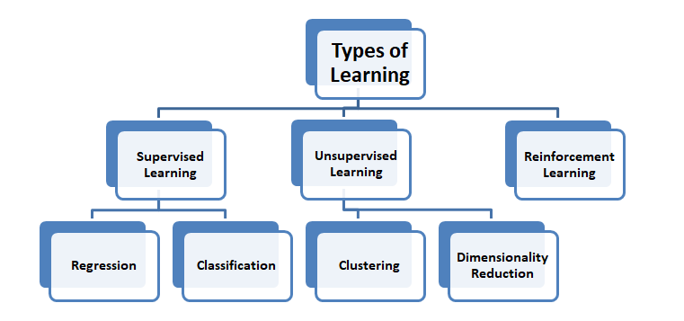

Figure Types of Machine learning

The common methodology in using Machine learning algorithmsfor the improvement in manufacturing process and quality optimization are as follows, (Ismail et al, 2021, Kant et al.,2015, Aksa et all.,2021, Ahmad et al.,2018, Kulkarni et al.,2020, Koksal et al., 2011)

* Data Collection – collect data on the performance of the chosen parameter under different operation conditions, e.g., phase overrun, phase duration, flow rates, temperatures etc.
* Data Prepossessing – removing outliers and missing values ensure the data is clean and accurate.
* Feature selection – selecting the relevant features that can help prediction.
* Model development – develop the predictive model and evaluate it using metrics such as accuracy, precision, and recall.
* Model Optimization – to improve its performance using hyperparameters or ensemble learning techniques.
* Model Deployment – deploying the model in a real-world setting and validate its performance.

According to Kang el al, 2020, most machine learning applications in the manufacturing industry were concerned with supervised learning, due to the abundance of production data available. Regression is the main task applied for quality optimization problems while classification and anomaly detection are mainly applied for product failure detection.

Machine learning has successfully been applied in industry, these are summarized below, (Diez-Olivan et al ,2019, Aksa et al, 2021, Menezes et al, 2019):

* **Descriptive** – accounting and analysis of historical data. e.g. Fault detection and diagnosis
* **Predictive** – Considers near past data to predict coming future trends, biases tendencies and behaviours through causation and correlation.
* **Prescriptive** – finds or prescribes the best mode route manner or moves to operate based on given data (output) and models (inputs). help make decisions on what to do and how to minimize failure impact.
* **Preventative** – determine the potential of failures happening.
* **Detective analytics** – makes diagnostics of collected data to eliminate and rectify inappropriate values used in predictive analytics.
* **Cognitive analytics** – automated predictions, prescriptions, and detections for smarter decisions over time

## Machine Learning for Predictive Analysis

Through this literature review, there was no direct research on the process optimization using machine learning models by predicting production phases downtime in the beverage manufacturing. However, there was plenty of research reviews on other types of processes in the manufacturing industry using various machine learning (Monostori et al, 1996, Md et al, 2022, Paturi et al, 2021).

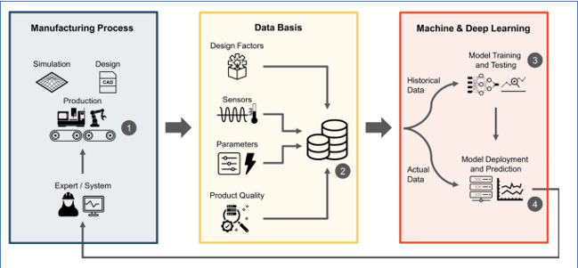

Figure Predictive Quality Approach for a Selected Manufacturing Process

Tercan et al, 2022, reviewed research publications between 2012 and 2022 dealing with predictive quality in manufacturing using machine learning models. The categorization was based on the manufacturing processes and machine models involved. None of the processes involved a beverage production process. Predictive quality uses machine learning methods in production to predict product-related quality base on process and product data, fig 6. Most research papers reviewed by Tercan et al, 2022, involve having a base machine model, fig 7 and then doing a comparison with other machine models and these mainly are ensemble methods. Ensemble methods involve the combination of multiple learning models, thereby aggregating their decisions to make a prediction.

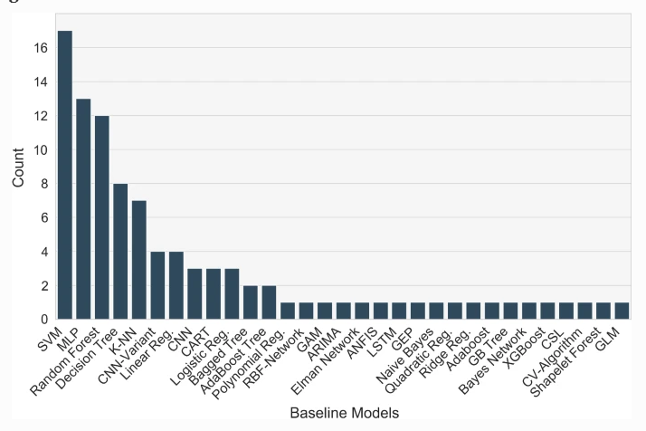

Figure Baseline Models used in Predictive Quality Process

In this research the initial part is focused on the exploratory data analysis where the goal is to understand the data and identify inefficiencies during the various instruction steps identified across the production tanks used. This is not a machine learning task, but it is a crucial preliminary step before applying machine learning models, (Santos M et al,2023, Komorowski et al, 2016).

## Machine Learning Models Application in Production Process Optimization

Most manufacturing processes involve multistage steps to produce accurate products. Papananias et al, 2019 developed a Bayesian linear regression model to estimate part quality of and associated uncertainties given in process monitoring data. The predicted results compared well with the experimental measurements and further a neural network model was developed which also showed similar results. It highlighted challenges to the model of evolution of more complex products, big data, and manufacturing intelligence. It also gave the suggestion to look at self-organising maps (SOM, Lieber et al, 2013), or principal component analysis for the consideration of process variables such as high sampling rates or large measurement uncertainties to reduce them. A study on the injection moulding process by Farahani et al, 2021, looked at over 10 different machine learning models. It was determined that Neural Networks is a perfect model for this type of prediction, but the computational power, time and cost are factors need to be considered.

A research paper concerned with engine oil aeration process step looked at a gaussian regression model used to correlate the identified features to measure oil aeration. The results were successful in the prediction of oil aeration to an uncertainty of +/-0.02 from the measured oil aeration values. The model was trained using previous oil pressure data. The results also highlighted that importance of looking at sampling measure as the cases used showed overfitting. This was calculated from using the metrics of RMSE, root mean square deviation. (Kulkarni et al 2021)

Under Predictive tool performances, logistic regression as a machine learning model has been used for the reliability estimation for cutting tools using the variable vibration signals. It is using correlation analysis approach to estimate the reliability and failure time of the cutting tools. It concluded that by further looking at the mechanical knowledge and probability density functions of other variables could further enhance the model’s predictions on machine tool performances. (Chen et al, 2010)

IBM Research has developed a process and system regression optimization service for optimising set points for process controls. The Process and System Regression Optimization service consists of three main components -- (1) Regression component and (2) Single Process Optimization component, and (3) System-wide Optimization component. The three components are used to model the problem at hand with the regression component being used to train one or more regression models based on historical data from the process or asset, and one of the optimization components used in combination with the trained model(s) to optimize the control points. Datasets are trained on the API and then it uses various models of regression to make predictions requested. It uses Mean Squared error and R2 as metrics to compare different regression algorithms.

Phan et al, 2021, used this IBM AutoAI toolkit for automated machine learning to search for the right learning algorithm and optimize its hyperparameters. They were able to restrict their models to decision tree, multivariate adaptive regression splines. Using cross validation to pick the best performance model.

Hassani et al, looked at the efficiency of the equipment rather than the product process in manufacturing, the methodology included a case study where the data was based on results from 2 machines. The applied methodology included data preparation, exploratory analysis of the data and creating training sets and applying various models. Including support vector regression, random forest. Model accuracy was calculated with and with cross validation. It is the same methodology for optimization of equipment as is process.

## Deep Learning via Neural Networks Application in Production Process Optimization

Deep learning provides advance analytics tools for processing and analysing big manufacturing data. It is seen as a breakthrough solution to the challenges of multimodal data, the high dimensionality of feature space and multicollinearity among data measurements. It has applications in speech recognition, image recondition, it allows automatically processing of data towards highly nonlinear and complex feature abstraction via a cascade of multiple layers, (Wang et al, 2018, Rivas et al, Manami et al, 2023, Trask, A.W., 2019, Chollet, et al., 2021). The following looks at its application in process optimizations in manufacturing.

Pfrommer et al, 2018, used ANN as a surrogate model to optimize the draping process of textiles. He used the surrogacy process to eliminate the costly process of trial experimentation that is often the approach for process optimization. The study achieved improved results using surrogacy with deep ANN but highlighted the importance of the training data and the sampling.

A combination of a neural networks with a genetic algorithm to predict critical parameters in a particle board and axial flow designs manufacturing process. The Genetic algorithm was then applied to the trained NN to determine the optimum values using the parameters successfully. (Cook et al, 2000, Liu et al 2023)

Fang et al, 2019, learned from Chen and Wang et al, 2013 studies to forecast the cycle time in a wafer fabrication factory using a fuzzy back propagation network. It shows that the NN models lacked generalization and fitting capabilities to deal todays big manufacturing data. It also highlighted the importance of considering expertise for feature extraction to reduce the input dimensionality. Fang et al, 2019 considered all this in their study of shop floor real time job remaining time prediction. They used a Deep stacked sparse Autoencoder to deal with every changing manufacturing floor. In its conclusion it suggested looking at LSTM, long short time models to analyse time series problems and find bottlenecks in the production line. It also suggests reinforcement learning to help with self-learning in the production control and optimization.

A Comparison between ARIMA, LSTM and GRU models was done on time series forecasting for bitcoin technology. ARIMA, Autoregressive integrated Moving average, turned out to be the better model, followed by the GRU model gated recurrent network whereas LSTM allows the tracking the dependencies of new observations with past ones. This study gave details on the methodology on creating and comparing types a recurrent network, with certain parameters and evaluation metrics. It highlighted the importance of data normalization, using Scikit-learn making it easier for the network model to learn. Another highlight from these studies was the importance of the architecture of the neural network itself and optimisation of these methods (Yamack et al, 2019, kuric et al, 2022, Sun et al, 2019).

The time series predictions are used to monitor time changes and monitor trends in the development of the examined parameter. The most used models in research and practice for time series prediction are linear autoregressive models (AR and ARX), LSTM neural networks, moving average mode (MA) and autoregressive moving average (ARMA), (Kuric et al.,2022).

Yamack et al, 2019 conducted a comparison between three different machine learning models in making a time series prediction. The three were ARIMA (Auto regressive integrate moving average), LSTM (Long Short-term Memory) and GRU (Gate recurrent Unit). The topic was predicting the price of Bitcoin. This research compared all three models by accuracy (measured by MAPE and RMSE) and time. It concluded that the outcomes could have been of effected by the parameters that were chosen and the total amount of data used.

Fang el al.,2019 examined the time predictions to complete a job in a discrete manufacturing system using a deep learning-based approach. A deep Stacked sparse autoencoder (S-SAE) model was designed to enable a machine algorithm to learn highly varying status of manufacturing for prediction. In this research the performance was compared to different models, such as linear regression, back propagation neural networks, multi- layer neural networks and deep brief neural networks. To do this, the above models were trained and tested using the same dataset via a fivefold cross-validation. He concludes that future work, includes using LSTM neural networks to analyse time series in production.

A study on a predictive maintenance of an industry machines by Geltz et al, 2021, looked at several machine models using firstly traditional models such as XGBoost, ridge regression and then neural networks using a multi-layer perceptron. The traditional methods produce good accuracies whilst the neural networks did not. They concluded that the lack of enough data points hampered neural networks thus highlight the importance of the data set. Kang et al, 2020 also noted that a larger dataset helps to achieve better results with neural networks, but they’re main advantage is ability to handle complexity which can be found in productions.

## Production Process of Manufacturing Mucilage containing Beverages

A production line involves a series of factory operations that refine materials into end products (Kang et al., 2020). In this study, the focus is on a tank-based production line involving steps like agitation and deaeration. While machine learning excels at deciphering complex patterns, its effectiveness in this context is uncertain. A manufacturing company may operate multiple production lines, each with distinct challenges. Vast data from some lines can lead to effective machine learning solutions; however, applying the same solution to lines with limited data might not yield the desired results (Kang et al., 2020). The Production lines are classified as continuous where the target variables are continuously measured. According to Kang et al, 2020, most machine learning models applied to Quality optimization problems on production lines are regression type. For this study the target variable for downtime predicting will be the phase overrun times measured in minutes. This attribute is measure of how much longer each instruction step took to complete above the target time predetermined.

This research is focused on understanding downtime during the production of beverage materials, a key performance metric in manufacturing. Downtime can be caused by a variety of factors, and in this study, two specific variables, 'phase overrun' and 'phase start delay,' were identified as indicators of such inefficiencies. Specifically, the 'phase overrun' provides insights into unexpected delays during the beverage mucilage batch production process, potentially reflecting equipment malfunctions, human errors, or supply chain disruptions. On the other hand, it’s important to mention ‘phase start delay’ as a downtime factor, as it can be associated with the initial setup or pre-production activities, where factors like equipment readiness, raw material availability, or staff allocation come into play, (Kadam et al, 2023, Williams et al , 1995).

### Process Instruction Steps

Three of the instruction steps in the process of producing mucilage containing beverage batches give rise to phase overrun downtimes. Each step is linked to each other.

Once the raw ingredients are added, the agitators are started, and the mixing begins. Agitators are equipment used to homogenise media inside a tank, they work by rotating immersed impellers at a controlled speed, call revolutions per minute. The fig below shows the various components of an agitator, which are present in the current production tanks that produce the mucilage containing beverage batches. From the production process batch data, agitation times are different for each tank which leads to varying production times and can lead to batch downtimes. The reasons for this are the dispersion of mucilage gum ingredient, once viscosity increase has started, agitation of the solution and therefore powder dispersion becomes increasingly difficult.

This results in longed mixing times are required to complete dispersion/hydration and creating more gas that needs to be dispersed during the deaeration phase.

It plays a crucial role in ensuring the quality and shelf life of the final product which was documented by Feilner et al. It involves the removal of dissolved gases such as oxygen from the beverage. The deaeration time must be carefully calibrated to achieve optimal results with the goal of preserving the desired sensory characteristic and stability of the beverage (Paquin et al, 2009).

There are many process parameters that can affect the length of deaeration time a beverage batch need. Examples of process parameters include the type of final product to be produced, the equipment used, the initial methods of addition and nature of raw material added, temperature and pressure factors. Optimization of these parameters can lead to a lower deaeration time thus an increased efficient process without compromising the final product quality and stability.

## Summary

The literature review underscores the application of machine learning in optimizing production processes, with an emphasis on predicting downtime in beverages containing mucilage. By analysing batch data, the goal is to enhance efficiency, reduce waste, and streamline the production cycle. Industry 4.0 accentuates the importance of digital transformation and the leverage of batch data, with analytics tools like machine learning yielding invaluable insights from this data, (Rai et al, 2021).. Traditional methods of optimization, like Statistical Process Control (SPC), are becoming outdated due to evolving technologies and the burgeoning integration of information systems. Machine learning, especially supervised learning, excels in identifying data patterns, continually refining its decision-making, and has found myriad applications in manufacturing, ranging from descriptive to cognitive analytics. In the broader context of manufacturing, machine learning is notably used for predictive analysis. Although the beverage industry hasn't been a focal point, other sectors have tapped into its potential, with various studies showcasing machine learning models, including the emerging deep learning techniques, for prediction and process efficiencies, (Aksa et al, 2021).

Furthermore, a consistent theme across the literature is the adoption of multiple machine learning models to evaluate data and forecast outcomes. Equally pivotal is the data: its acquisition, refinement, and preliminary understanding of inherent trends and correlations. The nature of the data—be it labelled, structured, or unstructured—directly influences the choice of a machine learning model. There's a shared methodology across diverse research, encompassing distinct, replicable steps, which will significantly benefit this study. The proposed metrics for assessing predictions and trends will further fortify the research foundation. The crux of the present study is to assess the efficacy of machine learning models in predicting phase overrun times for mucilage-containing batches, employing a spectrum of production tanks with diverse capacities.

# Research Methodology

Research methodologies typically fall into two main categories: primary and secondary data collection (Saunders, Lewis, and Thornhill, 2016). For the research questions poised at the start of this paper, a combination of primary and secondary data collection will be utilised.

Within both categories, various methods of data collection can be utilized. This section aims to outline the chosen collection strategies that, in the author's view, best serve to answer the research questions presented in chapter 1.

## Primary Research Data Collection

The author determined that employing a qualitative and quantitative approach for collecting primary research data would be the most suitable technique to gather first-hand insights, approaches as observing and interviewing individuals knowledgeable in beverage process production and data analytics.

Factors considered by the author when choosing this primary research method encompassed:

* Research Objectives – the appropriateness of the research method involved.
* Author status – role/access in the organisation if applicable
* Expertise of the Selected Participants – availability and validity
* Timeframe – how long this research method could take.
* Ethical Considerations – gaining consent of the participants to partake and the use the data collected.
* Bias - ensuring a diverse range of inputs by involving individuals with distinct roles in the beverage production process.

### Data Collection Through Observation Qualitative Approach

The author, employed full-time at a beverage production company, undertook participant observation in the production area to deeply understand the process, which inspired the research questions. Gaining access required a candid explanation to the production manager about the study's purpose and the expected insights, like comprehending process terminologies. Noting observations and informal conversations was cleared in advance, ensuring participant anonymity. Potential research challenges included the author's limited process comprehension, possibly leading to observer error, and the "Hawthorne effect" where observation might alter participants' behaviour. These potential pitfalls would be addressed in subsequent in-person interviews. This observational strategy provided vital insights and facilitated future interactions with process production experts for in-depth interviews. The production operative gave a detailed explanation of the mucilage beverage containing process.

### Data Collection through in-person Interviews

In-person interview can take many forms but the one used for this research is an unstructured informal interview, and for practicality and ease of transcription, these interviews were conducted online via the Microsoft Teams platform. By employing an informal interview using open- ended questions as this data collection method, it facilitated a more comfortable scenario allowing for in depth discussions surrounding the mucilage containing beverage production process and the potential use of data analytics. Chosen participants were able to freely talk about the process and the author was able to observe the participant reactions and adapt the interview flow, accordingly, as suggested by Saunders et al. (2012). This is a more flexible approach.

To address potential respondent bias, the author ensured a broad range of perspectives by engaging individuals from various roles within the production process. Each interviewee contributed a distinct viewpoint: one oversaw the production process, another actively worked in the production area, and the third played a role in data analytics within the organization. Through interviews with this diverse group, the author aimed to achieve a comprehensive understanding of the existing beverage production process, encompassing both common practices and individual variations.".

Transcripts from the interviews can be seen in appendix 8.1.

## Secondary Research Data Collection

The secondary data source used was internal to the organisation, from various industrial information systems which is integrated. The support systems are FactoryTalk batch software and SQL Server Management Studios.

The data for this research was originally stored on the manufacturing shopfloor database system. For each batch produced, each production process time step was recorded. By selecting the production time, we were able to request via SQL query all material batch details that had a deaerating step in their process. Therefore, reducing the amount of data was sent and stored as a CSV file.

The author chose a quantitative method for gathering secondary research data. Selection factors included:

* Relevance of secondary data to research goals
* The author's position and access within the organization
* Availability and knowledge of chosen participants.
* Estimated research duration.
* Ethical aspects, including participant consent.
* Bias - ensuring a diverse range of inputs by involving individuals with distinct roles in the beverage production process.

## Research Validity

To determine the extent of which the primary and secondary data collection above accurately assesses the research problem objectives is the basis of validity. We need to validate if the data collected for this research answers the research questions poised and are these answers trustworthy and meaningful.

The research addresses multiple facets of validity to ensure reliable findings in exploring the beverage production process and data analytics. Internal validity is reinforced by diverse participant selection and method triangulation, enhancing data reliability. External validity aims for generalizability by capturing varied roles and data sources like FactoryTalk® Batch and SQL Server Management. The study boosts ecological validity by using real-world settings and expert interactions. Content validity is ensured through on-site observations and expert interviews, offering a comprehensive understanding of the process. Finally, face validity is established through diverse data collection methods and transparent research objectives, ensuring methods seem credible. Rigorous checks for biases and methodological precision are integral to maintaining these validity levels.

## Research Ethics

Ethics in research is important because it ensures that the participants are treated fairly and respectfully. It will also help protect their privacy and well-being. It also ensures that the data gathered is honest and trustworthy.

In the context of the primary data collection, the expert participants will be invited to join the research with the freedom to withdraw consent or exclude their data contributions at any point before the submission date. During the interviews a professional approach will be maintained with confidentiality and anonymity of the participants and the data information given preserved for research purposes. A master file containing the responses will be kept by the author and will not be shared. This master file will be securely stored, and password protected as an enhanced security. Additionally, if the participant has any queries during or after the interview, they will be answered promptly and sensitively.

The secondary data source used was internal to the organisation and it is stored on the relational database system called shopfloor system. The author followed proper protocols when gaining access to the data by engaging in the relevant channels within the organisation. Such channels include the organisations legal counsel and ethics point software where you can determine if a non-disclosure is relevant. However, since the data received will be swiftly anonymized to prevent linkage to the individual participants and organisation, there was no legal or ethical worries. The safeguarding of the data will be ensured through secure storage and the implementation of passwords.

Furthermore, the study acknowledges the importance of adhering to the General Data Protection Regulation (GDPR) and is committed to implementing necessary measures to uphold compliance throughout all stages of the research process. This demonstrates a commitment to ethical research practices and the protection of participants' privacy and rights.

## Sampling Strategy

For effective research, understanding the quantity and type of data required is crucial. While the data gathered constitutes the population, it's not always necessary to analyse it all. Instead, a sampling strategy might be employed for conciseness without sacrificing representativeness. The sampling approach differs for primary and secondary data. Primary data, sourced from in-depth unstructured interviews, will utilize nonprobability sampling due to its qualitative nature. Conversely, secondary data will use probability sampling, ensuring every item in the population has an equal chance of inclusion.

Primary data for this research was gathered using in-depth, non-structured interviews, employing a non-probability, purposive sampling strategy. Participants were chosen based on their expert knowledge and unique perspectives. Purposive sampling, while not representing the broader population, emphasizes in-depth information, making it suitable for exploratory research. While this approach may limit generalizability, it ensures high validity by focusing on specific research questions and drawing from expert insights. The main advantage of purposive sampling is its ability to provide rich, targeted information, especially on complex topics. However, it might carry potential biases and may not always represent wider populations. In conclusion, while its findings might not be broadly generalizable, the depth of insights gained from purposive sampling makes it a crucial tool in research design.

Secondary data was sourced from the company's internal relational database, the "shopfloor system", which houses comprehensive production data. Given the vast volume, categorized as Big Data, a sampling strategy was essential. While probability sampling was initially considered, the sheer size made it unfeasible. Thus, data from the past two years focusing on mucilage-containing materials was chosen, leading to a purposive sampling approach. This method aimed to identify patterns over a specific time by examining production variables. The sampling frame encompassed all production batches, with the sample specifically filtering for mucilage-based materials, considering the various production tanks used. Of the 347 batches produced over two years in 16 tanks, all were included in the sample. Homogenous sampling was the chosen technique, focusing on similar production tanks. The strategy prioritizes depth over broad representation, offering detailed insights but potentially limiting generalizability. Purposive sampling provides rich, targeted insights but may introduce selection biases and challenges in broader applicability.

# Experimental Methodology

In this experimental methodology chapter, the primary intention is to delve deep into understanding the production phase downtimes. This will involve a systematic examination of the frequency and underlying reasons for downtimes in various phase stages across the production tanks, pinpointing potential areas of production phase overruns. Following this, the plan to employ machine learning techniques to analyse the production batch data, aiming to identify avenues for process optimization and to highlight the profound implications of utilizing advanced analytical methodologies. To conclude, the methodology will focus on the design and development of predictive machine learning models. The goal with these models is to foresee potential downtimes, facilitating a more efficient structuring of production schedules, minimizing interruptions, and thereby optimizing the overall production process. Fig 8 shows a detailed views of all method components of the machine learning,

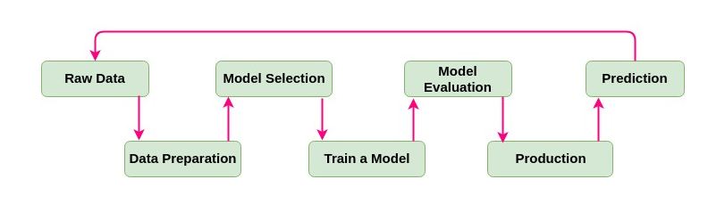

Figure Flow Diagram of the Machine Learning Process

## Data Collection

Historical batch data related to the production process was requested from the Microsoft SQL Server Management Studio (SSMS). Microsoft SQL Server Management Studio (SSMS) is a software application developed by Microsoft that is used for configuring, managing, and administering all components within Microsoft SQL Server. A central feature of SSMS is the Object Explorer, which allows the user to browse, select, and act upon any of the objects within the server.

The SQL query was structured to encompass a two-year time frame, focusing on batches containing mucilage beverage that undergo a deaeration phase, inclusive of all relevant phase details and time durations as per the research objectives. Once obtained, the data was initially in Excel format but was transitioned to a CSV format. This conversion not only ensured data integrity but also facilitated seamless integration with Python programs, given the format's readability and compatibility with the language.

## Data Pre-processing

### The Dataset

Each entry is complete with granular details, from timestamps to specific attributes related to production phase durations, raw ingredient materials involved, and other relevant metadata. While the vastness ensures a comprehensive representation of the production traces, it necessitates rigorous pre-processing to sift through noise and redundancies.

The original production csv file contained data on beverage batches that contain a mucilage ingredient produced in various production tanks with differing capacities over time of 2 years. In compliance with the organisations data usage agreement, specific data points have been omitted to maintain the confidentiality. Table 1 below provides an overview of the updated dataset’s column data with their units and explanations. The dataset is called. ProductionDateupdated1.



Table ProductionDataupdated 1 dataset table

Over 46 different type of beverage mucilage containing materials with a total of 367 beverage batches were produced across 16 production tanks of varying capacities. Which tank they were produced in; was dependent on the production schedule for that time. Table 2 gives details of all the productions tanks available for making mucilage containing beverage materials. It shows the capacity of each tank and number of materials and batches produced.

For the purposes of the study, the downtime prediction will be based on the phase overrun metric of beverage batch data produced in the production tanks grouped together according to their capacity and not in individual tanks. From Table 2, it shows the count of batches produced in each tank is limiting and may cause issues for some machine models.

Table Production Tank Details

The data was manipulated using python function aggregation and group by to transform the raw data into a summarized format for the purposed of applying a machine model. So, to examine the data in terms of the production tanks, the tanks were group by their capacities and then the various feature attributes of interest were aggregated. This created a new data frame whereby we could apply the machine learning model to.

The dataset was transformed again to show the phase overrun data for batches produced in these production tank groups but looking specifically at the three instruction steps/production phases of interest such as agitation, gum addition, and deaeration step. These instruction steps can be seen in the following table 3. Under STEP1_CONS step, the ingredient details referring to gum addition was selected, and the batches details selected, and attributes were aggregated. The same was completed for STEP 1,2 ,3 AGITATION steps and HP step which is the phase that is related to the deaeration phase (as confirmed by interview participant no.1). Machine learning model were applied to these specific prepared DataFrames.



Table Production Instruction Step

### Software, Libraries, Web Applications

For this research, the programming language employed was Python. Its selection stemmed from its user-friendly nature and the ease with which the researcher could learn and utilize it. The vast availability of open-source libraries in Python further enhances its adaptability, allowing customization based on the programmer's requirements, (McKinney,2012). One of the major advantages of using python and its libraries, is that they can be used together, in tandem for data analysis, scientific computing and machine learning. The following are examples of the open-source python libraries that were used:

* Pandas – provides data structures like DataFrames and Series that make it easy to handle structured data. It allows for quick data cleaning, visualisation, and statistical analysis. In this research its main use was in the handling of missing data, filtering rows and aggregation of data.
* NumPy -employed for its basic mathematical and array operations.
* Matplotlib – A plotting library – creates and display graphs and visualisations of the data working alongside other libraries such as pandas.
* TensorFlow – Deep learning frameworks – used for building and training neural network models.
* Seaborn – works along with Matplotlib to create statistical graphics.
* Scikit-Learn - allows a programmer to quickly implement a range of machine learning algorithms in conjunction with other libraries such as pandas and matplotlib.
* SciPy – a advanced scientific computing library built on NumPy for scientific computational tasks. It adds additional functionality.

All the libraries above were used in Jupiter notebook which is another open-source web application that allows the creation and sharing of documentation that contain live code, equations, visualisations, and narrative text.

### Data Cleaning

#### Handling Missing Values

Missing values are entries in the dataset, such as 0 or not a number (Nan). Using the panda’s library in python, the amount and type of missing values should be determined, (S. Xu et al , 2015). What columns in the data contain missing values and will it have an impact on the model used are questions that will be answered.). Bastos et al, 2014 highlights the importance of good quality data in order for use in a prediction setting and that during production activity, data may not always be cleaned I.e. noisy, missing and inconsistent.

Missing data can cause bias in estimating model parameters and loss of information (Ismail et al, 2022, Lee et al, 2019). Bastos et al, 2014 highlights the importance of good quality data for use in a prediction setting and that during production activity, data may not always be cleaned i.e. noisy, missing and inconsistent.

#### Removing Duplicates

To protect data integrity, the dataset will be checked for duplicate rows of data. Duplicated data can distort the actual data analysis and give inaccurate results and skew distributions. Using panda’s library, duplication can be determined, and before removing by drop function, the data results need to be check in case they are valid repetitions.

#### Handling Outliers

Boxplots were used to give an informative visual representation of the phase overrun data distributions where outliers can be easily identified. These outliers indicate significant deviations from the production process.

These outliers might arise from inconsistencies or variances in certain production tanks, potentially linked to factors like equipment malfunction, human error, or sporadic disruptions. Some tanks may exhibit these outliers due to unique challenges related to their age, maintenance history, or position in the facility. Another consideration is data entry errors, making it crucial to verify outlier data before making overarching decisions. Occasionally, outliers represent unusual production batches with distinct requirements or conditions.

The outliers identified will be further scrutinized and potentially removed using the Interquartile Range (IQR) method, which was employed during the preparation phase for the machine learning model application IQR is useful in the identifying outliers because it is based on the spread of the middle 50% of the data.

#### Data Normalization

This pre-processing technique involves the transformation of all numeric variables in the dataset to a standard scale. This is necessary when the data features in the dataset have different units or varying scales which can give skew interpretations from machine learning models.

An investigation using the Quantile-Quantile (Q-Q) Plot was looked at to determine the effect of the different types of normalisations such as standard scaling and minmax scaling have on the data. Using the data from the production tank 22MT – reference ProductionTank22_df2, the following graphs shows results of the distribution of the phase overrun data. Using two examples of standard scalar and min-max scaler, there is a S – Shaped curve which indicates that the data may be following a logistic or s curve distribution rather than a normal distribution.

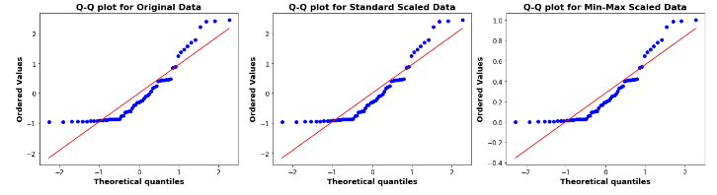

Figure Q-Q plots for the Original and Types of Scaled Data

From the data above, there was no difference between the two scalar methods and below table gives details of the machine models and their sensitivity to scaling.

Table Normalization and Machine Learning Models

The StandardScaler function from Scikit-learn was used to execute Z-score normalization, ensuring each feature contributes equally to model efficiency. This a solid general-purpose choice and had broad applicability,

## Exploratory Data Analysis

Exploratory Data Analysis (EDA) is important initial step in understanding the nature of production downtimes using phase overrun as the target in the beverage manufacturing process. It will be used to discover trends or patterns, to spot anomalies and check statistical assumptions with the help of summary statistics and graphical representations under the headings of Univariate Analysis and Bivariate and Multivariate Analysis. The following are the purpose of EDA:

* Visualising Downtime Frequencies – using histograms and bar plots to visualise the frequency of phase overruns in the production process.
* Identifying Causes for Downtimes – Scatterplots, boxplots or heatmaps/correlations can determine relationships between the different variables in the dataset. (Kumar et al, 2020)
* Spotting anomalies – highlighting of outliers, through boxplots
* Descriptive Statistics – concise summary of the downtimes giving understanding to average downtime durations.

This is aided by the python libraries: Pandas/ NumPy/ Matplotlib/ Scikit-Learn/ Seaborn.

## Application of Machine Learning Models

In this methodology, machine learning models will be utilized to predict production downtimes, a critical factor in optimizing operational efficiency. Given the continuous nature of the target variable – downtime as phase overrun –a regression-based approach ws adopted. The first step involved preprocessing our dataset, ensuring the data was cleaned, normalized, and relevant features were engineered to capture intricate patterns relating to production downtime. The data was then split into training and validation sets, ensuring a representative distribution. Several regression algorithms, from linear regression to more complex ensemble methods, were evaluated based on their ability to accurately predict downtimes. The chosen model was trained on the training set and its performance evaluated on the validation set using metrics accuracy and Root Mean Squared Error (RMSE). To avoid overfitting and ensure our model generalized well, cross-validation techniques were employed. Once satisfactory performance was achieved, the model underwent hyperparameter tuning to further refine its predictions. The ultimate goal of this methodology is to develop a robust machine learning model that can effectively forecast production downtimes, enabling proactive measures to minimize their occurrence and duration.

### Dataset Split

Once the dataset is established, it needs to be split into three subsets: Training, validation, and test sets. There is no optimal proportional for splitting, according to research, the rule of thumb was 70% for training and 15% for both validation and testing. It depends on the size of the dataset, (Barkov, 2019., Rajasekaran et al, 2022) The training set is used to build the model, validation set will be used to choose the machine learning algorithm and find the best values for hyperparameters, and test set will be used to assess the model,

To train the machine learning model, the collected data must be divided up into training and test sets, which are randomly divided by 70:30 ratio of the entire data set. (Cavalcante et al, 2019, Goli et al, 2019).

Using the train_test_split function in Scikit-learn, the dataset was partitioned into 80% for training and 20% reserved for testing.

### Evaluation Metrics

This was facilitated using the metrics module in Scikit-learn the predictions from the models are compared to the true values to calculate the Mean Squared Error (MSE) and the R-squared (R2) score for both training and testing datasets. The MSE provides a measure of the prediction error, whereas the R2 score provides a measure of the proportion of the variance in the dependent variable that is predictable from the independent variables. MSE was used as it was computational cheaper to work with and the choice of using RMSE or MSE is negligible the model with the lowest MSE will have the lowest RMSE as well. ( Zheng, et al, 2015)

### Machine Models

In addressing the research objectives, a diverse array of machine learning models was employed to capture the nuances of production data comprehensively. Sharma et al in 2021, completed a comprehensive study of literature examining the various data pre-processing methods and machine models that were utilised in various industries. The selection of models from linear, tree-based, distanced based, support vector machines to neural networks were chosen to ensure a comprehensive overview of machine learning could be applied to the beverage production data to predict phase downtimes. Table 5 gives an overview of each of the machine models through their description, advantages and disadvantages of use and cost. Sensitivity and tuning are also covered along with the relevant references where they were used, (Burkov et al , 2019, Raschka et al , 2019).

This variety ensures understanding by comparing each model's individual strengths, from linear models providing baseline relationships to tree-based ones uncovering non-linear workings. The use of multiple models enhances robustness through performance comparison. Particularly, advanced models like LSTM Neural Networks are tailored for time-series prediction, apt for downtime forecasting. Furthermore, regularized regression models, such as Ridge and Lasso, effectively prevent overfitting, ensuring the research's generalizability. Overall, this strategic utilization of various models optimizes predictive accuracy, scalability, and adaptability, vital for achieving the research's objectives.

Table An Overview of the Machine Models



### Cross Validation

Model selection and cross-validation (CV) are critical issues in data collection and data mining for predicting the performance of manufacturing processes. Feng et al [108-109] showed that there is no significant statistical advantage of using fivefold CV over threefold CV and or of using two hidden layer neural network over one hidden layer neural nets for turning surface roughness data, (Choudhary et al, 2009)

For each model in the table, a 5- fold cross-validation was performed, (CV=5). The mean and standard deviation of the mean square error was calculated.

A list of the machine models is creating so that a loop can iterate over each model to perform the cross validation. The model is trained and evaluated 5 times (CV=5), each time with a different split of data in training and validation sets.

The scoring parameter is neg_mean_squared_error which means the mean squared error will be calculated for each of the 5 crosses., (Alpaydin et al, 2014, Kuhn et al , 2013)

### Hyperparameter Tuning

Hyperparameter tuning is performed using GridSearchCV. This ensures that the best parameters are chosen for the model to enhance its performance.

The following steps will be used for hyperparameter tuning:

* A grid of potential hyperparameter values will be defined.
* **GridSearchCV** is used to search over this grid and find the best hyperparameters for the model based on 5-fold cross-validation.
* The best model (with the optimal hyperparameters) is then used for predictions and the same metrics as before are computed.

The hyperparameters for each model examined are outlined in appendix 8.2 and it shows the reasoning behind the choice. Various regression algorithms were evaluated with their corresponding hyperparameters. Linear Regression was implemented without any hyperparameter tuning due to its simplicity. Ridge and Lasso Regression both utilized alpha values ranging from 0.01 to 10, offering different regularization strengths. Ensemble models, like Random Forest and Gradient Boosting, considered multiple configurations in terms of tree depth and estimator count. Techniques such as K-Nearest Neighbors and Support Vector Machines were fine-tuned based on neighbourhood count, kernel types, and regularization. Furthermore, neural network-based approaches, from simple dense networks to LSTMs, were also explored, tuning parameters like neuron counts in layers and batch sizes. The LSTM model tuning was particularly computationally intensive, demanding careful configuration. Lastly, an optimized dense neural network was approached using RandomizedSearchCV to identify optimal architecture and training settings. This extensive approach ensures a comprehensive search over potential model configurations to yield the best predictive results.

S. Farahani et al, 2021 suggested the importance to have a framework for the model adaptation and hyperparameter tuning for better model implementation. This is an extensive approach to a comprehensive search over potential model configurations to yield the best predictive results.

### Conclusion

This chapter presented a comprehensive methodology for leveraging machine learning to enhance production parameters. The following chapter will discuss the results obtained from implementing this methodology.

# Results

## Introduction

This chapter explains the impact of the primary data and secondary data on the research objectives, through the information received from the three expert participants and the production batch data downloaded from the organizations database system.

The author examines various machine models to determine if the production downtime as phase overrun variable can be predicted for the various production tanks used to produce mucilage containing beverage materials. It leverages historical data and relationships between features and a target variable to determine if predictions about phase downtime in the future is possible. The downtime was examined for three instruction phases of the production: Agitation, Deaeration and the addition of Gum ingredient.

## The Primary Data – Interviews

From the in-depth interviews, responses from the participants with expert knowledge and distinct perspectives in the research area was reviewed and summarised here. The actual interview transcripts are in appendix 8.1.

### Participant no 1: Data Scientist

Participant number 1, a Data Scientist, played a crucial role in enhancing the existing system's objectives. Initially, the system solely focused on executing batches, with data collection lacking a structured approach for analytics. To rectify this, the participant was involved in refining tracking mechanisms by developing a stored procedure that summarized batch data comprehensively, covering aspects like start times, consumption, problems, weights, agitation times, deaeration times, and homogeneity. They further established targets for different phases through historical data analysis, providing clear objectives for each batch and aiding in issue identification when batches fell short. Resource management was addressed by quantifying departmental needs for shared resources like mobile tanks. Operational Efficiency (OE) calculations, focused on equipment effectiveness rather than usage, were employed to pinpoint areas for improvement. The participant also highlighted the company's emphasis on data analytics, mentioning the creation of a Digital Performance Management (DPM) system for data visualization and future consideration of machine learning where it genuinely adds value. Moreover, they stressed the significance of preventative maintenance, citing examples of early issue detection through thermal balance tracking and the importance of team awareness and training in efficient problem resolution.

The key insights from the Data Scientist's contributions revolved around enhancing batch process tracking, target setting, issue resolution, and emphasizing the role of data analytics and preventative maintenance in optimizing organizational processes.

### Participant no. 2 Production Manager

Participant 2 highlighted the company's data-driven approach, where they utilize operational data to calculate Overall Equipment Effectiveness (OE) figures for each batch, which are then reviewed during daily 9:15 meetings involving cross-functional teams. They stressed the importance of acting based on these figures, with diligent follow-up to ensure completion. OE calculations are performed at the phase level, considering prerequisite times, enabling a granular assessment of phase efficiency. The interviewee discussed various batch phases, such as agitation, deaeration, and ingredient additions, outlining their timing and criteria for proceeding to the next phase. Quality checks before batch finalization were emphasized to meet quality standards. Initiatives to reduce downtime were mentioned, including pre-weighing bulk powders, and optimizing temperature and pump speed. Downtime challenges like liquid filling delays and breakdowns were addressed. Recording downtime reasons and their impact on OE data were explained. Setting targets for parameters like flow rate involved collaboration between different teams. Tank assignments, numbering, and capacity details were provided, with some batches requiring multiple tanks. Different systems, ranging from 20-tonne to medium-to-small systems, were discussed based on production volume needs. An efficiency improvement example involving juice barrel handling was presented. The interviewee reiterated the importance of continuous collaboration, data analysis, and process enhancement to minimize downtime and boost productivity.

### Participant no.3 Production Operative

From the participant's point of view, the conversation primarily revolved around production downtimes and efficiency in a manufacturing process, specifically related to gum mixing. The participant discussed the challenges of interruptions during production, which could result in extended downtimes, impacting operational efficiency (OE). They emphasized the importance of accurately recording extra downtime for batches where gum mixing takes longer due to poor agitation, as this data is crucial for analysis. Additionally, the participant acknowledged that target times for production phases should be more realistic to account for batch-to-batch variations and highlighted potential solutions like improving agitation and pre-mixing highly concentrated gum batches. The conversation also touched on the phases of a typical batch, including ingredient addition, agitation, and transitioning to the high-pressure phase.

The key insight from the participant's point of view is the focus on addressing production downtimes and operational efficiency challenges in gum mixing, emphasizing the need for accurate data recording, realistic target times, and potential solutions to improve the manufacturing process.

## The Secondary Data –

### Exploratory Data Analysis of All Production Tanks

#### Univariate Analysis

The seaborn library(‘sns’) was used to visualise distribution of batches via a count plot overall production tank, (Fig 10). The height of each bar corresponds to the number of records for each tank. The 25MT03 and 04 tanks produced the most batches, they have a capacity of 10 tonne.

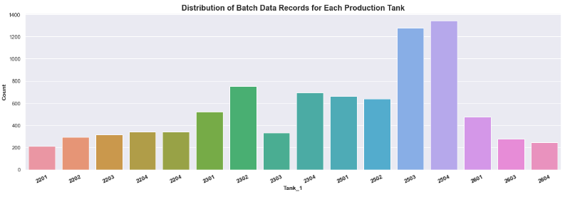

Figure Distribution of Beverage Batches for each Production Tank

Fig 11 shows the distribution of material data records for each tank and allows you to see which materials were produced the most. This was beverage batch material 1756358 – produced 61 times.

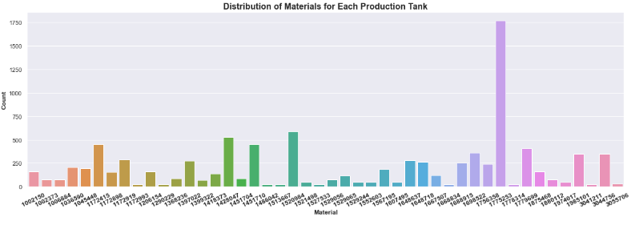

Figure Distribution of Beverage Materials over Production Tanks

#### Multivariate Analysis

The Bar Chart in Fig 12 illustrates phase metrics across different production tanks. The 22MT and 23MT tanks, each with a 20-tonne capacity, have the most significant phase start delays. In contrast, the 22MT tanks experience longer phase durations than the 23MT tanks, indicating slower batch production. Despite all tanks experiencing phase overruns, the 20-tonne 22MT tanks exhibit the highest downtimes. Two outliers, Tanks 22MT01 and 23MT03, show low overruns, attributed to their limited batch production. Participant 3 identified these tanks as ideal due to their minimal metric values, which is consistent with the chart's findings. While 25MT tanks produced more batches, their metrics were better than the larger capacity tanks. Thus, tanks will be grouped by capacity for further analysis. The higher phase delays and overruns in the 22MT and 23MT tanks correlate with the increased mucilage gum ingredient in their batches, echoing interview feedback about longer production times for higher mucilage quantities. In contrast, smaller tanks require less gum.

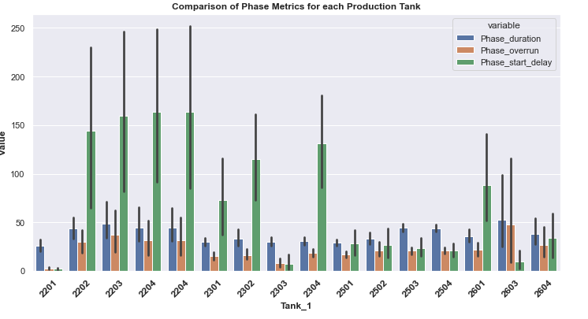

Figure Comparison of Phase Metrics for Production Tanks

#### Correlation Analysis

In exploring the interactions of production variables, a correlation heatmap (Table 6) was used. A strong positive correlation of 0.98 between 'phase overrun' and 'phase duration' indicates that when the phase duration increases, there is a corresponding increase in the phase overrun. Essentially, any delays seem to have a significant effect on extending production time. A correlation of 0.52 between batch quantity and flowrate highlights a moderate positive relationship. As batch quantity grows, the flowrate correspondingly rises, possibly reflecting the system's effort to manage larger batches by enhancing material or liquid flow. Importantly, the absence of other high intercorrelations eliminates concerns about multicollinearity, which can conceal the distinct impact of each variable in regression models. Such strong correlation between phase duration and phase overrun persisted across correlation charts for all production tank groups.

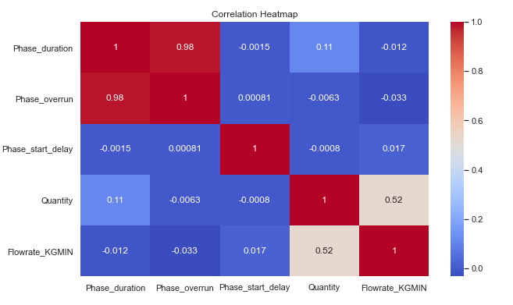

Table Correlation Table

In Fig 13, the scatterplot visually emphasizes the relationship between "phase overrun" and "phase duration". An upward trend suggests a positive correlation: as phase duration increases, so does phase overrun. The closely clustered data points indicate a strong linear relationship, emphasizing their predictability. This visualization, combined with the high correlation coefficient, not only offers insights into potential production inefficiencies but also reinforces the interaction between these critical variables. The actual representation provided by the scatterplot adds to the quantitative findings, allowing a comprehensive understanding of their influence on the production process. This relationship is seen for each production tank group data and the instruction steps examined.

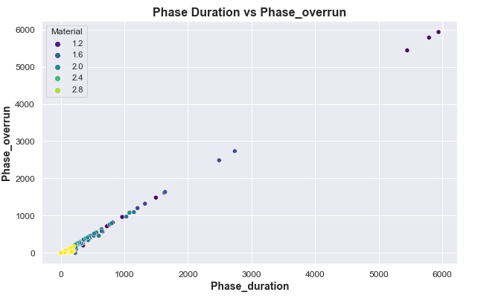

Figure Scatterplot of the Phase duration times vs Phase Overrun times

#### Handling Outliers

To determine the presence of outliers, boxplots were utilised. Figure 14 displays the distribution of data overall the production tanks available for the phase overrun variable. There is the presence of outliers for each tank, with points present outside the range. Under each investigation of the selected phases and production tanks, outliers were assessed and removed prior to machine modelling. Fig 15 – 18 shows the box-plots for each production tank group. For 26MT tanks chart, there is an obvious outlier in 26 MT 04 phase overrun results which could highlight a production process issue. The median line inside the boxes which represents the middle value of the data, seem to be towards the bottom of the box, indicating that the data might be positively skewed. This may be due to the presence of outliers, a few extremely high values which pull the mean in their direction.

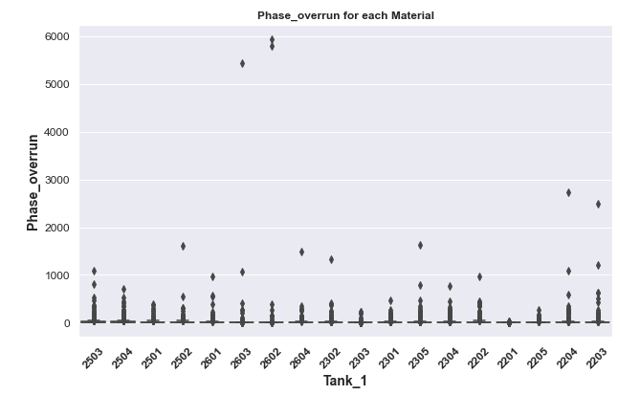

Figure Boxplot of the Distribution of Beverage data over All Production Tanks

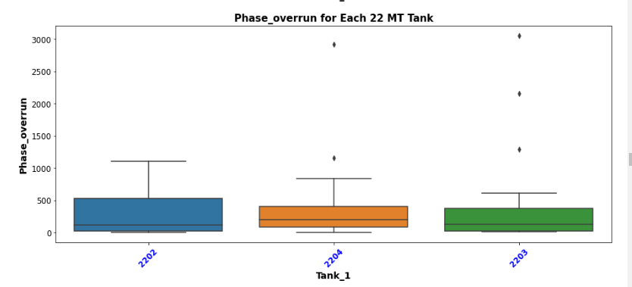

Figure Boxplot of Phase Overrun for each 22MT Tank.

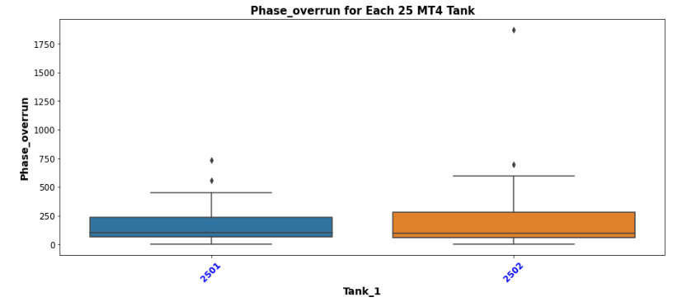

Figure Boxplot for Phase Overrun for each 25MT 4 tanks

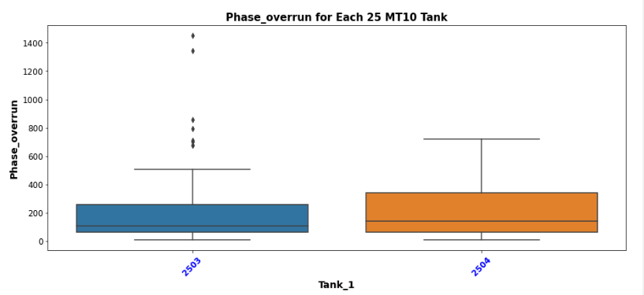

Figure Boxplot for Phase Overrun for each 25MT 10 Tanks.

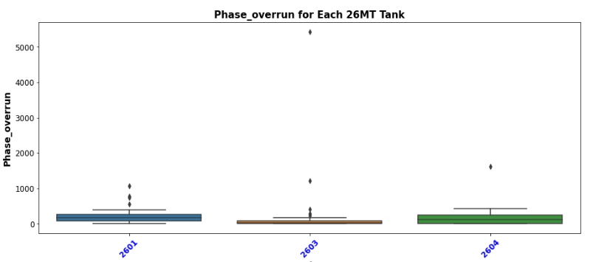

Figure Boxplot for Phase Overrun for each 26 MT Tank

#### Descriptive Statistics

|  |  |  |  |  |  |
| --- | --- | --- | --- | --- | --- |
| **All Production Tank Descriptive Statistics: Mean Values** | | | | | |
| **Tank** | **Batch Count** | **Capacity ( tonne)** | **Phase_overrun** | **Phase_duration** | **Phase_start_delay** |
| **22MT** | 73 | 20 | 371.7 | 595.0 | 2026.8 |
| **23MT** | 162 | 20 | 200.4 | 428.7 | 1603.3 |
| **25MT4** | 100 | 4 | 192.2 | 402.2 | 356.0 |
| **25MT10** | 74 | 10 | 123.1 | 301.7 | 455.6 |
| **26MT** | 74 | 1.8 | 216.8 | 591.0 | 299.1 |

Table Summary Descriptive Statistic: Mean Phase Overrun Values

Figure Mean Overrun Phase values per Production tank.

The descriptive analysis was completed for each of the production tanks and table 7 shows a summary comparison of the mean values for the 3 main metrics. The full descriptive statistics results are in appendix 8.4.

Figure 19 shows the mean overrun phase overrun values per production tank, its hows 22MT with the highest phase overrun value, even though it has the lowest batch production count.

While both 22MT and 23 MT tanks have the same capacity, 22MT tends to experience longer durations in both overrun and actual phase times compared to 23MT. Additionally, the startup phase delays for processes in 22MT are considerably longer. Given these insights, Tank 23MT appears to be more efficient in its operations than Tank 22MT.

25MT10 stands out for having the shortest phase overrun and duration, 26MT, despite its small size, has the longest phase duration but the shortest start delays. Tank 25MT4 offers a balance with moderate phase durations and delays given its capacity.

### Exploratory Data Analysis: Ingredient Addition Phases

Table 8 shows a list of common ingredients are used in the production of mucilage containing beverage batches. The ingredients and their quantities are important to the phase overrun times, any delay in their addition reflects in the phase duration times. The table below lists the main ingredient components in the batches in the dataset. The quantities are approximated average, they depend on the recipe for each of the batch produced. The main ingredients that have the most quantities are treated water which is delivered via the automated bulk delivery system, and the mucilage /gum ingredient. The dry ingredients are all added manually via bags through the manifold on the top of the tank. So, for the gum ingredient, this is very labour intensive. Not every batch has a colour ingredient addition, but for those that do, there is a significant quantity to be added.



Table List of Common Ingredients used in Mucilage containing Beverages.

The instruction Step that governs the addition of ingredient is called STEP1_CONS. Fig 19 shows the effect of this instruction step on the down times for the batches produced in the production tanks. 22MT04 tank has the highest downtime based on ingredient addition, whereas the rest of the tanks are all steady at the same level of downtime.

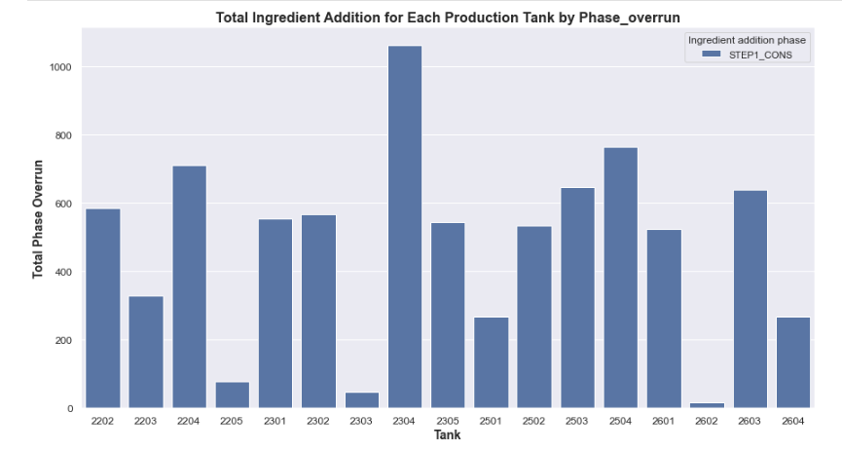

Figure Total Ingredient Addition for Each Production Tank by Phase Overrun

Fig 21 shows a breakdown of the effect of the addition of different type of ingredients in the production tanks. It highlights that the mucilage ingredients which are the gums has the highest rate of phase overrun, that is a significant downtime when using these ingredients. As per interview data, the production operative mention that Gum addition is a problem as its manual addition and that it takes time to mix. Overall, the production tanks the addition of gum ingredient shows the highest phase overrun times.

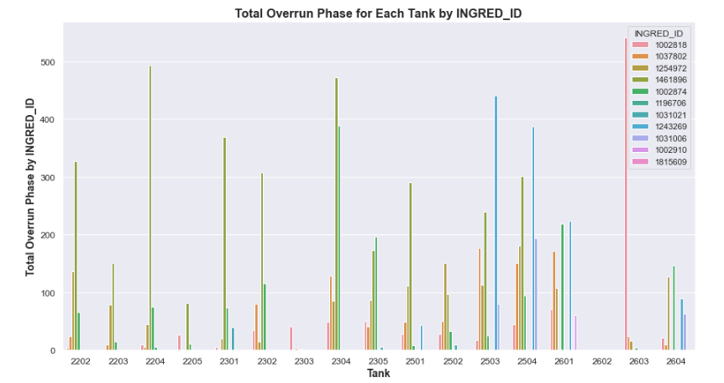

Figure Total Overrun Phase for each Production Tank by Ingredient

#### Ingredient Addition: GUM

Fig 22 shows the distribution of the gum ingredients across the production tanks. For tanks 22 MT and 23 MT beverage batches using gum material 1461896 had the highest phase overrun values. For tanks with the smallest capacity, the phase overrun times were less.

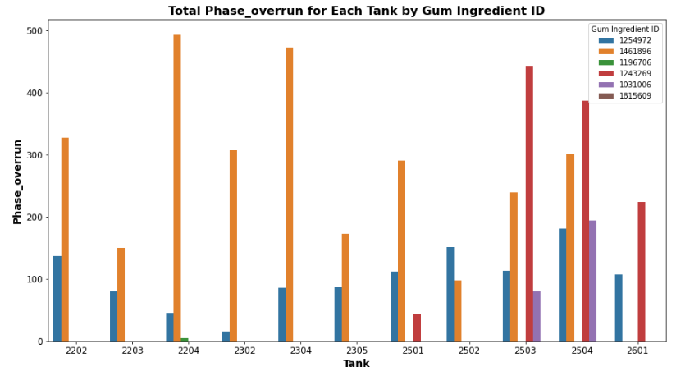

Figure Total Phase Overrun times for each Tank by Gum Ingredient ID

### Exploratory Data Analysis: Beverage Production Instruction Steps

In Appendix 8.5, the graph shows an overview of the down times per instruction step in the production process of a mucilage containing beverage overall production tanks. The following instructions steps have high overrun times., Table 9. Highlighted in red are the steps which are examined in this step. Where STEP1_CONS refers to the step where the ingredients are added. ENSURE GUM is MIXED IN step is a prompt to highlight the importance of the gum addition.

|  |  |
| --- | --- |
| **Instruction_Steps** | **Total Phase Overrun (mins)** |
| STEP1_CONS | 70024 |
| TAKE A SAMPLE AND SUBMIT FOR QA | 22259 |
| ENSURE GUM IS MIXED IN ? | 18055 |
| HP | 14109 |
| TAKE A SAMPLE AND SUBMIT FOR QA. | 13285 |
| PLEASE VERIFY BULK ADDITION | 9093 |
| STEP2_CONS-Deaeration | 9034 |
| WEIGHT_VALIDATION | 4508 |
| SAMPLE TO LAB. RESULTS OK? (NO TO HOMOGENISE) | 2832 |
| SAMPLE TO LAB.RESULTS OK?. (NO TO HOMOGENISE) | 648 |
| STEP3_CONS | 513 |
| GUM_PROMPT | 412 |
| PROCEED ONLY WHEN GUM IS DISSOLVED. | 349 |
| STEP4_CONS | 305 |
| SAMPLE TO LAB. RESULTS OK? | 114 |

Table List of the Top Instruction Steps with high Phase Overrun s

The instruction step associated with deaeration phase is called STEP2_CONS, this was confirmed by the primary interviews. It is not specifically mentioned in the instruction step column data in the dataset. It follows the agitation steps.

The Phase start delay, and phase overrun was examined, as the deaeration phase is affected by both.

The chart, fig 23 below shows how long it takes to start the deaeration phase after agitation, Tanks 22MT and 23 MT has the highest wait time before the deaeration phase starts, indicating that previous phases are overrunning, which are the ingredient addition.

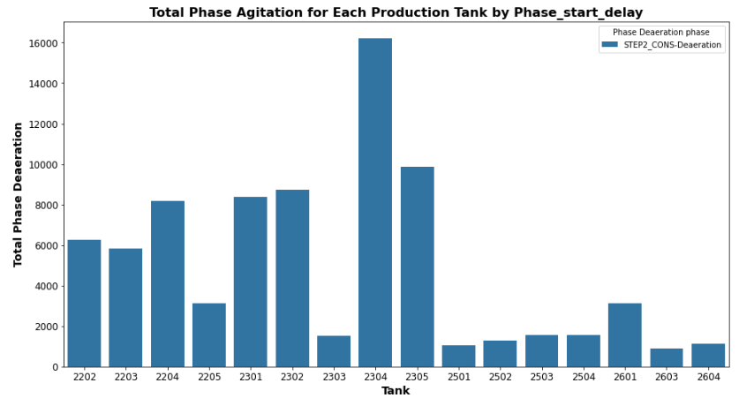

Figure Total Agitation Phase for each production tank by Phase Start Delay

Following on once the deaeration phase has started, fig 24 shows that for each production tank there is overrun time logged. It is especially high for 23 MT tanks.

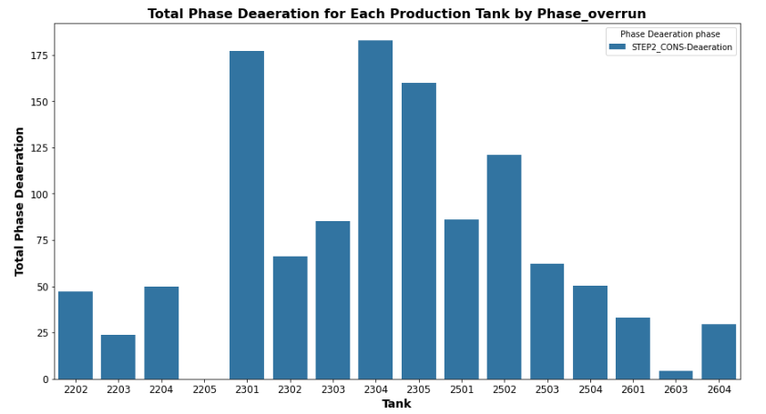

Figure Total Phase Deaeration for Each Production Tank by Phase overrun.

### Production Tanks group Results

The following sections looks at the results for each production tank group and the effect of the chosen instruction step phases. It will cover the exploratory data analysis first followed by the machine learning evaluation. Prior to the model evaluation, there will be a table outlining, the evaluation considerations for each tank, such as the no. of batch data reviewed before and after outlier detection. For details on the overall model evaluation results for each production tank, these are found in appendix 8.3.

### Production Tank – 22 MT 02 ,03, 04

#### Exploratory Data Analysis

#### Univariate Analysis

The comparison of Phase Metrics for each Material for the 22MT TanksThis histogram gives a performance overview of each of the 22MT tanks, looking at common materials that were produced. Each material produced in the 22MT tanks experienced phase start delay, phase overrun, and the production time was different between all tanks.

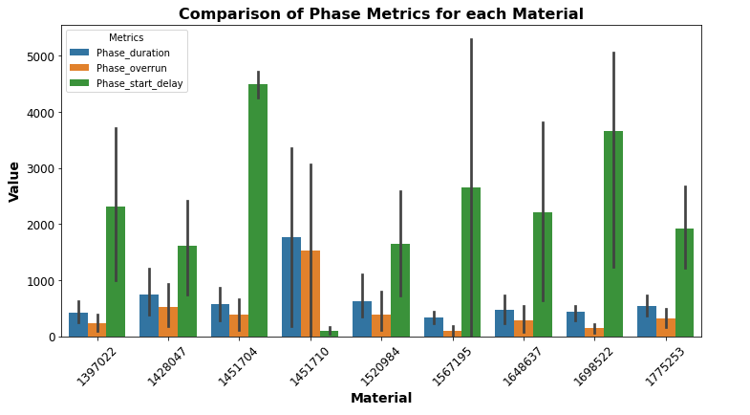

Figure Comparison of Phase Metrics for Each Material Produced in 22MT tanks.

The phase overrun for common materials in each 22 MT tanks are shown in fig. 25, its shows that there is difference in phase overrun times for materials between all 3 22 MT production tanks. For example, for material 1297022, the histogram shows that it would be better to produce in tank 2202 as the phase overrun time is lowest for this tank. Important to note, that for each of the materials produced there is a phase overrun and there was a delay in the start of the instruction steps.

In relation to the interview with participant no. 3 the production operative, he stated that one problematic material, reference no. 1428047. This material is produced in the 22 MT tanks with their 20-tonne capacity, from the graph, phase overrun times are high. When looking at the instruction steps for these materials, there is two high quantity additions of the mucilage material. requiring two agitation times, but the production tanks 22 MT show differences in the phase duration times for each tank with 2204 tank being the better tanks to use for fast production time and lower overrun times.

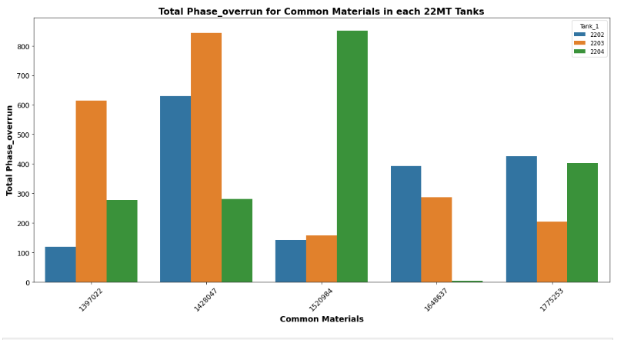

Figure Total Phase Overrun Time for Common Materials in each of the 22 MT Tanks

Fig 26 shows the total phase overrun time for the common materials produced in the 22MT tanks. For each material there was downtime in their production, however for each material, you can see which was the better tank to use for its production, e.g. material 1397022, tank 22 MT 02 had the lowest phase overrun time.

#### Model Evaluation for 22 MT. Tanks.

|  |  |
| --- | --- |
| **Evaluation Details** | |
| Instruction Step | All |
| Production Batches no. | 73 |
| Production Batches after Outlier removal no. | 59 |
| Target Variable (mins) | Phase Overrun |
| Instruction steps/Phases per batch | 27 |

Table 22MT Model Evaluation



Table Top Performing Machine Model for Tanks 22 MT

Random Forest Regressor achieves almost perfect scores on both the training and testing datasets before applying tuning or cross validation, table 11. This regressor model provides stability and is less likely to overfit. Another of its advantage is interpretability of feature importance, the graph below shows which feature phase duration as the driver of the predictions. The scatterplot and residual plot show good model performance, with no obvious outlier points.

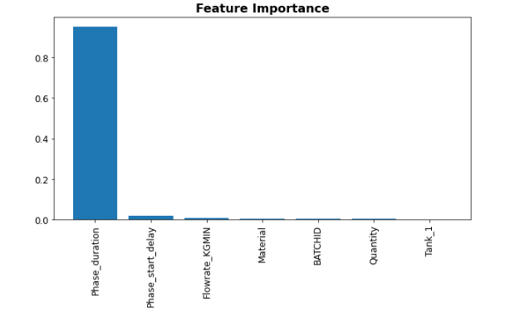

Figure Feature importance for the Random Forest Regressor Model

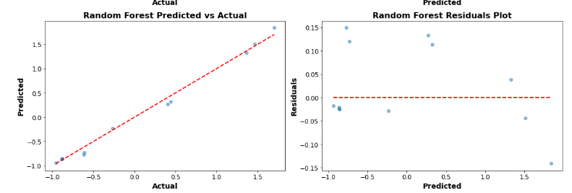

Figure Performance of the Random Forest Model for 22 MT Tanks



Table Poor Performing Machine Model for Tanks 22 MT

The poorest performing model was the LSTM Neural Network, table 12, with a poor accuracy score R2 of -0.14 for R^2. This is highly likely due to the target variable not been a time series or text format. LSTM require a lot of data for the training, and this could affect the hyperparameter choices as the top performing models are much simpler models, the complexity of using LSTM is redundant.

#### Model Evaluation for 22 MT. Tanks- Deaeration Instruction Step



Table 22MT Model Evaluation - Deaeration Phase

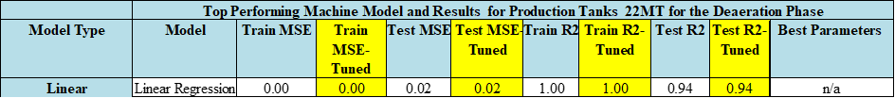

Table Top Performing Machine Model for Tanks 22 MT Deaeration Phase

Given the results, the linear regression model, a perfect accuracy score R2 of 1.00 on training data and a score of 0.94 on test data. This indicates that this model can explain 100% of the variance in the training dataset and 94% in the test dataset. This indicates that these models can explain 100% of the variance in the training dataset and 94% in the test dataset, reflecting an excellent fit. Furthermore, the Mean Squared Error (MSE) for these models is 0.00 for both training and test datasets, showcasing the model's precision in estimating phase overrun in production tanks. The consistent performance in both tuned and untuned metrics shows the strength of linear regression model in capturing the linear relationships in the given dataset for production tank group 22MT, making it a prime choice for predicting phase overrun for the deaeration production phase. The accuracy is shown in the following graphs, fig 29.

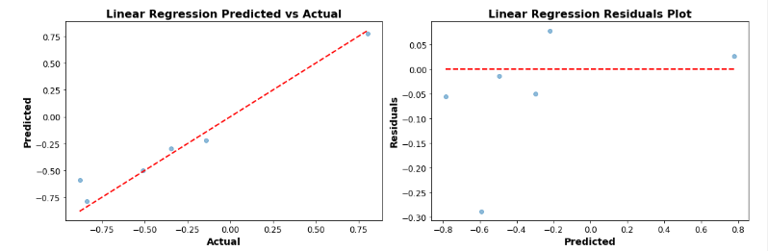

Figure Performance of the Linear Regression Model for 22 MT Tanks Deaeration Phase



Table Poor Performing Machine Model for Tanks 22 MT Deaeration Phase

The Long Short-Term Memory (LSTM) Neural Network, a type of Recurrent Neural Network (RNN), presented mixed results when predicting phase overrun in production tanks. The training values R2 were notably negative, standing at -0.91 and -0.79 for the untuned and tuned models respectively. This indicates that the LSTM model failed to capture the underlying patterns in the training data. On the test side, the values further declined to -1.24 and -1.10 for the untuned and tuned models, respectively, suggesting the model's predictions were worse than a basic horizontal line mean prediction. Additionally, the high Mean Squared Error (MSE) values, 1292.83 for training and 424.13 for testing in the untuned model, underscore its lack of precision. While tuning did bring about some improvements, they were marginal. In this context, the LSTM model appears unsuitable for the task, possibly due to its inherent complexity and tendency to model sequential or time-dependent data, which might not align with the nature of the provided dataset.

#### Model Evaluation for 22 MT. Tanks- Agitation Instruction Step

|  |  |
| --- | --- |
| **Evaluation Details** | |
| Instruction Step | Agitation phase |
| Production Batches no. | 47 |
| Production Batches after Outlier removal no. | 34 |
| Target Variable (mins) | Phase Overrun |

Table 22 MT Model Evaluation - Agitation Phase



Table Top Performing Machine Model for Tanks 22 MT Agitation Phase

The Decision Tree Regressor top performing model when assessing the Agitation Phases for Production Tanks 22MT, Table 17. Both the tuned and untuned models presented good results with a Train and Test score R2 of 1.00, indicating that the model perfectly explained the variance in the target variable. The Mean Squared Error (MSE) for both training and testing was impressively low at 0.00 and 0.01 respectively, highlighting the model's precision. These results suggest that the Decision Tree Regressor, without any need for parameter tuning, can capture the inherent patterns and relationships in the dataset with high accuracy.

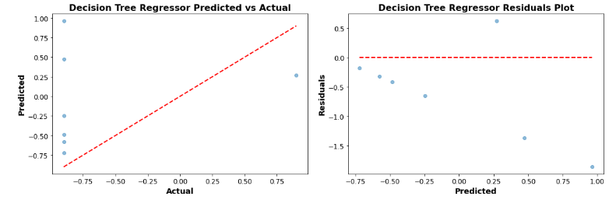

Figure Performance of the Linear Regression Model for 22 MT Tanks Deaeration Phase



Table Poor Performing Machine Model for Tanks 22 MT Agitation Phase

On the other hand, the Dense Neural Network (FCN) displayed the weakest performance among all with a R 2 -of0.72 which declined significantly for the test data, registering a poor R 2 of -2.14. Tuning the model parameters led to some improvements in the training. R 2, but not the test scores. The negative values, R 2, especially for the test data, point towards the model's inability to predict the phase overrun in Production Tanks 22MT reliably. Moreover, the high MSE values reinforce the model's lack of precision in its predictions. Despite the inherent capabilities of neural networks, in this context, the Dense Neural Network failed to generalize well to unseen data.

#### Model Evaluation for 22 MT. Tanks- Gum Addition Instruction Step

|  |  |
| --- | --- |
| **Evaluation Details** | |
| Instruction Step | Gum addition phase |
| Production Batches no. | 43 |
| Production Batches after Outlier removal no. | 29 |
| Target Variable (mins) | Phase Overrun |

Table 22 MT Model Evaluation: Gum Addition



Table Top Performing Machine Model for Tanks 22 MT Gum Addition Phase

For the Gum Addition process in Production Tanks 22 MT, the Linear Regression model demonstrated superior performance. Both the tuned and untuned variants exhibited excellent predictive capabilities, as evident from the Train and Test R 2 scores which consistently hovered around 0.98 and 0.99 respectively. These scores suggest that the model was able to explain almost 99% of the variance in the test data. The MSE values further bolster the model's credibility with figures as low as 0.02 for training and 0.01 for testing, indicating accurate predictions with minimal error. In this context, Linear Regression, without any need for parameter tuning, seems to adeptly capture the underlying relationships in the dataset, offering a reliable model for predicting outcomes in the Gum Addition process. This is visualised in the graphs below.

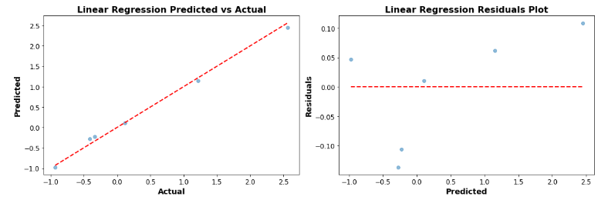

Figure Performance of the Linear Regression Model for 22 MT Tanks Gum Addition Phase



Table Poor Performing Machine Model for Tanks 22 MT Gum Addition

On the opposite end of the spectrum, the Simple Neural Network model proved to be the least efficient in predicting outcomes for the Gum Addition process. While the untuned model presented a discouraging Train R 2of -0.71, the situation worsened after tuning, dropping the score to -0.47. This negative indicates that the model's predictions are worse than simply predicting the mean of the target variable. The test data didn't fare much better with R 2scores of -1.10 and -0.82 for the untuned and tuned models respectively. Furthermore, the high MSE values, especially in the test data, emphasize the model's imprecision. Despite the inherent power of neural networks, in this specific scenario, the Simple Neural Network seems ill-equipped to generalize or make accurate predictions.

### Production Tank – 23 MT 02 ,03, 04

#### Exploratory Data Analysis

#### Univariate Analysis

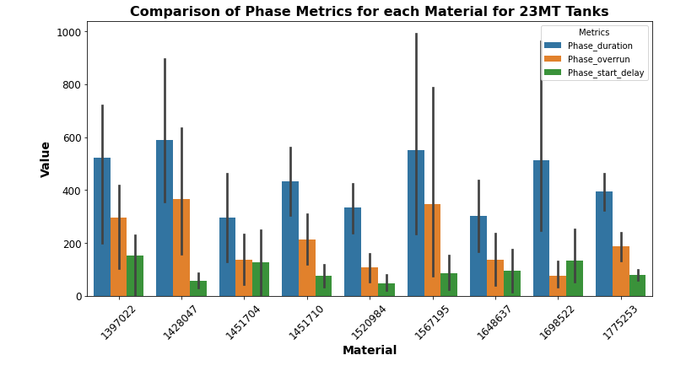

Figure Comparison of Phase Metrics for Each Material Produced in 23MT tanks.

For all the materials produced in the 23 MT production tanks, the bar chart, fig32,above shows that there was little delay in the starting of the production phases for all tanks, however again there was phase overrun downtimes noted

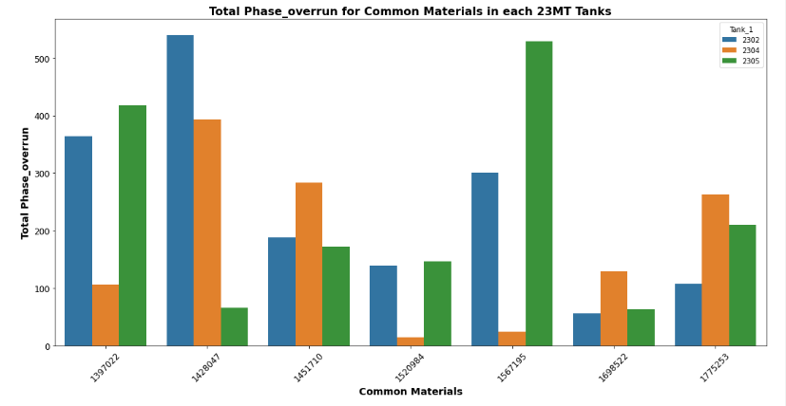

Figure Total Phase Overrun Time for Common Materials in each of the 23 MT Tanks

Fig 33 , Bar Chart gives visual representation of how phase duration and phase overrun varies for the common materials produced across the 23MT production tanks. Each bar represents a tank, and the height is the phase metric for that tank. There is a lot of variability, and each material would have to reviewed separately, but for material 1567195, it seems that tank 23MT 04 would be the better tank to use, as the phase overrun times were lower in this tank. In general, for tanks that have the same capacity and materials with the same quantity and ingredient addition, there is a lot of variation in the production time and the down time.

#### Model Evaluation for 23 MT. Tanks

|  |  |
| --- | --- |
| **Evaluation Details** | |
| Instruction Step | All phase |
| Production Batches no. | 162 |
| Production Batches after Outlier removal no. | 39155 |
| Target Variable (mins) | Phase Overrun |
| Instruction steps/Phases per batch | 27 |

Table 23MT Model Evaluation



Table Top Performing Machine Model for Tanks 23 MT

The Gradient Boosting Regressor is the star performer for the Production Tanks 23 MT dataset. Even without tuning, it exhibits a pristine R 2score of 1.00 on the training set, indicating a flawless fit. Upon tuning, this model maintains its high fidelity on the training data and demonstrates robust predictive power on the test set, achieving an R 2score of 0.95. The optimal parameters that accentuate its performance include a learning rate of 0.2, a max depth of 3, and 300 estimators. This model's ability to systematically build trees by adjusting to the errors of the previous ones gives it an edge in capturing intricate data patterns.

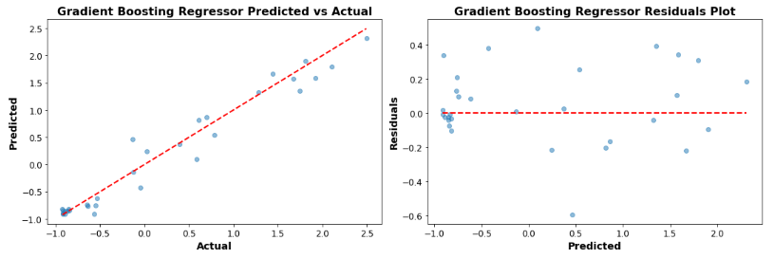

Figure Performance of the Gradient Boosting Regressor Model for 23 MT Tanks

The K-Nearest Neighbors (KNN) model is considered the poorest performer because, despite its perfect training score of 1.0 after tuning, it failed to replicate this high performance on the test data, only achieving a score of 0.70. This large discrepancy between the training and test scores indicates potential overfitting. Overfitting occurs when a model performs exceptionally well on the training data but poorly on new, unseen data. The model becomes too tailored to the specific details and noise of the training set, making it less generalizable to new data. In practical applications, a model's performance on test or unseen data is more crucial than on the training data, hence why the KNN's subpar test score positions it as a weak performer in this context.



Table Poor Performing Machine Model for Tanks 23 MT

#### Model Evaluation for 23 MT. Tanks – Deaeration Phase

|  |  |
| --- | --- |
| **Evaluation Details** | |
| Instruction Step | Deaeration phase |
| Production Batches no. | 83 |
| Production Batches after Outlier removal no. | 67 |
| Target Variable (mins) | Phase Overrun |

Table 23MT Model Evaluation - Deaeration Phase



Table Top Performing Machine Model for Tanks 23 MT Deaeration Phase

The Gradient Boosting Regressor stands out as the best performer. It demonstrates near-flawless results with a Train R 2 score of 1.00 and a Test R 2 score of 0.99. After tuning with a learning rate of 0.1, a maximum depth of 3, and 200 estimators, it consistently maintains its top-tier performance, showing its robustness and adaptability.

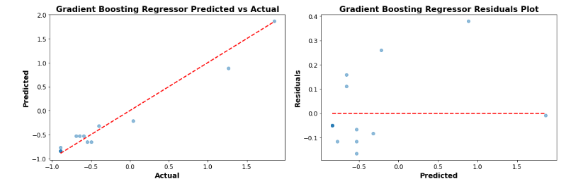

Figure Performance of the Gradient Booster Model for 23 MT Tanks Deaeration Phase

The K-Nearest Neighbors (KNN) model falls short in its test performance. While it achieves a perfect Train R 2 score of 1.00 after tuning, it plummets to a Test R 2score of just 0.4. This indicates that the model might be overfitting the training data. Despite an exhaustive tuning process involving 160 fits to pinpoint the best parameters, like using the 'auto' algorithm, selecting 3 neighbours, and distance-based weights, the model doesn't translate its training success to the test set. This stark difference emphasizes the importance of a model's ability to generalize beyond its training data.



Table Poor Performing Machine Model for Tanks 23 MT Deaeration Phase

The K-Nearest Neighbors (KNN) model falls short in its test performance. While it achieves a perfect Train R 2 score of 1.00 after tuning, it plummets to a Test R 2score of just 0.4. This indicates that the model might be overfitting the training data. Despite an exhaustive tuning process involving 160 fits to pinpoint the best parameters, like using the 'auto' algorithm, selecting 3 neighbours, and distance-based weights, the model doesn't translate its training success to the test set. This stark difference emphasizes the importance of a model's ability to generalize beyond its training data.

#### Model Evaluation for 23 MT. Tanks – Agitation phase

|  |  |
| --- | --- |
| **Evaluation Details** | |
| Instruction Step | Agitation phase |
| Production Batches no. | 82 |
| Production Batches after Outlier removal no. | 39 |
| Target Variable (mins) | Phase Overrun |

Table 23MT Model Evaluation - Agitation Phase



Table Top Performing Machine Model for Tanks 23 MT Agitation Phase

The **Linear Regression model** stands out with perfect results. It achieves a Train R 2score and a Test R 2score both of 1.00, indicating that it can explain 100% of the variance in the target variable for both training and test datasets. This is mirrored in the extremely low Mean Squared Error (MSE) values, which approach zero. No tuning was necessary for this model, suggesting that a simple linear relationship was likely sufficient to capture the patterns in the data.

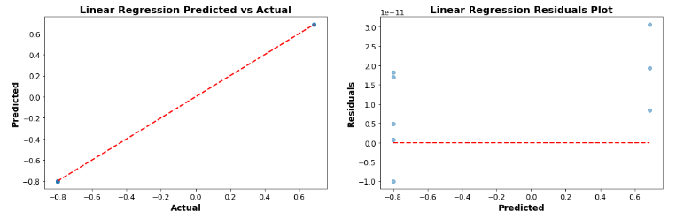

Figure Performance of the Lass Regression Model for 23 MT Tanks Agitation Phase

The **Lasso Regression** model has shown the least promising performance before tuning. Its Train R 2 score of 0.17 and Test R 2score of 0.02 suggests that it struggled to capture the variance in the target variable initially. However, after tuning with an alpha value of 0.01, the performance improved drastically to an R 2score of 1.00 for both training and test sets. This indicates a significant improvement, but the stark difference in performance before and after tuning might raise concerns about the model's robustness and its ability to generalize across different datasets.



Table Poor Performing Machine Model for Tanks 23 MT Agitation Phase

The **Lasso Regression** model has shown the least promising performance before tuning. Its Train R 2 score of 0.17 and Test R 2score of 0.02 suggests that it struggled to capture the variance in the target variable initially. However, after tuning with an alpha value of 0.01, the performance improved drastically to an R 2score of 1.00 for both training and test sets. This indicates a significant improvement, but the stark difference in performance before and after tuning might raise concerns about the model's robustness and its ability to generalize across different datasets.

#### Model Evaluation for 23 MT. Tanks – Gum Addition Phase

|  |  |
| --- | --- |
| **Evaluation Details** | |
| Instruction Step | Gum Addition phase |
| Production Batches no. | 82 |
| Production Batches after Outlier removal no. | 73 |
| Target Variable (mins) | Phase Overrun |

Table 23 MT Model Evaluation: Gum Addition



Table Top Performing Machine Model for Tanks 23 MT Gum Addition Phase

The **Random Forest Regressor** stand out with perfect results. They achieve a Train R2 score and a Test R2 score both of 1.00, which suggests that these models can capture almost all the variance in the target variable for both training and test datasets. The very low MSE values, approaching zero, further confirm this excellence in prediction. The best parameters indicate that for the Random Forest, the optimal number of trees (estimators) is 200 and there's no restriction on depth. These models seem well-suited for predicting phase overrun during the GUM addition phase.

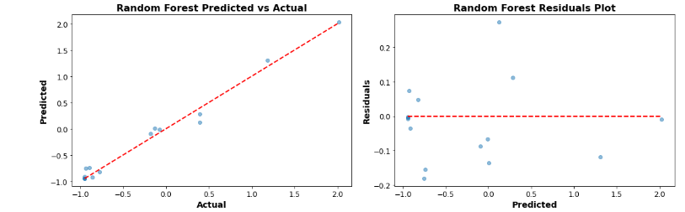

Figure Performance of the Random Forest Model for 23 MT Tanks Gum Addition Phase



Table Poor Performing Machine Model for Tanks 23 MT Gum Addition

The **Lasso Regression** model initially performed poorly with a Train R2 score of 0.10 and a negative Test R2 score of -0.13, indicating that the model was worse than a horizontal line. However, after tuning with an alpha value of 0.01, the performance dramatically improved to an R2 score of 0.99 for training and 0.97 for testing. Despite this improvement, the initial poor performance might cause concerns about the reliability and robustness of this model for this specific dataset.

### Production Tank – 25 MT 01 ,02

#### Exploratory Data Analysis

#### Univariate Analysis

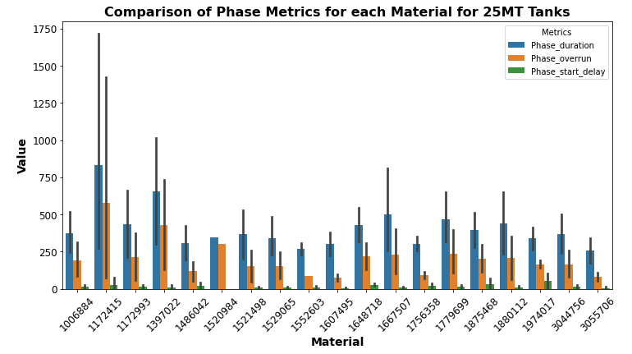

Figure Comparison of Phase Metrics for Each Material Produced in 25MT 4 tanks.

The comparison of Phase Metrics for each Material for the 25MT 4 tanks is given in fig 39 This histogram gives a performance overview of each of the 25MT 4 tanks, looking at common materials that were produced. Each material produced in the 25MT4 tanks experienced phase start delay, phase overrun, and the production time was different between all tanks.

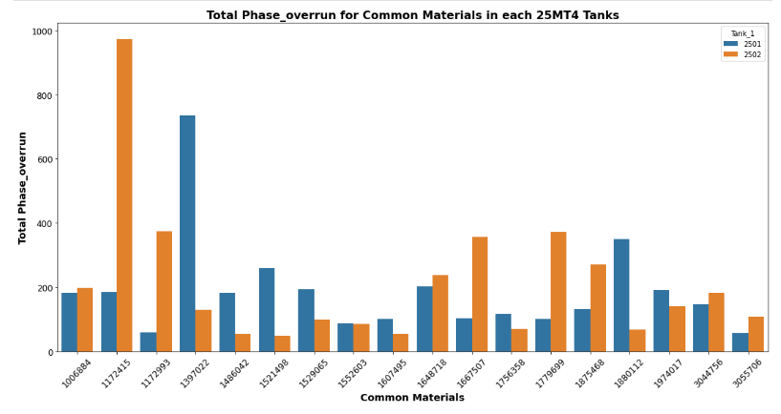

Figure Total Phase Overrun Time for Common Materials in each of the 25 MT 4 Tanks

Fig 40, Bar Chart gives visual representation of how phase duration and phase overrun varies for the common materials produced across the 25MT 4 production tanks. Each bar represents a tank, and the height is the phase metric for that tank. There is a lot of variability, and each material would have to reviewed separately, but for material 1172415, it seems that tank 25MT4 01 would be the better tank to use, as the phase overrun times were lower in this tank. In general, for tanks that have the same capacity and materials with the same quantity and ingredient addition, there is a lot of variation in the production time and the down time.

#### Model Evaluation for 25 MT 4 Tanks

|  |  |
| --- | --- |
| **Evaluation Details** | |
| Instruction Step | All phases |
| Production Batches no. | 98 |
| Production Batches after Outlier removal no. | 81 |
| Target Variable (mins) | Phase Overrun |
| Instruction steps/Phases per batch | 27 |

Table 25 MT4 Model Evaluation



Table Top Performing Machine Model for Tanks 25 MT4

The Random Forest Regressor stood out as the star performer for predicting phase overrun across all production phases in Production Tanks 25MT. It showcased superior accuracy with an R2score of 1.00 on the training data and an impressive 0.98 on the test data. These metrics reflect the model's excellent capacity to capture the underlying patterns in the data, positioning it as an ideal choice for predicting phase overruns in this context.

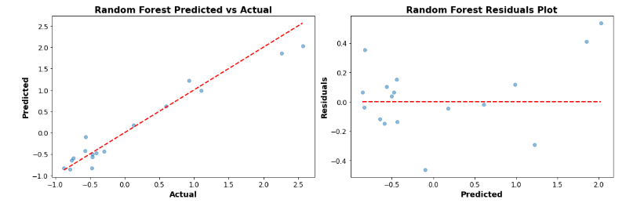

Figure Performance of the Random Forest Model for 25 MT4 Tanks



Table Poor Performing Machine Model for Tanks 25MT4.

Conversely, the LSTM Neural Network struggled significantly in this predictive task. With an R2score of -0.57 on the training set and an even more concerning -1.26 on the test set, the model displayed a conspicuous inability to make accurate predictions for the given data. This underwhelming performance suggests that the LSTM, in its current configuration, might not be suitable for predicting phase overruns for Production Tanks 25MT.

#### Model Evaluation for 25 MT 4 Tanks – Deaeration Phase

|  |  |
| --- | --- |
| **Evaluation Details** | |
| Instruction Step | All phases |
| Production Batches no. | 98 |
| Production Batches after Outlier removal no. | 81 |
| Target Variable (mins) | Phase Overrun |

Table 25MT4 Model Evaluation



Table Top Performing Machine Model for Tanks 25 MT 4

The Random Forest Regressor stood out as the star performer for predicting phase overrun across all production phases in Production Tanks 25MT. It showcased superior accuracy with an R2score of 1.00 on the training data and an impressive 0.98 on the test data. These metrics reflect the model's excellent capacity to capture the underlying patterns in the data, positioning it as an ideal choice for predicting phase overruns in this context.



Figure Performance of the Random Forest Model for 25 MT4 Tanks Deaeration Phase



Table Poor Performing Machine Model for Tanks 25 MT4 Deaeration Phase

Conversely, the LSTM Neural Network struggled significantly in this predictive task. With an R2score of -0.57 on the training set and an even more concerning -1.26 on the test set, the model displayed a conspicuous inability to make accurate predictions for the given data. This underwhelming performance suggests that the LSTM, in its current configuration, might not be suitable for predicting phase overruns for Production Tanks 25MT.

#### Model Evaluation for 25 MT4. Tanks – Agitation phase

|  |  |
| --- | --- |
| **Evaluation Details** | |
| Instruction Step | Agitation Phases |
| Production Batches no. | 51 |
| Production Batches after Outlier removal no. | 50 |
| Target Variable (mins) | Phase Overrun |

Table 25 MT4 Model Evaluation



Table Top Performing Machine Model for Tanks 25 MT 4- Agitation Phase

In the Agitation Phase for Production Tanks 25MT 4, the Linear Regression model demonstrated top performance. Both its Train and Test Mean Squared Error (MSE) are practically at zero, showcasing the model's excellent capability in fitting the training data and generalizing to unseen data. A perfect R2score of 1.00 for both training and test sets, even after tuning, highlighting its predictive power.

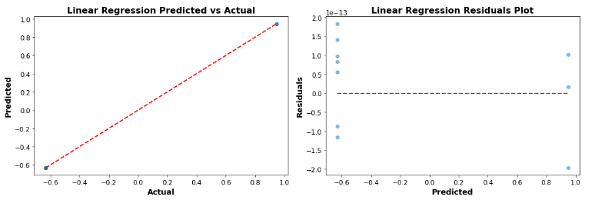

Figure Performance of the Linear Regression Model for 25 MT4 Tanks Agitation Phase



Table Poor Performing Machine Model for Tanks 25 MT4 Agitation Phase

Conversely, the Instance-based K-Nearest Neighbors model underwhelmed in its performance for the Agitation phase. Its Train MSE was 0.43, and it only achieved a low R2score of 0.04 for training and an even more diminished 0.07 for testing. Tuning only marginally improved its R2score, reaching 0.13 for training and remaining at 0.04 for testing. The model's performance suggests that it struggled to find relevant patterns in the dataset for this phase, even after considering 9 neighbours and opting for uniform weight.

#### Model Evaluation for 25 MT4. Tanks – Gum Addition Phase

|  |  |
| --- | --- |
| **Evaluation Details** | |
| Instruction Step | Gum Addition |
| Production Batches no. | 50 |
| Production Batches after Outlier removal no. | 35 |
| Target Variable (mins) | Phase Overrun |

Table 25 MT4 Model Evaluation



Table Top Performing Machine Model for Tanks 25 MT4 Gum Addition Phase

In the Gum Addition Phase for Production Tanks 25MT 4, the Linear Regression model emerged as the top performer. The model demonstrated almost perfect fitting with a Train Mean Squared Error (MSE) of 0.00, which held consistently even after tuning. Its testing performance was equally outstanding, with a Test MSE of 0.00 both pre- and post-tuning. The R2score, a measure of the model's predictive power, achieved a flawless 1.00 for both training and testing datasets, highlighting its exceptional efficacy in this phase.

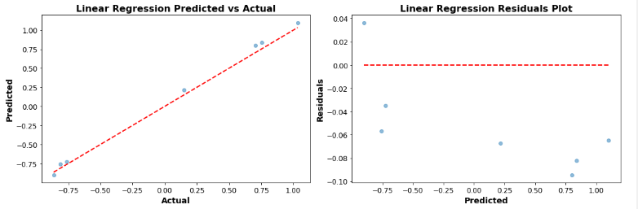

Figure Performance of the Linear Regression Model for 25 MT4 Tanks Agitation Phase



Table Poor Performing Machine Model for Tanks 25 MT4 Gum Addition Phase

Neural Network (RNN) model using LSTM displayed poor performance. Before tuning, the Train MSE soared to an alarming 3116.96, and the Test MSE reached 2442.13. The R2score, registering at -0.81 for training and an even lower -1.64 for testing, indicated that the model's predictions were substantially worse than simplistic, mean-based predictions. Even after tuning, while there was a marginal improvement in the scores, the results remained unsatisfactory with the Test R2 still lingering at -1.19, underscoring the model's struggle to capture the inherent patterns of the Gum Addition Phase effectively.

### Production Tank – 25 MT 10 -03 ,04

#### Exploratory Data Analysis

#### Univariate Analysis

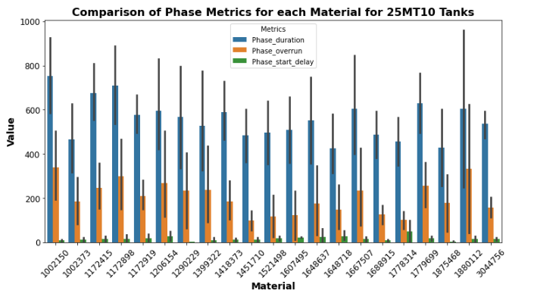

Figure Comparison of Phase Metrics for Each Material Produced in 25MT 10 tanks.

The comparison of Phase Metrics for each Material for the 25MT 10 tanks is given in fig 45 This histogram gives a performance overview of each of the 25MT 10 tanks, looking at common materials that were produced. Each material produced in the 25MT 10 tanks experienced phase start delay, phase overrun, and the production time was different between all tanks.

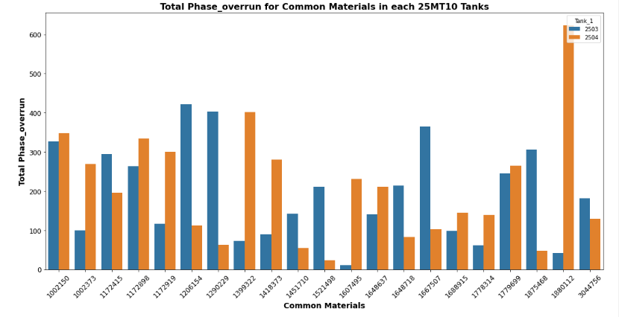

Figure Comparison of Phase Metrics for Each Material Produced in 25MT 10 tanks.

Fig 46, Bar Chart gives visual representation of how phase duration and phase overrun varies for the common materials produced across the 25MT 10 production tanks. Each bar represents a tank, and the height is the phase metric for that tank. There is a lot of variability, and each material would have to reviewed separately, but for material 1880112, it seems that tank 25MT10 03 would be the better tank to use, as the phase overrun times were lower in this tank. In general, for tanks that have the same capacity and materials with the same quantity and ingredient addition, there is a lot of variation in the production time and the down time.

#### Model Evaluation for 25MT 10

|  |  |
| --- | --- |
| **Evaluation Details** | |
|  |  |
| Instruction Step | All Phases |
| Production Batches no. | 194 |
| Production Batches after Outlier removal no. | 150 |
| Target Variable (mins) | Phase Overrun |
| Instruction steps/Phases per batch | 27 |

Figure 25 MT10 Model Evaluation



Figure Top Performing Machine Model for Tanks 25 MT10

The Gradient Boosting Regressor showcased best performance in the modelling for All Phases for Production Tanks 25MT 10. Before tuning, it had a negligible Train Mean Squared Error (MSE) of 0.001 and a Test MSE of 0.088. The model's ability to explain the variance in the data was almost flawless with a training R2score of 0.999 and a testing R2score of 0.905. After tuning, the model managed to achieve a perfect training R2score of 1.000, although with a slight drop in the test R2to 0.887. This was accomplished using a learning rate of 0.2, a maximum depth of 4, and 300 estimators.

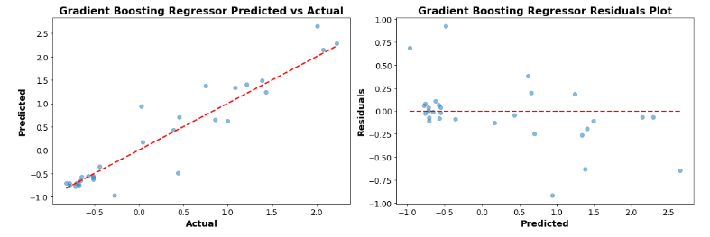

Figure Performance of the Gradient Boosting Regressor Model for 25 MT10 Tanks

Table 45 Poor Performing Machine Model for Tanks 26MT

In stark contrast, the Neural Network (RNN) model using LSTM Neural Network displayed significant underperformance. Prior to tuning, it registered a massive Train MSE of 51437.30 and an even larger Test MSE of 63756.90. The R2scores were notably poor, with -0.98 for training data, indicating that the model's predictions were drastically worse than basic mean predictions. The test R2score was at a dismal -1.69. Despite tuning efforts, the results remained subpar with the Test R2improving only slightly to 0.19. The best parameters for the tuned model included 30 neurons for LSTM, 100 epochs, and a batch size of 64.

#### Model Evaluation for 25 MT10 – Deaeration Phase

|  |  |
| --- | --- |
| **Evaluation Details** | |
| Instruction Step | Deaeration |
| Production Batches no. | 92 |
| Production Batches after Outlier removal no. | 58 |
| Target Variable (mins) | Phase Overrun |

Table 25 MT10 Model Evaluation- Deaeration Phase



Table Top Performing Machine Model for Tanks 25 MT10 – Deaeration Phase

The Gradient Boosting Regressor demonstrates good performance for the deaeration results of the Production Tanks 25MT10. The model, before tuning, delivered a Train MSE of 0.01 and a Test MSE of 0.04. The R2 scores were highly commendable with a score of 0.99 for training data, indicating the model's proficient ability to explain 99% of the variance. Its testing R2 score stood at 0.88. Remarkably, after tuning, the training R2 reached a perfect score of 1.00. The model achieved this exceptional performance with a learning rate of 0.01, a max depth of 4, and 300 estimators. This is also seen in the plots below with a good predictions and residuals.

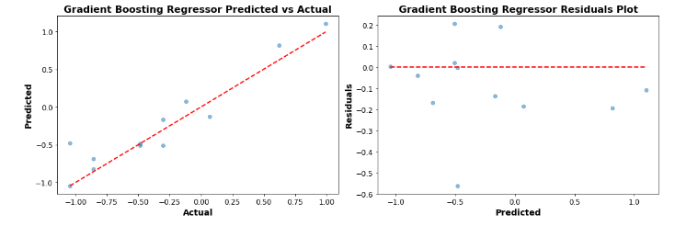

Figure Performance of the Gradient Boosting Regressor Model for 25 MT10 Tanks



Table Poor Performing Machine Model for Tanks 26MT

The LSTM Neural Network, a form of RNN, notably struggled in modelling the deaeration results. Pre-tuning, it registered a Train MSE of 54.79 and a much worse Test MSE of 19.09. The R2 values were concerning: -0.67 for training and -0.75 for testing, indicating the model's predictions were significantly worse than a naive mean-based approach. Fortunately, tuning improved the model to some extent, bringing the training R2up to 0.85 and the testing R2to 0.77. This improvement was accomplished with 50 LSTM neurons, 100 epochs, and a batch size of 16.

#### Model Evaluation for 25 MT10 – Agitation Phase

|  |  |
| --- | --- |
| **Evaluation Details** | |
| Instruction Step | Agitation |
| Production Batches no. | 97 |
| Production Batches after Outlier removal no. | 90 |
| Target Variable (mins) | Phase Overrun |

Table 25 MT10 Model Evaluation- Agitation Phase



Table Top Performing Machine Model for Tanks 25 MT10 – Agitation Phase

The Gradient Boosting Regressor stands out as the top-performing model for the agitation phases of the Production Tanks 25MT10. Prior to tuning, it exhibited a Train MSE of 0.01 and a Test MSE of 0.09. Its R2scores are strikingly good, with a score of 0.99 for the training data, which indicates the model's superior capability to account for 99% of the variance. For testing data, it scored 0.90. After optimization, both the training and testing R2scores reached a perfect 1.00. The model achieved this stellar performance using a learning rate of 0.01, a max depth of 4, and 300 estimators.

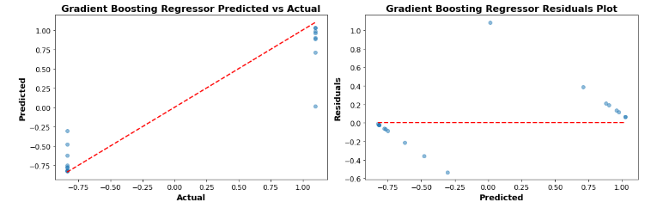

Figure Performance of the Gradient Boosting Regressor Model for 25 MT10 Tanks – Agitation phase



Table Poor Performing Machine Model for Tanks 26MT

The Lasso Regression model, before tuning, struggled in this task. It reported a Train MSE of 0.90 and an even worse Test MSE of 1.10. The R2scores were not promising: 0.11 for the training set and -0.19 for the testing set. Negative R2 values, especially for the test set, suggest the model's predictions were considerably worse than a simplistic mean-based strategy. While tuning did improve the performance slightly, raising the training R2to 0.32 and the testing R2 to just -0.01, the results were still far from satisfactory. This improvement was possible due to an alpha value of 0.01.

#### Model Evaluation for 25 MT10 – Gum Addition Phase

|  |  |
| --- | --- |
| **Evaluation Details** | |
| Instruction Step | Gum Addition |
| Production Batches no. | 96 |
| Production Batches after Outlier removal no. | 81 |
| Target Variable (mins) | Phase Overrun |

Table 25 MT10 Model Evaluation- Gum Addition Phase



Table Top Performing Machine Model for Tanks 25 MT10 – Gum Addition Phase

The top-performing model appears to be the **Linear Regression** under the "Linear" model type. This model exhibits a perfect Train and Test performance with both MSE (Mean Squared Error) and R2 (R-squared or Coefficient of Determination) values. Specifically, it has an MSE of 0.00 for both training and testing phases, and its R2 score stands at 1.00, indicating that the model perfectly predicts the outcomes. Even after tuning, the model retains its superior performance, demonstrating its robustness.

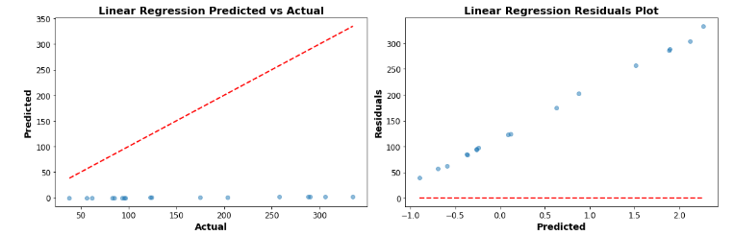

Figure Performance of the Linear Regression Model for 25 MT10 Tanks – Gum Addition Phase



Table Poor Performing Machine Model for Tanks 26MT – Gum Addition Phase

**LSTM Neural Network** under the "Neural Network (RNN)" category showed the poorest performance. Before tuning, it had a Train MSE of 18366.10 and a Test MSE of 34292.40. The R2 values for training and testing were -1.45 and -2.66 respectively. Even after tuning, though there was a reduction in the MSE values (Train MSE tuned to 11195.51 and Test MSE tuned to 20525.29), the R2 scores did not show significant improvement, with -0.50 for training and -1.19 for testing. The negative R2 values indicate that the model is performing worse than a simple horizontal line (mean-based model), signalling that the model might not be the right choice for this dataset or task.

### Production Tank – 26 MT -01,03 ,04

#### Exploratory Data Analysis

#### Univariate Analysis

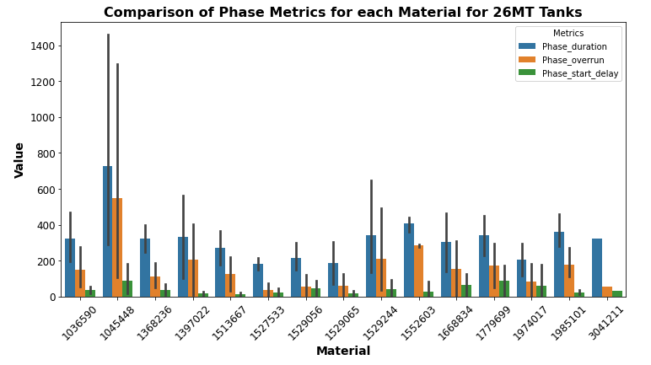

Figure Comparison of Phase Metrics for Each Material Produced in 26MT tanks.

Fig 53 shows a comparison of the phase metrics for each material produced in 26MT tanks. A noticeably trend is that the Phase start delay time is low showing that there was small delay in the start of the production instruction steps for each material. There was a phase overrun in each of the materials. There is one material 1045448, that shows a higher phase duration time and a phase overrun time whereas the rest of the materials show similar phase overrun values.

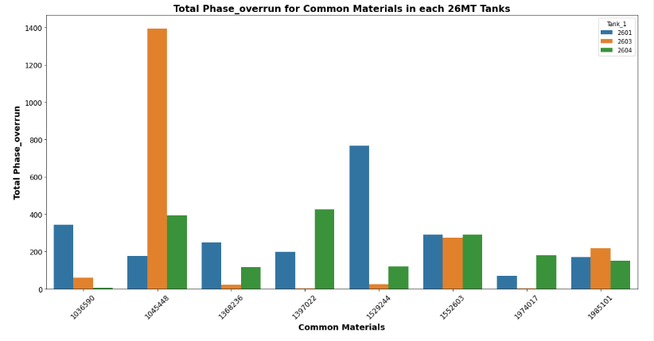

Figure Comparison of Phase Metrics for Each Material Produced in 26MT tanks.

Fig 54 shows the phase overrun values of each of the 26MT tanks versus their common materials. Theres a lot of variability between the 26MT tanks. Overall, 26 MT 04 shows the lowest phase overrun times for the materials compared to the other 2 tanks. For material 1045448, there is high overrun time, indicating that there is a possible issue when using this tank for producing this material.

#### Model Evaluation for 26 MT Tanks

|  |  |
| --- | --- |
| **Evaluation Details** | |
| Instruction Step | All Phases |
| Production Batches no. | 46 |
| Production Batches after Outlier removal no. | 27 |
| Target Variable (mins) | Phase Overrun |
| Instruction steps/Phases per batch | 27 |

Table 26 MT Model Evaluation



Table Top Performing Machine Model for Tanks 26 MT –

Table 53 shows for the Production Tanks 26MT across all phases, a Linear Regression model exhibited stellar performance with an impressive R2 of 0.97 on test data, which improved to 0.99 after tuning. The model's MSE on test data notably improved from 0.04 to 0.02 post-tuning. This model not only boasts high accuracy but also benefits from the inherent interpretability of linear regression, showcasing a direct relationship between predictors and response. Its consistent performance on both training and test datasets signifies its robustness and aptitude in generalizing well to unseen data.

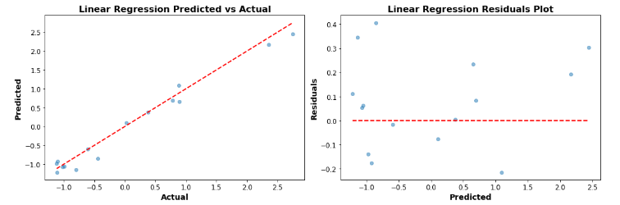

Figure Performance of the Linear Regression Model for 26 MT Tanks

The performance plots, Fig 55, depict visually a close alignment between predicted and actual values, with minimal deviation, showcasing the model's accuracy and efficiency.



Table Poor Performing Machine Model for Tanks 26MT.

Table 56 shows for 26MT Production Tanks, the LSTM Neural Network under the Neural Network (RNN) model type exhibited poor performance. The high mean squared error (MSE) values indicate significant discrepancies between the model's predictions and the actual observed values. Moreover, negative R2 values highlight that this model doesn't capture the variance in the data well and could even be less accurate than a basic model that predicts the mean value for all observations.

#### Model Evaluation for 26 MT – Deaeration Phase

|  |  |
| --- | --- |
| **Evaluation Details** | |
| Instruction Step | Deaeration |
| Production Batches no. | 46 |
| Production Batches after Outlier removal no. | 27 |
| Target Variable (mins) | Phase Overrun |

Table 26 MT Model Evaluation



Table Top Performing Machine Model for Tanks 26 MT – Deaeration Phase

Table 58 shows that Linear Regression exhibits good accuracy for this dataset. It achieved a perfect *R*2value of 1 for both the training and test datasets. Additionally, the Mean Squared Error (MSE) for this model is extremely low, nearly zero for both the training and test sets.

The Linear Regression model's performance great for this dataset. To achieve a perfect *R*2, may indicate a potential for overfitting. Overfitting means the model may not generalize well to unseen data. This perfect score also raises concerns about possible data leakage, where the model might have unintentionally accessed the target variable during training. Other regression methods were looked at, that have regularizations such as lasso and ridge, they also showed good accuracy and precision.

The performance plots, fig 56, below also highlight how good the predictions made by the linear model area and also low variances in the residuals.

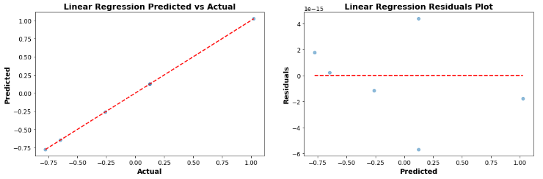

Figure Performance of the Linear Regression Model for 26 MT Tanks- Deaeration Phase



Table Poor Performing Machine Model for Tanks 26MT – Deaeration Phase

Table 59 shows the LSTM Neural Network, when applied to predict phase overrun times in the 26MT tank for the deaeration instruction step, demonstrated poor performance. Before and after tuning, the model consistently exhibited negative R2 values for both the training and test datasets, indicating that it fits the data worse than a horizontal line would. Specifically, the Train R2 and Test R2 were as low as -0.82 and -2.38, respectively. Furthermore, the Mean Squared Error (MSE) values were relatively high, suggesting significant discrepancies between the model's predictions and actual phase overrun times. Even after parameter tuning, which was done over 15 fits, the model's performance remained suboptimal. This suggests that the LSTM Neural Network may not be suitable for accurately predicting phase overrun times for the deaeration step in the 26MT tank.

#### Model Evaluation for 26 MT– Agitation Phase

|  |  |
| --- | --- |
| **Evaluation Details** | |
| Instruction Step | Agitation |
| Production Batches | 46 |
| Production Batches after Outlier removal | 40 |
| Target Variable | Phase Overrun |

Table 26 MT Model Evaluation



Table Top Performing Machine Model for Tanks 26 MT – Agitation Phase

Table 61 shows the Gradient Boosting Regressor top performing in terms of model accuracy. With a R2 value of 0.97 for the training set, it indicates that the model captures 97% of the variance in the target variable. The test R2 is lower at 0.28, it's still the highest positive test R2 value among all the models. Its Mean Squared Error (MSE) for both the training and test datasets is low, further indicating its high predictive capability. It provides a good balance between fitting the training data and generalizing to the test data. There is potential for overfitting as there is a difference between the training and test R2 values. Further improvements with hyperparameter tuning, more batch data, or regularization techniques could help this.

In fig 57 below shows that predictions using this model gives errors and the residuals plot shows that there is none linearities in the data

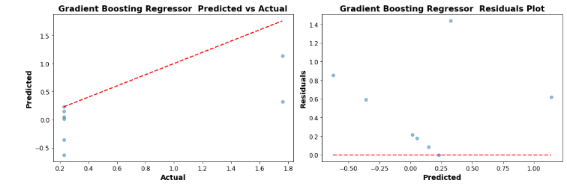

Figure Performance of the Gradient Boosting Regressor Model for 26 MT Tanks- Agitation Phase



Table Poor Performing Machine Model for Tanks 26MT – Agitation Phase

The LSTM Neural Network has a training R2 of -0.42 and a much worse test R2 of -5.51. The negative R2 values, especially one as low as -5.51, imply that the model is doing an exceptionally poor job at predicting the target variable. The high MSE values, 0.62 for the training dataset and 1.22 for the test dataset, further affirm the model's inadequacy.

The LSTM model's poor performance suggests it's not the right choice for this dataset. LSTMs, as a subtype of recurrent neural networks, are primarily designed for sequence prediction problems. The LSTM model might need significant architecture and hyperparameter adjustments.

#### Model Evaluation for 26 MT– Gum Addition Phase

|  |  |
| --- | --- |
| **Evaluation Details** | |
| Instruction Step | Gum Addition |
| Production Batches | 44 |
| Production Batches after Outlier removal | 43 |
| Target Variable | Phase Overrun |

Table 26 MT Model Evaluation



Table Top Performing Machine Model for Tanks 26 MT – Gum Addition Phase

In Table 64, the Gradient Boosting Regressor, after tuning, displayed good performance. The Train MSE of 1.07513 *E*−13 - 1.07513*E*−13, it essentially got close to a perfect fit for the training data. Moreover, the R2 value of 1.00 for both training and 0.98 for the test dataset indicates a good fit of the model to the data. The test MSE is also considerably low at 0.011. The hyperparameters provided, including a learning rate of 0.2, max depth of 3, and 300 estimators, seem to be optimally tuned for the dataset.

This can be also enhanced by the results from the plots below, fig 58, where there is good alignment of points along the line for the predicted vs actual and good distribution of points around the line in the residual plot.

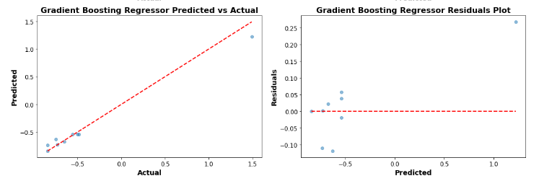

Figure Performance of the Gradient Boosting Regressor Model for 26 MT Tanks- Gum Addition Phase



Table Poor Performing Machine Model for Tanks 26MT – Gum Addition Phase

The LSTM Neural Network is ill-suited for this dataset. The high Train MSE of 5461.17 (even after tuning) and the Test MSE of 1773.12 highlight the inadequacy of the model. Although the LSTM model improved its test R2 from -0.34 to 0.01 after tuning, it's still barely better.

These results could be since LSTM models are primarily designed for time-series data where the sequence and temporal dependencies are important.

# Discussion

## Effectiveness of Machine Learning

The primary aim of employing machine learning models in this context is to predict the phase overrun downtime for production batches, specifically those containing mucilage. By accurately predicting this downtime, organizations can gain insights into potential inefficiencies across all production stages. This, in turn, aids in proactive decision-making, optimized resource allocation, enhanced production schedules, and eventually, a reduction in costs due to unanticipated downtimes in Production stages such as ingredient addition or agitation steps as highlighted in this study.

The main benefit from using machine learning is its potential for integrating into a production process due its ability to adapt quickly to any issues or problems during production. There are limitations to using machine learning such as:

* Maintaining Data Integrity- ensuring accuracy, consistency, and reliability of the data
* Computational Overheads – additional resources required such as time, memory, and processing power.
* Model Selection- choosing the most appropriate model for the dataset and problem.

### Exploratory Data Analysis

Exploratory Data Analysis (EDA) was conducted on the batch data from each production tank group. Metrics for each phase of every material were analysed and compared, especially focusing on phase overruns. Within each tank group, significant phase overruns were evident, as was the downtime recorded for every material manufactured. This data provided clear insights, allowing us to discern which tank was most efficient for producing specific materials.

The analysis of the instruction steps, where individual ingredients were added, revealed that the addition of gum had the most significant impact on the phase overrun metric and also the effect of agitation on the deaeration phase was examined.

Insights from the EDA can enable optimized resource allocation by identifying the most efficient tanks for specific materials, leading to reduced downtimes and consistent product quality. This data-driven approach paves the way for cost savings, better production planning, and predictive maintenance opportunities.

The EDA provided a foundation by highlighting patterns, correlations, and areas of concern, such as specific tanks or materials that frequently experience phase overruns. Armed with this knowledge, machine learning algorithms can then be trained to predict when these overruns are likely to occur.

### Overview of Beverage Production Downtimes

Downtime in the production process was assessed using the Phase Overrun metric, derived from instances when recorded phase duration exceeds the target. All production tanks exhibited downtimes, notably the 22MT and 26MT tanks, despite their differing capacities of 20 tonnes and 1.8 tonnes respectively. Among the 25MT tanks, the 25MT4 had longer downtimes than the 25MT10. A closer examination pinpointed gum mucilage addition as the primary culprit for phase overruns, especially evident in tanks 22MT and 23MT. This is likely because larger batches in these tanks demand more of this ingredient. However, the differential downtimes between 22MT and 23MT remain unexplained given their identical capacity. This finding is reflective of the primary data from the interviews process. Experts confirmed that the gum addition instruction step is problematic.

The observed downtimes, especially stemming from the gum mucilage addition, directly impact production efficiency. Extended phase overruns not only delay the immediate production cycle but can also create a cascading effect on subsequent batches, potentially leading to bottlenecks or unplanned scheduling adjustments. Inefficiencies in key tanks like the 22MT and 26MT can have more pronounced repercussions, given their significant capacities. As these tanks face extended downtimes, resources—including manpower, energy, and time—are not maximized, resulting in increased operational costs.

### Predictive Models' Performance

Table 67 gives an overview of the top and poor performing machine models for each of the production tanks and the chosen instruction step. Different instruction steps had varied performances of machine models, indicating the unique data patterns fundamental to each step. Traditional machine learning models - Random Forest, Linear Regression, and Gradient Boosting Regressor - commonly appear as the top performers across the different instruction steps. The LSTM Neural Network, equally, finds itself frequently at the bottom, suggesting it might not be the best choice for these specific data characteristics.



Table Overview of the Top and Poor performing Models for Instruction Step

#### Performance by Instruction Step

* Deaeration:

Gradient Boosting Regressor and Linear Regression seem to excel, while LSTM Neural Network lags across various tank groups. This could mean the deaeration step may exhibit patterns best captured by linear methods.

* Agitation:

The Decision Tree Regressor, Linear Regression, and Gradient Boosting Regressor models outperform others in different scenarios. This hints at a mix of linear and non-linear behaviours during the agitation step.

* Gum Addition:

Linear Regression and Random Forest Regressor dominate, indicating potential structured or linear behaviours in gum addition processes.

#### Real-World Applications

When predicting overruns during the Deaeration step, a traditional model like Gradient Boosting or Linear Regression might be more reliable in real-world settings. For Agitation, it might be beneficial to experiment with a mix of models given the varied top performers. The Gum Addition step, given its consistency with traditional models, could benefit from a straightforward, linear model.

#### Interpretability and Advantages

For stages like Deaeration and Gum Addition, where traditional models perform well, the production process would benefit from model transparency, helping in deducing reasons behind specific predictions. Agitation, with its mixed model results, might benefit from ensemble methods, where the strengths of multiple models are combined.

#### Top Performing Machine Learning Models: Random Forest Regressor (RFG) and Gradient Boosting Regressor (GBR)

**Performance Over Other Models:** Random Forest Regressor (RFR) and Gradient Boosting Regressor (GBR) emerged as standout models in predicting phase overruns in the beverage production process. Several factors contributed to their superior performance:

* **Ensemble Learning**: Both RFR and GBR employ ensemble techniques, where multiple models (trees) are used, and their outcomes are aggregated. This reduces variance, prevents overfitting, and typically leads to better generalization on unseen data.
* **Feature Importance**: RFR naturally provides feature importance, indicating which factors have the most influence on phase overruns. This can help in understanding the root causes of inefficiencies.
* **Handling Non-linearity**: GBR, with its boosting mechanism, can capture complex non-linear relationships in the data by focusing on mistakes of previous trees and correcting them.
* **Flexibility**: Both models are less sensitive to outliers and can handle missing data, which is invaluable in real-world manufacturing datasets.

**Practical Applications in the Industry:**

1. **Predictive Maintenance**: By understanding when phase overruns are likely to occur, preventive maintenance can be scheduled, reducing unplanned downtimes.
2. **Optimization of Production Process**: Insights from the models can lead to more efficient scheduling, better resource allocation, and identification of bottlenecks in the production process.
3. **Cost Savings**: Reducing phase overruns can lead to significant cost savings in terms of reduced wastage, optimized energy consumption, and efficient manpower utilization.
4. **Continuous Improvement**: With ongoing data collection, the models can be continuously trained, leading to iterative improvements in predictions and insights.
5. **Feature Insights**: Using the feature importance from the models, the industry can focus on the most impactful areas for process improvements.

### Limitations

The following are the constraints that occur during the study:

* For all instruction steps, neural network-based models (like LSTM) posed challenges. They can be computationally intensive, require vast amounts of training data, and might not offer the transparency desired in understanding production nuances.
* The complexity of models such as Random Forests and GBMs posed challenges. While they may give better results, their intricate structures but it's harder to see why they make certain decisions. They don't provide a straightforward way to understand the reasons behind individual predictions. This trade-off can be significant in industries or applications where explanations are crucial,
* Using models like Random Forests or Gradient Boosting might give better results, but it's harder to see why they make certain decisions. They don't provide a straightforward way to understand the reasons behind individual predictions.
* The generalizability of our models remains a concern. Data and scenarios that differ from our training sets could potentially lead to inaccurate predictions.
* Ethical concerns also arose, particularly around potential biases embedded within the data, which could inadvertently effect or even worsen existing gaps when making predictions. One such bias is time, the production beverage batch data requested was for only 2 years. This might not represent trends or patterns outside of this period. to be able to compare the downtimes of the individual production tanks.
* The dataset - There was not enough material batch data available to compare the production tanks individually.
* Research Literature – there was very little in relation to predictive analysis using machine learning for specifically the beverage manufacturing industry.

Considering these limitations, while the research provides valuable insights, a cautious and informed approach is recommended when applying these models to practical situations.

### Future Recommendations

* Collect more data over time to retrain and validate models, ensuring they remain robust and accurate as processes and conditions develop.
* For Models like random forest regressor and gradient boosting regressor, to further fine tune the hyperparameters to ensure optimal performance such as tree depths, learning rates.
* Validate the selected models in real-world settings, ensuring they can generalize well beyond the training data and handle practical challenges like sensor errors or process fluctuations.
* For the instruction steps of the production process that exhibited similar patterns investigate if a model trained on one process can be fine-tuned for another.

# Conclusion

In the quest of understanding phase overruns in the beverage production process, our research revealed several key findings. Primarily, advanced machine learning models, particularly the Random Forest Regressor and Gradient Boosting Regressor, demonstrated a robust capacity to predict phase overruns across varied tanks and instruction steps, emphasizing the transformative potential of such techniques in the industry. In summary, the superior performance of Random Forest Regressor and Gradient Boosting Regressor, as evidenced by MSE and r^2 metrics, offers a compelling case for their adoption in the beverage production industry. Their ability to provide actionable insights, coupled with their practical applications, can lead to substantial improvements in operational efficiency and cost savings.

The initial step of exploratory data analysis was crucial, shedding light on production nuances and inefficiencies, even before delving into machine learning applications. Interestingly, the diversity of top-performing models across tanks and steps indicated that a bespoke approach, tailored to specific tasks, might offer optimal results. However, a limitation of utilizing just two years of data surfaced concerns about model generalizability and adaptability to long-term production changes. This research not only holds significant implications for enhancing the beverage production sector but also offers a blueprint for similar manufacturing domains seeking efficiency upgrades.

# Appendices

## Primary Data: Interview Transcripts

### Participant 1 Interview- Meeting Script

**Participant 1 Interview-**

**August 29, 2023, 8:51AM**

**19m 32s**

 **Michelle M. Moran** 0:20  
I'm useless containing bear products, so I just gotta you, would you? You would you be have been involved in setting off the factory talk batch process. Like say the phases and the system.

**Participant 1** 0:36  
Yeah. So basically, so the the system was always there, right? So, but it's at the objective of the system is to execute the batches, right? So there's a whole host of data being collected behind the scenes, but it was basically not in a, it was all there, but it wasn't.

  
Michelle M. Moran 0:45  
Yes.

**Participant 1** 0:53  
And if I was structured in the in the way a typical way where it was just ready for use for analytics. So I I was involved with. So if you guys, I suppose when they hired when I started three years ago, one of the first things they said to me is, hey, look, we have a black box up in manufacturing. We're like we know the batch starts at for example 8:00 AM in the morning when the guys come in and we know what they finish it at 6:00 PM. But in between is a total black box. I mean we have the recipe, we know exactly how to build it, but we have no tracking of time.  
So I started basically looking in the back end and I built a store procedure that basically looks at every recipe and summarises it. So I look for the key things like.  
I look for the starter batch, I look for all the consumption. I look for all the problems that get answered. I look for like, yeah, the weights that are captured for the materials I look for any agitation time I look for deoration time and I look for homogeneity. I like the processing. So either we have like single modernization, double homogenization, homogenization and pasteurisation and pasteurisation and and basically and then lab, sample and closeout. So if I can get that I can that's basically summarising the batch start to end. And when I did that.  
Face.  
They owe monitors and the manufacturing team were kind of saying Jesus right, you're halfway to building an OE system for us, right? So if you you, you have all the actuals, but we have no. So that's what actually happened. But we have no target, I don't know like if it took like the Dr ration time would say like we have it all, all recipes are set to 480 minutes. So like what's it like 8 hours whatever, but they they don't. There's nothing in between.

  
Michelle M. Moran 2:14  
Hmm.  
Yeah.

 **Participant 1** 2:32  
And to say there's nothing to say. Well, how so? What's the targets like that? So we have like the plan, but we don't have the target. Likewise for adding powders or drums or hate P process we they didn't basically have like a target. So what I did is I took the data using my stained stored procedure. I just just expanded the time range for the last five years.  
And use that to then get a timing for everything. So I said OK, every time we add powder or every time we add treated water in this system of this size, how long does it take us? So I try to like exclude the outliers. So I took the valley which was the 90th percentile means it was a repeat full time not the fastest time but a repeatable achievable time for us. And then we assess that. So every time now the guys executed batch they have like a target for everything. So then afterwards if we didn't meet our target.

  
Michelle M. Moran 3:14  
Yeah.

 **Participant 1** 3:24  
He can say why we can say okay there was slow pumping or the froze the the juice that came in from the boat juicer outside it was it was too cold. It was like moving ice not you know. So then we could start having really good meetings saying hey actually.

  
Michelle M. Moran 3:34  
Yeah.  
Yeah.

 **Participant 1** 3:40  
This is the reason we didn't achieve our target time and then from that over the last three years we've been putting projects in place to say, OK, mobile tanks are a big problem. Okay, whoa, what's going on here, you know, OK. Mobile tanks are a shared resource between the kitchen and manufacturing. So sometimes when the guys go to use mobile tank. Ohh, there's not one, they're available. So how do you solve that? We can look at we didn't analysis then to say okay how many mobile tanks do manufacturing need? How many do the kitchen need okay take these 10 mobile.  
Thanks. And manufacturing there yours only, so you manage them now they're not a shared resource anymore. So straight away that problems resolved. So Long story short, by like, yes. If you're question was did I do that work? Yes. And that led on to so many more projects because we could guess we could get detailed behind what was happening and like that what you had looked inwards basically the dehydration time because.  
We have about 15% of our recipes in the company that have that required the dehydration time, but because it's such a long time it's more like, hey, what are the factors affecting this is it? Does it change winter to somewhere? Is it, you know, does the flow rate impacted? Is it the system like is it like what can change this cause you know we wanted to to reduce it and I know engineering are actually looking into buying a high share mixer which is essentially a blender to blend all the stuff together to get a more consistent.  
I suppose consistent density and forward their product which will put it will ultimately reduce the duration time. So Long story short, bazi involved yes.

 **Michelle M. Moran** 5:14  
Yoga.  
Yeah, you answered a number of questions there for me. Thank you. I so I just a question then. So when I, I took a look at let's say I printed out just a sample of let's say a product and the what the different phases are involved in this particular product. Now you have your star process and your step one cons which is the addition of all the raw materials which are manual and the water treats it. Then you have step 1-2 and three which is the agitations phases.

 **Participant 1** 5:43  
Yeah.  
Yeah.

 **Michelle M. Moran** 5:47  
But there is no specific duration phase.

 **Participant 1** 5:51  
There is, I suppose, yeah, because I suppose it it's.

 **Michelle M. Moran** 5:53  
There it's not. It's it's not, it's not like, let's say, everything else is spelled out. Step one calms step one agitation. There is no duration phase. So why is that?

 **Participant 1** 5:58  
Yeah, yeah, yeah, it's.  
It.  
Well, it did well it I suppose it's the understanding of the recipes. So the deoration will always come.  
And after the agitation before the addition of the first mobile tank. Right. So I kind of knew because I'd worked on the recipes for so long, I knew exactly where it was. So I know if you look at the recipes, you'll see a long phase start delay between the end cause I'm looking only the key phases, which is agitation at consumption, tank status and prompts and things like that. So like necessarily like dehydration is a process it. So I just kind of knew it was in there. I know exactly where it should be and.

 **Michelle M. Moran** 6:19  
Yeah.  
Yeah. Prompts and different prompts and.  
Yeah.  
Yeah.

 **Participant 1** 6:40  
Like that, you know I it it it you know the recipe just calls for. So I knew I didn't necessarily need to call it out as suppose I knew it was there.

 **Michelle M. Moran** 6:47  
Ohh OK that's fine. Um and then the different kind of metrics are things that you're you're quantifying. So let's say the phase duration times, then there's the phase start delay and then there's the flow rates and then you're phase overruns. So would you look at so the face start delay then that was just that's more or less just like how long it took to start it, is it?

 **Participant 1** 7:03  
Yeah.  
Well, it's the time between. So if one phase ends like say that the aeration, right, take that for an example, you might have a phase that ends at 12:00 PM in the like midday. Then the next phase didn't start till 6:00 PM, but that was the duration time they like. There was just we didn't necessarily call it out as as a phase, but that was it. The the time between one phase and the next phase was your duration time because you first whatever reason we could end a phase and there could be a breakdown on the on the homogeniser will say or something like that. There could be some some issue like the guys go offline.

  
Michelle M. Moran 7:21  
Yeah.  
Yeah.

 **Participant 1** 7:43  
Lift handle for whatever it is. They would end one phase and they don't necessarily stack the next phase and it's just capturing that time between 1:00 and the other so that we can account for it down the line.

 **Michelle M. Moran** 7:52  
Okay so that wouldn't be reflected. Let's say that wouldn't be such a, let's say that wouldn't be a phase overrun. As such, the downtime, the downtime is just between the start and the end of the phase.

 **Participant 1** 7:59  
Yeah, it know.  
Exactly, yeah.

 **Michelle M. Moran** 8:03  
Yeah, alright, OK, now it's perfect and.  
So what? How does what kind? How is he OE calculated from these results?

 **Participant 1** 8:15  
It.  
Yeah. So it's essentially what we do is. So our production week is from 7:00 AM Saturday morning until Thursday evening, 7:00 PM, so that is per tank. That's 132 hours. If you work it out. So what we do is we say okay, let's say we're going to run.

  
Michelle M. Moran 8:28  
Yeah.

 **Participant 1** 8:33  
50 batches, 20 batches would say 20 batches and.  
We sum up all the batch running time that might come to 80 hours. So then we know we had 132 hours 80 hours divided by 132 hours will come out. What's that 80 divided by?

  
Michelle M. Moran 8:42  
Yeah.

 **Participant 1** 8:51  
Duck that about 60% awe. So essentially we're all we're really doing what the OE is the target is, I suppose this supposed it's giving you information on how much you're actually using your equipment. So one thing is like, OK, how much you're using it, but just because the machine is on doesn't mean it's necessarily effective. That's what we, that's where we're measuring the OE 2 will say or the OE3. That's why we put a target against every phase to say not it goes to that next level of okay perfect. You said you were adding bulk water, but how long it should have taken you 20 minutes. Why did it take you 30 minutes?

  
Michelle M. Moran 9:09  
Hmm.

 **Participant 1** 9:21  
And then that's you say. Ohh well, that's just the way it. That's just the race of pumped. I started a machine that just ran to that long. That's when you might get the engineers involved and say hey, look at take a look at their.  
And that, you know, that might say, you know, geez, that, that pull, that bong that you know we we haven't changed that that piece of equipment and you know 10 years let's look at that and then they might get some sort of an uplift or whatever but that's the reason I suppose we will give you an indicator of how much you're using your equipment and how effective you are when you are using the equipment.

 **Michelle M. Moran** 9:32  
Yeah.  
Ohh Okay and that is um.  
I was with for want of a better word, broadcast it on the dashboard.

 **Participant 1** 9:57  
Yeah, it is. Yeah. So well, power BI and we actually built this DPM. So it's said the digital performance management screen. So it's available in all the areas and actually where we're rolling it out to all the sites in the world.

 **Michelle M. Moran** 9:57  
Barbie. Yeah.  
OK.  
Wow.  
Um, actually screen. OK, that's perfect screens.  
So for example, I was talking to Ollie and uh Thomas last night and um, I'm looking the results that I am looking at the majority of the time the downtime or the overrun is to do with the manual edition of the gums.

  
Participant 1 10:31  
Yeah.

 **Michelle M. Moran** 10:31  
And for all batches. So there is an overrun.  
For every one of them, so it overruns the target.

 **Participant 1** 10:38  
He tells you have such a problem.

 **Michelle M. Moran** 10:38  
And.  
Yeah, there's a problem. So. So like it's not a solution to change the target, but um.

 **Participant 1** 10:47  
Well, we don't. Well, think about it like you wouldn't necessarily want to change the target cause then you, you you're accepting poor performance, I suppose what you want to do is, hey, you get the smart people in the room, you get the pro and you get there, you get the associates, you get the team leads, you get the OE manager, you get the engineers, you get all the people around the room and say, hey, this is a problem and then you say, OK, well, what's our target? OK, it's 60 minutes. And what are we getting now? We're getting 75 minutes. OK, well, let's look at why is that. And then you start looking at, well, is it to do with like?

 **Michelle M. Moran** 10:51  
No.  
Yeah, poor performance.  
Yeah.

 **Participant 1** 11:17  
Don't be material, is it to do with like we're not like there was some reason basically, but we wouldn't necessarily accept we if we bend to low performance then we'll get a high OE. But we're not necessarily solving any problem. We're just we're just making the numbers look a bit better you know.

 **Michelle M. Moran** 11:32  
Yeah, absolutely.  
And.  
OK.  
And yeah, no, that's that's just your you've answered everything a few questions. Few questions for me, but you've expanded which is fantastic. No that's that's brilliant. Ohh and thank you so so much.

 **Participant 1** 11:44  
Yeah.  
No worries and I suppose it's it's great to see that you're getting into it and more people getting into it because the company is changing, you know, like the whole world is changing. Everyone's becoming a bit more data-driven like everyone has a smartphone. Most people now have smart watches like you track your steps, you track everything, you know, like now in work, like, I suppose it's not odd to think that we're going to be looking at how do we take use data to our advantage to make things more effective and efficient. And having spoken to consultancy firms out there and having matched.

 **Michelle M. Moran** 11:48  
Um.  
Yeah.  
Yes.

 **Participant 1** 12:18  
Us against all other peers in the industry, top performers like we are ahead of the curve actually, so that what they're saying well we what we're doing is actually is world class. And while we're doing actually is we're not necessarily going out and buying software packages and spending hundreds of thousands of millions of euro, we built a lot of the stuff in house because we're just reusing our data smartly. So but there's this is not going away. It's only getting bigger and bigger. So it's great to see that actually people like yourself are actually going out, getting the skills upskilling themselves.

  
Michelle M. Moran 12:47  
Ohh.

 **Participant 1** 12:48  
Preparing themselves for the future, you know, and it goes to everywhere. It's not necessarily manufacturing like the lab have a lot of self required as well like you know.

 **Michelle M. Moran** 12:55  
I know. Yeah, absolutely.

 **Participant 1** 12:57  
So it's everywhere.

 **Michelle M. Moran** 12:58  
It's a it's amazing. It's really is. I I I am, however hard it is and getting my head around these things as it is, it's actually very interesting just to see what it can tell you. You know, data is that data is key, I suppose. Just a quick question like so in terms of data analytics and machine learning and anything like is that currently is that that's what's applied is that?

 **Participant 1** 13:08  
Yeah, yeah, 1%.  
Yeah.  
But we're not necessarily applying machine learning at the moment because we're our fingers are on the pulse like because we've done like so like machine learning.

 **Michelle M. Moran** 13:22  
And what?  
No.  
You you you've skipped that part. Really. You've gone straight to to the.

 **Participant 1** 13:31  
Well, like, yeah, advanced analytics, who because we're like we're we're tracking everything in real time like we don't necessarily like machine learning would be fantastic in one way where like you know like one problem we have in in the on the site in our company is like the schedule, right. So you can imagine like every area, every PO trying to put that schedule together every week is like trying to get a lot of numbers. So like if you actually asked the guys like how do you do it, you actually like find out that it's a very, very manual process.

 **Michelle M. Moran** 13:37  
Yeah.  
Yes.  
Oh, oh gosh. Mental.

 **Participant 1** 14:03  
So like whilst our team was only in existence for three years and we've done a lot of good work, there's a lot more to do, like there's kind of there's kind of an evolution like of data analytics where it's like okay you get like the prescriptive analytics will what has happened and then you're saying well what should have happened and then how do I affect that, what will happen and then like so then it's like there's an evolution and we're kind of getting there at the moment. But I just had to start. Our team is life. So we're trying to expand so, but it's a machine learning is on the way. But I suppose it's not necessarily like you know the.

 **Michelle M. Moran** 14:07  
Uh huh.  
Ohh yes.  
Yeah.  
Yes, exactly.

 **Participant 1** 14:34  
Answer to all problems and some some business stakeholders do think that they're like just throw machine learning at it's like you don't like, it's that will not. What will that tell us? We won't tell us anything you know.

 **Michelle M. Moran** 14:35  
No. Ohh no no no.  
No. You have to quantify it. You have to kind of justify it. And in fairness like is it going to answer what you want at this particular moment in business in the time like so I do get that. So another thing would be the preventative maintenance side of things. So let's say if the tank production tank goes down and it's a mechanical issue.

 **Participant 1** 14:53  
Yeah.  
Yeah. So we are, we're.

 **Michelle M. Moran** 15:03  
Rather than a software issue, so are is the prevent. Is there preventative maintenance being tracked?

 **Participant 1** 15:09  
There is, yeah. So for the Homogenizers will still last year we had an issue where like the homogeniser seals broke. So the the the engineering team was are the main team was saying well that's kind of unusual like we wouldn't have expected to see that they you know. So basically they said well you know what what's the most pressure on those and it's to do with the like trying to get the tanks into terminal balance to basically.

  
Michelle M. Moran 15:33  
Yeah.

 **Participant 1** 15:33  
To blast it in the pasteurisation process to kill all germs or whatever and but basically the teams were leaving.  
And I suppose it just goes back to the training of the teams. They were leaving us in thermal balance for too long, so that was putting way too much pressure on the seal. So now we're tracking that in real time and maintenance can see that and they can give feedback back to the team. Like, you know, I think it's just more awareness around it. So like analytics helped us to answer the question of, yeah, there was a problem here. And this is the answer. And now the solution as well. It's just more awareness, you know, the kind of way it doesn't need to because we solved the problem upstream. We don't necessarily need machine learning to tell us a problem is about to happen here. You know, it's just more awareness.

  
Michelle M. Moran 16:06  
Yes.

 **Participant 1** 16:11  
And then it's just not gonna happen again.

 **Michelle M. Moran** 16:14  
Perfect. Yeah. No, no, I just. I just thought of that. Alright. Cause a lot of the research I've I've looked at is more preventative maintenance rather than the predictive. Like like what she has said that while we are currently doing it's not really applied yet because you're getting what you need from the data for the lowly or the OE, whatever measure metrics. So yeah, a lot of it was basically on preventative maintenance and anticipating issues and documenting them on that. So yeah, no, no, that's that's just wanted to know have has that been.

 **Participant 1** 16:22  
Yeah.  
Yeah.

 **Michelle M. Moran** 16:44  
Applies in there, but yeah, no, that's brilliant, Owen. I think that's it actually, to be honest with you. Thank you so, so much for your time and all your help and.  
I.

 **Michelle M. Moran** stopped transcription

### Participant 2 Interview – Meeting Script

Participant 2 Interview

0:0:0.0 --> 0:0:0.390  
Michelle M. Moran  
OK.

0:0:0.-310 --> 0:0:1.910  
Participant 2  
I met Mary Walsh this morning. She was in great form.

0:0:2.540 --> 0:0:3.760  
Michelle M. Moran  
Ohh yeah, very good.

0:0:4.410 --> 0:0:4.660  
Participant 2  
Yeah.

0:0:21.270 --> 0:0:21.470  
Participant 2  
Yeah.

0:0:25.10 --> 0:0:25.460  
Participant 2  
No problem.

0:0:6.560 --> 0:0:33.630  
Michelle M. Moran  
OK. So we will get going and we won't waste your time. So thanks million Ollie for doing the our Miss Oliver for doing this for me. I have sent you on the consent form earlier on. So if you could organise that for yourself and Thomas that would be much appreciated. It's just for a preliminary thing really. So I'm just going to ask you just a few questions based on round my research objectives. So the first was just really the explanation.

0:0:33.850 --> 0:0:42.200  
Michelle M. Moran  
Operation on the quantification of production downtimes is what I'm looking at. So I just want to just your expert knowledge on it.

0:0:43.530 --> 0:0:50.860  
Michelle M. Moran  
So, do you know how the company is currently documenting and quantifying downtimes during the production process at the moment?

0:0:51.780 --> 0:0:54.350  
Participant 2  
Yes. Yeah. Michelle, the company are using.

0:0:55.650 --> 0:1:9.620  
Participant 2  
Data-driven results from operations and it's used to calculate OE. So you have OE figures for every single batch that's built in the plant and those are reviewed.

0:1:9.750 --> 0:1:17.820  
Participant 2  
And every morning at what's called the 9:15 meeting, it's the operations meeting where they go through.

0:1:18.160 --> 0:1:48.910  
Participant 2  
And all the different systems and any downtime which has affected those systems in the last 24 hours. So it's a concise piece of information that the guys didn't take actions from. And as this 9:15 meeting is a cross functional meeting, you have OPS, you have engineers, you have PC present and there may be actions required for each of those areas to be completed and these are reviewed on.

0:2:5.270 --> 0:2:5.720  
Michelle M. Moran  
You OK?

0:1:49.240 --> 0:2:6.130  
Participant 2  
Different lists the guys would take, they would generate a list of actions and would follow up on those actions in due course where they'd be the following morning, whether it be in a week's time or whether it be in two to three weeks time so that they're not lost.

0:2:6.750 --> 0:2:18.380  
Michelle M. Moran  
That's perfect. So in the case of, um, in the case of the tanks, the production area that I'm looking at, um, what you call it? So I'm looking at the 20.

0:2:27.10 --> 0:2:27.810  
Participant 2  
Correct. Yeah.

0:2:19.70 --> 0:2:30.790  
Michelle M. Moran  
22 to 23 systems the 25 and the 26. So they're all governed by owe as well. So for batches there meds with mucilage containing batches.

0:2:31.600 --> 0:2:33.200  
Michelle M. Moran  
They are all governed by OE.

0:2:33.940 --> 0:2:34.830  
Participant 2  
That's correct, yes.

0:2:35.400 --> 0:2:49.10  
Michelle M. Moran  
OK. So then do they look at different phases, you know the activities, so the different stages or does it look and in terms of the the the batch start to the minute the batch ends?

0:2:53.100 --> 0:2:53.860  
Participant 2  
No, you're you're.

0:2:50.10 --> 0:3:7.920  
Michelle M. Moran  
And that's how we calculate your operate your your owe. You don't look at the, you don't look at the individual. Let's say the the agitation. You're the ingredient addition followed by the agitation followed by the duration. Or do you just look at it as a whole as a batch?

0:3:8.590 --> 0:3:9.180  
Michelle M. Moran  
Mate.

0:3:10.170 --> 0:3:20.120  
Participant 2  
No, no there is. There is certain visuals on our GPM, which is our our our local software which calculates.

0:3:35.90 --> 0:3:35.400  
Michelle M. Moran  
Yeah.

0:3:42.430 --> 0:3:42.860  
Michelle M. Moran  
Yes.

0:3:21.300 --> 0:3:51.890  
Participant 2  
How the batch has been built as a whole, but in relation to E it does go down to the phase level. You have a different phase for every single action in a in a batch build, each of those phases is completed or has prerequisite time associated with them, so therefore it is a gauge of how well the associate is or has completed the build as per the particular time associated with that.

0:3:51.960 --> 0:3:53.530  
Participant 2  
Is so there.

0:3:52.960 --> 0:3:54.800  
Michelle M. Moran  
Alright, OK, well, very good.

0:4:0.420 --> 0:4:0.850  
Michelle M. Moran  
Horse.

0:3:54.340 --> 0:4:11.610  
Participant 2  
Therein lies the community there they therein lies the the calculation of our OE. So for example, we have set time and you mentioned come earlier, we have set time put aside for the DA relation of a gum. So it might not necessarily deaerate.

0:4:30.300 --> 0:4:30.750  
Michelle M. Moran  
Hmm.

0:4:12.30 --> 0:4:41.790  
Participant 2  
Uh to that level of acceptance within that time, therefore, we have to extend the time this is all visual. This has taken a sample measuring the density. The associate will then make a decision whether they can progress with the next phase of the match, which is edition of your oil, or they have to wait for another while for it to do a rate further. Again, it's a quality check that is completed that will dictate whether the adoration is fully completed or not.

0:4:49.220 --> 0:4:49.780  
Participant 2  
I can, yeah.

0:4:42.440 --> 0:5:11.990  
Michelle M. Moran  
Okay. So for example I just this is just an example, I know you probably can't see it, but this is just for Kenya. So this is just an example of a batch, A batch from start to finish and the different phases that were involved in each one. It's just a sample and so let's say it doesn't say pacifically the generation stage or face. OK, but these do have it because these are specifically the ones I'm looking at and you.

0:5:12.410 --> 0:5:15.930  
Michelle M. Moran  
I think previously had said to me that anything that contains gum.

0:5:16.660 --> 0:5:18.430  
Michelle M. Moran  
Would require to be settled.

0:5:19.560 --> 0:5:21.450  
Participant 2  
That's correct. Yeah. That's correct. Yeah.

0:5:19.480 --> 0:5:28.660  
Michelle M. Moran  
Isn't that correct? So I just wanna know the after what's from what days to what days would be the duration time.

0:5:50.760 --> 0:5:51.70  
Participant 2  
Yes.

0:5:29.660 --> 0:5:52.10  
Michelle M. Moran  
So I have let's say, so the batch starts and process the S3 batch and process tank status. Then this is step one comes. So all the step one cons is the addition of the raw material which is the water, the sodium benzoate, the citric, the 2 the gums and then further water addition. Then there's step one, Step 2 and Step 3 agitation. Then there's HP.

0:6:9.950 --> 0:6:10.280  
Participant 2  
Yes.

0:5:53.90 --> 0:6:13.760  
Michelle M. Moran  
And then there's the selection of the destination tank. Then the batch complete QA pending. Take a sample and submit for QA sample to the lab results are OK and then HP again and then it's. So I just want to understand the. So once the after the government added and then the water is added so there's a flow, there's a flow rate there.

0:6:14.390 --> 0:6:14.700  
Participant 2  
Yes.

0:6:14.620 --> 0:6:17.420  
Michelle M. Moran  
And then step 212 and three is the agitation.

0:6:18.780 --> 0:6:23.660  
Michelle M. Moran  
This is followed by the HP. So what part is it stopped? And let's settle.

0:6:33.200 --> 0:6:33.510  
Michelle M. Moran  
Yeah.

0:6:34.540 --> 0:6:34.890  
Michelle M. Moran  
Yeah.

0:6:24.430 --> 0:6:35.840  
Participant 2  
So after after your initial agitation, so when we put all our materials into the mobile tank, sorry, into the main tank and we add our final.

0:6:38.630 --> 0:6:38.940  
Michelle M. Moran  
Yeah.

0:6:43.400 --> 0:6:43.760  
Michelle M. Moran  
Yes.

0:6:46.150 --> 0:6:46.520  
Michelle M. Moran  
Right.

0:6:37.160 --> 0:6:47.920  
Participant 2  
Amount of water it there will be an agitation step there, which is a quite an aggressive agitation to blend all of these into place at the end of that one phase.

0:6:50.950 --> 0:6:51.250  
Michelle M. Moran  
Yeah.

0:6:49.370 --> 0:6:59.370  
Participant 2  
Which would be timed. You will have the agitator knocked off that. That then is the DA bration time from the from the moment that the agitator is stopped.

0:7:8.590 --> 0:7:8.890  
Michelle M. Moran  
Yeah.

0:7:11.370 --> 0:7:11.790  
Michelle M. Moran  
Yes.

0:7:15.100 --> 0:7:15.530  
Michelle M. Moran  
Sorry.

0:7:0.450 --> 0:7:18.620  
Participant 2  
It's it's no derating. So because we had to agitate at such high levels to bring this into a a homogeneous solution, we would have introduced so much air into it. And it's at that stage again, I repeat that stage where the educator is knocked off and that it's left to the year 8.

0:7:19.350 --> 0:7:24.150  
Michelle M. Moran  
Okay so in can I just what's the HP phase then?

0:7:24.310 --> 0:7:28.430  
Participant 2  
The HP phase is later on, so the HP phase.

0:7:27.920 --> 0:7:32.860  
Michelle M. Moran  
This. This is dad. So the hphp phase follows the generation.

0:7:33.450 --> 0:7:41.980  
Participant 2  
It it would follow the addition of oil after the aeration. So your, your, your, your mucilage is your base basically.

0:7:42.270 --> 0:7:42.620  
Michelle M. Moran  
Yeah.

0:7:49.200 --> 0:7:49.590  
Michelle M. Moran  
Yeah.

0:8:3.660 --> 0:8:3.970  
Michelle M. Moran  
Yeah.

0:8:11.560 --> 0:8:11.910  
Michelle M. Moran  
Okay.

0:7:42.860 --> 0:8:12.140  
Participant 2  
At the same time as the Mucilages settling, the associate would go and they would build their oil mobile tank or their colour and they they know that they have sufficient time while it's deorating to get their oil mobile built. Once they're happy. So once they have taken their sample of the D rated solution and gotten the desired density, it's only then that they would go on to the next step, which would be oil addition or colour edition.

0:8:12.520 --> 0:8:20.80  
Michelle M. Moran  
So the oil edition of the colour edition, right? So for let's say the oil they would become they would, is that what you, 85 Mt are?

0:8:20.630 --> 0:8:21.100  
Participant 2  
Correct.

0:8:21.800 --> 0:8:22.210  
Participant 2  
Correct.

0:8:21.470 --> 0:8:33.520  
Michelle M. Moran  
These exhaustive cause, so much, so much, I'm looking at some of the batches have colour yes, and some have these additional ingredients from these U85 mtts. So these are the oil additions that are necessary.

0:8:39.30 --> 0:8:39.670  
Michelle M. Moran  
OK.

0:8:40.410 --> 0:8:40.780  
Michelle M. Moran  
Yeah.

0:8:33.140 --> 0:8:43.920  
Participant 2  
The the, the they they are oil additions and also you could have a flavour booster edition towards the end which is also coming in 85 Mt either 60.

0:8:49.570 --> 0:8:50.160  
Participant 2  
Correct.

0:8:51.70 --> 0:8:51.600  
Participant 2  
That's correct.

0:8:43.70 --> 0:9:13.680  
Michelle M. Moran  
Them them actually 586 them once they're all to do with the separate what they're making separately to add on after the duration. OK, so OK, so you know, I just wanted to get into my head because I'm there in, in the batch details that out from the factory floor shop batch and it gives these to the each of the phases, but it just doesn't specifically mention duration phase. So I just wanted to know at what stage what timings am I looking at in terms of so it's before?

0:9:13.780 --> 0:9:15.220  
Michelle M. Moran  
It's the step before the HP.

0:9:15.890 --> 0:9:17.150  
Participant 2  
Absolutely, yeah, yeah.

0:9:18.260 --> 0:9:18.460  
Participant 2  
Yeah.

0:9:20.80 --> 0:9:20.330  
Participant 2  
Your.

0:9:16.990 --> 0:9:21.970  
Michelle M. Moran  
OK, that's fine. And that is fine. So thank you. No, that's that's clear actually.

0:9:26.390 --> 0:9:27.330  
Michelle M. Moran  
Nearly yes, yeah.

0:9:21.20 --> 0:9:28.790  
Participant 2  
Your your HP, your HP is ultimately the the batches nearly there. So all your all your magicians are in place.

0:9:29.330 --> 0:9:29.680  
Michelle M. Moran  
Yeah.

0:9:32.520 --> 0:9:32.810  
Michelle M. Moran  
Yeah.

0:9:37.590 --> 0:9:37.940  
Michelle M. Moran  
Yeah.

0:9:29.570 --> 0:9:40.570  
Participant 2  
And they've it's been completely mixed and now the HP is the point of no return. Once we once we put it through the HP we have, we have a marginalised and pasteurised.

0:9:41.250 --> 0:9:43.860  
Michelle M. Moran  
Ohh. Perfect. OK, so then I am.

0:9:44.660 --> 0:9:50.640  
Michelle M. Moran  
The S4 is batch completes QA pending. What's that about what? What you what are you looking for there?

0:10:5.290 --> 0:10:7.10  
Michelle M. Moran  
I watched that for you.

0:10:10.10 --> 0:10:11.590  
Michelle M. Moran  
Depending on the the mixture.

0:10:12.610 --> 0:10:13.450  
Michelle M. Moran  
And the material?

0:10:18.740 --> 0:10:19.110  
Michelle M. Moran  
Works.

0:10:19.800 --> 0:10:20.200  
Michelle M. Moran  
Yep.

0:9:51.670 --> 0:10:22.530  
Participant 2  
So once the guy is completed, their HP or any type of a blend or any any batch build upstairs, there will be a quality check that must be completed before they can closeout the batch. It's either, it's can either be a density check or a bricks check. OK, so dependent upon the components in the batch. So obviously juice based materials will be closed out on bricks and other batches will be closed out on density.

0:10:23.10 --> 0:10:23.620  
Michelle M. Moran  
Ours.

0:10:32.750 --> 0:10:33.80  
Michelle M. Moran  
OK.

0:10:35.670 --> 0:10:36.120  
Michelle M. Moran  
Hmm.

0:10:23.130 --> 0:10:39.590  
Participant 2  
As for the point to note, if we have a brand new batch, no matter what it is, it would always look to close on density in its very first manufacturer and it's from that then that we get a bricks reading which will be used in in batches 234 and so on after that.

0:10:40.130 --> 0:10:45.490  
Michelle M. Moran  
Yours and where they they're logged in the the BMR. Or is it on system?

0:10:44.810 --> 0:11:10.560  
Participant 2  
They there will be, there will be initially lodged in open batch so they guys would key in the result that they got and that then subsequently would be relayed onto the paperwork. So we have gone paperless to a certain extent in, in beverage base. But at the very end we print out all the results onto 2, maybe three pieces of paperwork, which is now our new BMR.

0:11:11.670 --> 0:11:12.50  
Michelle M. Moran  
OK.

0:11:11.290 --> 0:11:26.330  
Participant 2  
And it used to be 10 pages long. Now we have it. We have it, we have it compacted down to two. What, what with all the data printed, not handwritten in it's all printed. And they are for to to keep, for, for, for the next few years.

0:11:27.370 --> 0:11:29.20  
Michelle M. Moran  
Very good. Um.

0:11:29.750 --> 0:11:32.440  
Michelle M. Moran  
I says sample to the lab results OK.

0:11:33.570 --> 0:11:33.770  
Participant 2  
Ohh.

0:11:33.170 --> 0:11:33.960  
Michelle M. Moran  
It's it's.

0:11:44.630 --> 0:11:45.130  
Michelle M. Moran  
I think that.

0:11:46.660 --> 0:11:46.980  
Michelle M. Moran  
Here.

0:11:34.770 --> 0:12:4.550  
Participant 2  
So. So in certain circumstances, like in flexible manufacturing, I suppose a better example, you may have a clarity sample to send to the lab in order to get the green light to proceed to closeout or top up or whatever, whatever is needed to close it out in relation to our beverage base, main systems and the only sample that we will be sending to the lab would be retained.

0:12:13.690 --> 0:12:14.80  
Michelle M. Moran  
Hmm.

0:12:4.700 --> 0:12:16.950  
Participant 2  
And the retention samples for the bigger batches, um, there would be no batch that would require intermediate testing or in process testing prior to closeout.

0:12:17.920 --> 0:12:19.210  
Michelle M. Moran  
OK, that's perfect.

0:12:18.490 --> 0:12:30.620  
Participant 2  
But again, as I said already, that's not the same in flexible and for some of the coke or Sprite matches that we have where in process tests are required to to give the go ahead to closeout.

0:12:31.230 --> 0:12:41.350  
Michelle M. Moran  
Okay. That's perfect. Thanks, Olly. So then um, just just random questions are really, but are there any initiatives and strategies in place to address and reduce potential downtimes?

0:12:42.360 --> 0:12:43.170  
Participant 2  
Yes there is.

0:12:44.630 --> 0:12:54.370  
Participant 2  
I suppose we have a lot or we had a lot of different types of additions into main tanks, so anything from liquids?

0:12:55.150 --> 0:13:3.460  
Participant 2  
From drums, we have bulk charges. We have mobile bills that are then put into them into the the main tank.

0:13:4.60 --> 0:13:22.200  
Participant 2  
But what we did a project that was completed over the last 18 months to two years was trying to pre weigh bulk powders into tots that they can be, you know put into tots in a very safe manner using a gantry and a hoist.

0:13:22.900 --> 0:13:52.250  
Participant 2  
At with with calibration scales underneath, what we would do then is we'd take those tots, we'd say for example 726 kg of sodium gluconate and transfer that directly into the main tank. You compare that then to what we used to do prior to this, which was to handle this ingredient in 25 kg bag. So you're talking about an awful lot of bags to be handled.

0:13:52.320 --> 0:14:11.180  
Participant 2  
Manually to be pushed straight through the memory of a tank compared to the initiative that the guys came up with where we'd pre weigh super sacks of this ingredient into a tote and that tote then would be fork tripped over as far as the area it would be.

0:14:12.220 --> 0:14:31.880  
Participant 2  
Moved over the Manway and the gate at the bottom of the tolls will be opened and we would dispense in exactly what we were looking for, which has already been pre weighed. So that's one initiative that has really helped two of our main runners in there.

0:14:36.860 --> 0:14:37.200  
Michelle M. Moran  
Yeah.

0:14:33.500 --> 0:15:3.10  
Participant 2  
And it's it has. It has saved us some time. I suppose you might ask the question well, does it not take time to build these thoughts? When we looked at the schedule, we found that there was opportunities earlier on in the week where matches were processing and there were long processes where really all they need is 1 associate keeping an eye on a screen. The other associate then could go and build a tots in advance so that that's where the saving was. So that we're utilising.

0:15:3.410 --> 0:15:5.330  
Participant 2  
The associates time to the best we could.

0:15:7.130 --> 0:15:7.310  
Participant 2  
Yep.

0:15:6.170 --> 0:15:10.950  
Michelle M. Moran  
Absolutely sounds good and that would be, let's say for the likes of the addition of the gums with it.

0:15:36.360 --> 0:15:36.680  
Michelle M. Moran  
Hmm.

0:15:11.370 --> 0:15:41.560  
Participant 2  
Uh, the gums, I suppose, could be used. I know for the system 24 and 25, which are medium sized tanks, and I know there's a a batch out there which requires I think it's 650 odd kg of gum. So our gum comes in either 25 kg bags or 500KG super sacks. So there is going to be a certain level of manual intervention where an associate.

0:15:47.670 --> 0:15:47.940  
Michelle M. Moran  
Yeah.

0:15:41.630 --> 0:15:51.20  
Participant 2  
You'll have to physically lift A25KG bag over the manway and dispense it to make up to the 600 odd kg, but.

0:15:50.710 --> 0:15:51.70  
Michelle M. Moran  
Yes.

0:15:56.500 --> 0:15:56.950  
Michelle M. Moran  
Yeah.

0:15:51.640 --> 0:15:59.820  
Participant 2  
That the density of gum is quite large and we don't have torts big enough at the moment to actually.

0:16:0.820 --> 0:16:8.250  
Participant 2  
Fill out our pre way such a large amount of gum so the guys do have a another.

0:16:25.30 --> 0:16:25.640  
Michelle M. Moran  
Much better.

0:16:8.340 --> 0:16:30.320  
Participant 2  
And in in engineered Auger in place where they can just spend the ingredient as slowly as they can into their tanks. Therefore, it might help the agitation and blending it in much better. But again that that's project work that, that, that still has a lot of work to be completed on.

0:16:31.700 --> 0:16:32.180  
Participant 2  
What's that?

0:16:30.860 --> 0:16:45.700  
Michelle M. Moran  
Yeah. So thank you. So let's say for example, I'm just look at there are looking at the results of what I've been doing so far of all the ingredients. That's the gums that takes the longest cause and it is manual. It's a manual process.

0:16:46.160 --> 0:16:58.970  
Michelle M. Moran  
And I just wanna know that the difference. So I'm in the research results that I got downloaded and it has the phase duration. So how long it takes then it has the start phase.

0:16:59.780 --> 0:17:8.520  
Michelle M. Moran  
Delay measure and then it has the and then it calculates the phase overrun, which is the downtime which you know what makes it extra but.

0:17:8.920 --> 0:17:27.390  
Michelle M. Moran  
And the face start to delay. So and I and and then there's the there's the target start delay and then there's the target duration who sets the targets, who who, who sets them targets? Let's say there's also a target for the flow rate as well. So are these all just preset?

0:17:45.30 --> 0:17:45.420  
Michelle M. Moran  
Yeah.

0:17:27.970 --> 0:17:46.540  
Participant 2  
Yeah, the the would have been investigations completed and timings completed for a lot of these. So for instance you you mentioned the flow rate, the particular flow rate, A-Team looked at the rate of flow, we'll say for bulk orange juice if was.

0:18:3.910 --> 0:18:4.230  
Michelle M. Moran  
To.

0:17:48.100 --> 0:18:13.310  
Participant 2  
It was pumping from the bulk storage area out of a container out there 22 odd tone which was temperature set at -5 degrees. So obviously the viscosity at that temperature was quite quite high, and the speed that the liquid was able to come up to the beverage base area was was much slower. So it team of engineers and.

0:18:13.930 --> 0:18:43.430  
Participant 2  
Um associates and beverage base, along with process quality assurance, completed a project whereby they brought the temperature of the juice to 0 degrees OK and they did some cheques and trials at having the pump speed higher, which eventually showed us that we could get the juice in much quicker. Chests were done on the stability of the juice at that temperature and results came back to say that everything was going to be okay. So the guy who's.

0:18:43.520 --> 0:18:56.720  
Participant 2  
Put that in place as. Now when you set point that our juice will now be stored at 0 degrees Celsius and our pump speed now can go to. I believe it was 180 litres per minute.

0:18:58.580 --> 0:18:58.920  
Michelle M. Moran  
OK.

0:18:58.70 --> 0:19:8.510  
Participant 2  
So that was one collaboration between many different groups in order to help the efficiency of a batch Bild in relation to the pumping of bulk juice.

0:19:9.860 --> 0:19:10.450  
Michelle M. Moran  
OK.

0:19:12.550 --> 0:19:12.870  
Michelle M. Moran  
Now.

0:19:14.130 --> 0:19:14.820  
Michelle M. Moran  
Yeah, yeah.

0:19:11.20 --> 0:19:16.380  
Participant 2  
So that was that. That was a very good initiative and I supposed to further on through your question then.

0:19:16.840 --> 0:19:20.650  
Participant 2  
And associates in the area would have done timings on.

0:19:21.670 --> 0:19:30.890  
Participant 2  
The whole process of taking a barrel, sorry, a pallet of barrels into the room removing their lids.

0:19:37.800 --> 0:19:38.110  
Michelle M. Moran  
Here.

0:19:31.500 --> 0:20:0.540  
Participant 2  
Uh, pulling out the inner liners? I'm folding them over the sides of drums, physically taking those drums, tipping them into a hopper, A squeezing the bag and returning the pallet away so they can bring a fresh palette in. They would have completed timings on X number of drums per hour, and those figures then would have filtered into all the phases for all the batches that the guys doing beverage base they're on.

0:20:1.230 --> 0:20:4.250  
Michelle M. Moran  
Nor is OK. Um, OK.

0:20:6.150 --> 0:20:10.720  
Michelle M. Moran  
Um, where would lost my three and thought now? But I mean it's OK. No, that's great. Thank you.

0:20:10.990 --> 0:20:11.460  
Participant 2  
No home.

0:20:12.220 --> 0:20:16.920  
Michelle M. Moran  
What factors are pivotal when setting up who sets up the the production schedule?

0:20:24.820 --> 0:20:25.220  
Michelle M. Moran  
Hmm.

0:20:37.710 --> 0:20:38.20  
Michelle M. Moran  
Yeah.

0:20:17.800 --> 0:20:38.990  
Participant 2  
OK, so I suppose ultimately the production schedule is dependent upon our customer, #1 and #2. Then the planners would look at what trends are out there. You know is there, you know is there what kind of stock is in house and relation to we'll just call it the German market. So we have a German Fanta.

0:20:40.150 --> 0:20:48.340  
Participant 2  
They would then look to see what the forecast is in relation to the next week, 2 weeks, 3 weeks, and they would plan accordingly then.

0:20:49.440 --> 0:20:54.550  
Participant 2  
In relation to their intention to build German Fanta so.

0:21:8.250 --> 0:21:8.720  
Michelle M. Moran  
Hmm.

0:20:55.320 --> 0:21:14.330  
Participant 2  
That's only the the start of it. What they have to do in the background then is they have to get juice. They have to make sure they have sufficient ingredients in place for operations actually to be able to follow through and build said batches. So they do have a lot of work to do, both before and after the forecast is is set.

0:21:14.950 --> 0:21:38.190  
Participant 2  
And so yeah, they would, they would ensure that we have the correct amounts of material, which is in unrestricted available to us. So that would say in week 35 the intention is to build 4 tanks of German Fanta that we would have everything available to us for that week in that particular day that was meant to be built.

0:21:46.160 --> 0:21:46.490  
Participant 2  
Yeah.

0:21:39.70 --> 0:21:48.450  
Michelle M. Moran  
So for for just using this as an example, then just to keep it, just call it orange and watch got it so.

0:21:48.530 --> 0:21:57.80  
Michelle M. Moran  
It, like so in the production area with all these various tanks, depending on the schedule, depending on the quantity this required.

0:21:57.770 --> 0:22:1.860  
Michelle M. Moran  
On the coast of water, the customer wants will depend on what tank it's used. It's built in.

0:22:2.820 --> 0:22:3.800  
Participant 2  
That that is correct.

0:22:3.280 --> 0:22:5.880  
Michelle M. Moran  
Are as it is. The tank is a tank assigned.

0:22:7.770 --> 0:22:8.30  
Michelle M. Moran  
You.

0:22:6.760 --> 0:22:12.480  
Participant 2  
No, no. A system would be assigned for the larger runners, so we have we have many different.

0:22:12.570 --> 0:22:18.190  
Participant 2  
Have a fantastic out there that go to very large markets so.

0:22:18.200 --> 0:22:18.570  
Michelle M. Moran  
Yeah.

0:22:24.290 --> 0:22:24.600  
Michelle M. Moran  
Hmm.

0:22:28.130 --> 0:22:28.380  
Michelle M. Moran  
Yeah.

0:22:18.770 --> 0:22:43.90  
Participant 2  
And we have big systems which are 20 tonne and we have medium to small systems which are tin and four tonne. So dependent upon the volume required, obviously the the bigger runners will go as multiple chains on the larger systems and our smaller runners then would be fitted into the medium to small beverage base tanks.

0:22:43.930 --> 0:22:45.420  
Michelle M. Moran  
Ohh OK very good.

0:22:46.20 --> 0:22:47.490  
Michelle M. Moran  
Um, OK.

0:22:49.20 --> 0:22:49.750  
Michelle M. Moran  
And see.

0:22:50.560 --> 0:22:55.530  
Michelle M. Moran  
So do you foresee any any major challenges so?

0:22:56.850 --> 0:23:3.960  
Michelle M. Moran  
So I didn't realise that you have E actually have OE on every tank on every batch Med.

0:23:4.460 --> 0:23:4.780  
Participant 2  
Yes.

0:23:5.430 --> 0:23:12.640  
Michelle M. Moran  
And that is as a result of the entire phases, the timing of each part part of the batch makeup.

0:23:13.500 --> 0:23:14.590  
Participant 2  
That is correct, yeah.

0:23:14.500 --> 0:23:21.280  
Michelle M. Moran  
And you just go start it. So we have certain targets to meet. And if they don't meet, if you discuss it at the 9:15 meeting.

0:23:21.900 --> 0:23:22.380  
Participant 2  
Correct.

0:23:22.860 --> 0:23:33.830  
Michelle M. Moran  
So let's say you have your German Fanta. It was met in, let's say one of the 20 tonne ones, the 22 to empty ones and it was delayed.

0:23:34.980 --> 0:23:37.270  
Michelle M. Moran  
Or goes downtime.

0:23:38.50 --> 0:23:39.690  
Michelle M. Moran  
And so that's brought up at the meeting.

0:23:40.720 --> 0:23:41.110  
Participant 2  
Yes.

0:23:40.850 --> 0:23:42.510  
Michelle M. Moran  
And you have to have a reason why.

0:24:4.470 --> 0:24:4.910  
Michelle M. Moran  
Or.

0:24:5.630 --> 0:24:6.120  
Michelle M. Moran  
Right.

0:23:43.90 --> 0:24:13.110  
Participant 2  
Yes, we would strive to try and come to the OR get to the bottom of what? What's the what caused the downtime. So I suppose 11 particular example might be that there may have been a delay further down the chain. There may have been a delay in liquid filling which may have held up a tank that we needed as a destination tank for a HP of a particular chain. But that's look at that is an extreme measure that we can't really put an action in place.

0:24:14.740 --> 0:24:15.150  
Michelle M. Moran  
No.

0:24:13.180 --> 0:24:25.130  
Participant 2  
Against Porsche, if there was, if there was would say a breakdown, or if there was a an issue with staging or you know if there was an issue with.

0:24:25.250 --> 0:24:25.730  
Participant 2  
Um.

0:24:26.620 --> 0:24:33.400  
Participant 2  
Uh, the correct amount of juice not being present for some reason or other that we had to go and call up another.

0:24:34.50 --> 0:24:44.740  
Participant 2  
Batch of that same ingredient and it was an hour away from being sent up to the area. There are other types of downtime that wedding car.

0:24:43.940 --> 0:24:49.380  
Michelle M. Moran  
Downtimes, yeah, 100% workers, that's all. Is that all recorded in?

0:24:56.200 --> 0:24:56.480  
Michelle M. Moran  
Yeah.

0:25:5.640 --> 0:25:6.0  
Michelle M. Moran  
Yeah.

0:24:50.40 --> 0:25:16.990  
Participant 2  
That would be recorded in the phase. So obviously if we didn't have enough of a certain juice X that we needed, that phase would keep running until we've all the required quantity in. So there was a set time against the phase and now it's been extended by an hour, an hour and a half. We have to account for that hour and a half and we have we have to put in the explanation as to why, why this downtime occurred.

0:25:17.810 --> 0:25:18.320  
Michelle M. Moran  
OK.

0:25:17.760 --> 0:25:33.900  
Participant 2  
So we'll say for example, if it was juice not available, we'd have to put that in place and then that would philtre into our our OE data. And when we go to review the particular build of that batch, we would find that.

0:25:34.710 --> 0:25:44.190  
Participant 2  
It had a this issue had a serious contributing factor towards the the extended time it took to get it completed in that phase.

0:25:45.280 --> 0:25:48.640  
Michelle M. Moran  
OK. Thank you. So prior to OE.

0:25:49.620 --> 0:25:50.710  
Michelle M. Moran  
How is this managed?

0:25:55.720 --> 0:25:56.260  
Michelle M. Moran  
That that.

0:25:51.720 --> 0:25:56.510  
Participant 2  
This was managed through the start and the finish of a batch, so we would have had.

0:26:0.370 --> 0:26:0.680  
Participant 2  
No.

0:25:57.10 --> 0:26:3.520  
Michelle M. Moran  
Okay so you wouldn't be looking individually at the phases you would have been just looking at the start to the batch to the end of the match and?

0:26:4.390 --> 0:26:5.870  
Michelle M. Moran  
Yeah. OK.

0:26:4.380 --> 0:26:12.980  
Participant 2  
Correct and and and figuring out then. Well if if that batch took 8 hours to build, we'd have to find out the reason why it actually took 9 1/2.

0:26:13.860 --> 0:26:18.30  
Participant 2  
Just from when it started to when it got closed out and we.

0:26:17.490 --> 0:26:28.300  
Michelle M. Moran  
And yeah, and hot water. So what? What has happened between then and now? So is it just a more and more more software, more capability?

0:26:27.500 --> 0:26:29.470  
Participant 2  
Ohh it's it's it's it's data.

0:26:29.70 --> 0:26:31.830  
Michelle M. Moran  
Did that the data analysts excited things? Is it?

0:26:36.200 --> 0:26:36.580  
Michelle M. Moran  
OK.

0:26:31.370 --> 0:26:40.830  
Participant 2  
The Dash Analytics site has been the the main main force or here. It has opened, basically opened her eyes and relation to you know.

0:26:55.50 --> 0:26:55.370  
Michelle M. Moran  
Yeah.

0:27:1.140 --> 0:27:1.520  
Michelle M. Moran  
Hmm.

0:26:41.490 --> 0:27:2.690  
Participant 2  
What's involved in the phase the impact of a phase running over the impact of a phase starting too early? That's another one that can give us a negative OE even though we're trying to get a step ahead. So if I bring you back to the example we discussed earlier where the mucilage is agitating and the ages have been turned off.

0:27:3.670 --> 0:27:11.360  
Participant 2  
If the associate started the mobile prep phase a little bit early because you know they were available to do that.

0:27:11.780 --> 0:27:12.90  
Michelle M. Moran  
Here.

0:27:36.690 --> 0:27:37.100  
Michelle M. Moran  
OK.

0:27:12.610 --> 0:27:43.20  
Participant 2  
That that phase keeps running until the mobile is actually dispensed into the tank. So you're looking at data timers running there. You know that, you know are going to impact the OE, but you know it hasn't impacted the overall build of the batch even though your owe might be down slightly, does a lot, there's still a lot of work to do in the background there to get the most accurate data.

0:27:43.260 --> 0:27:46.890  
Participant 2  
To represent what the associates are doing to build a batch.

0:27:47.390 --> 0:27:56.990  
Michelle M. Moran  
OK, OK, I understand. So do you understand, do you understand the background that's going on? So when you like so?

0:27:58.220 --> 0:28:7.380  
Michelle M. Moran  
And are these results? Are these are automatically calculated in the background and it gives you onto a dashboard like say the power BI is that it?

0:28:8.330 --> 0:28:8.660  
Participant 2  
Yes.

0:28:8.50 --> 0:28:11.640  
Michelle M. Moran  
So what you it's already it's once the match starts.

0:28:12.290 --> 0:28:22.20  
Michelle M. Moran  
Work. And when she start the batch, everything is logged. Everything's documented in the background and it automatically calculates the OE and is displayed on a dashboard.

0:28:28.170 --> 0:28:28.400  
Participant 2  
Yep.

0:28:40.240 --> 0:28:40.450  
Participant 2  
You.

0:28:22.710 --> 0:28:42.420  
Michelle M. Moran  
So we continue on you, you do the prompts on your screen and all of that, but that's as far as you go in terms of you won't unless something happens in on, on site. Are you there are no downtime, you'll see it, but if not, you won't see anything until you get the OE for that batch.

0:28:45.580 --> 0:28:45.690  
Michelle M. Moran  
Is.

0:28:55.270 --> 0:28:55.640  
Michelle M. Moran  
Yeah.

0:28:42.550 --> 0:28:58.660  
Participant 2  
Yeah, correct. Correct. You're you don't really know what the fifth. You don't have your finger on the pulse at the exact time that something is happening. So we'll say if it's an addition phase or an oil mobile build phase, you won't know until after the fact how that is going.

0:29:0.310 --> 0:29:1.180  
Participant 2  
That that does that.

0:28:59.700 --> 0:29:9.430  
Michelle M. Moran  
Okay so like you can't you can't dip in and say let's say at the duration stage you can't dip in to say that all everything else is running according to time.

0:29:10.140 --> 0:29:10.460  
Michelle M. Moran  
No.

0:29:23.210 --> 0:29:24.120  
Michelle M. Moran  
No, no, just.

0:29:25.570 --> 0:29:26.440  
Michelle M. Moran  
Yeah, yeah, yeah.

0:29:11.260 --> 0:29:38.780  
Participant 2  
Well, I suppose you could if you went looking, but it you know, the guys wouldn't have had time really to go looking at that to that level of detail. And myself personally I wouldn't have been looking at it. I'd have been interested in what the data was after. But at the time at the time, you know you, you you get a feel for a phase if there's a problem and you go into the downtime tool that the guys have, you would say you would certainly see if something was running over.

0:29:39.240 --> 0:29:42.860  
Michelle M. Moran  
Yeah. Yeah, yeah, yeah. And with the. So would it be um.

0:30:1.440 --> 0:30:1.780  
Participant 2  
Yeah.

0:29:44.490 --> 0:30:4.100  
Michelle M. Moran  
Let's say for example, for the likes of when I'm talking to Thomas. Now, after you like, he wouldn't even more or less concerned about this. He'll be very concerned about getting the batch done, getting it out basically. And it'll be management that looks after the newest there's anything wrong with the bachelor that late starts or the the downtimes isn't that is it that would be very it.

0:30:8.530 --> 0:30:9.250  
Michelle M. Moran  
Ohh.

0:30:10.200 --> 0:30:11.330  
Michelle M. Moran  
Yeah, absolutely.

0:30:19.920 --> 0:30:20.260  
Michelle M. Moran  
Yeah.

0:30:24.170 --> 0:30:24.660  
Michelle M. Moran  
Ohh.

0:30:9.300 --> 0:30:24.880  
Participant 2  
An issue that he knew of and that he was trying to get sorted but transfer your question. Yeah, there's certain things that he won't know until he closes it out and he has to go and enter his downtime for the different phases at the end and he going, what happened here? He'd have to look back and see.

0:30:27.510 --> 0:30:27.750  
Participant 2  
Yeah.

0:30:33.710 --> 0:30:34.170  
Participant 2  
You're fine.

0:30:25.350 --> 0:30:34.620  
Michelle M. Moran  
Okay okay. Well, I can ask him that. Then when I when I'm talking to him anyways. But let me see anything I need. Anything else? Sorry I've kept you long time first.

0:30:37.680 --> 0:30:42.340  
Michelle M. Moran  
Let me see. I think I've asked you most everything really. You've really very good explaining.

0:30:42.930 --> 0:30:43.640  
Michelle M. Moran  
And.

0:30:52.300 --> 0:30:57.510  
Michelle M. Moran  
Okay so the there isn't, is there? So it's really a dense and research to check the QA check.

0:30:58.680 --> 0:30:58.920  
Participant 2  
Yeah.

0:30:58.330 --> 0:31:1.580  
Michelle M. Moran  
Depending on the March, you could be a prick, the bricks or the density.

0:31:2.710 --> 0:31:3.780  
Michelle M. Moran  
Is there flow metres?

0:31:11.790 --> 0:31:12.580  
Michelle M. Moran  
For water.

0:31:4.500 --> 0:31:19.380  
Participant 2  
The flow metres in line, so flow metres for juice. Bull juice. Sorry. And there will be a flow metre for water also flow metre during HP. Very important that all these criteria are met and that we have those.

0:31:19.470 --> 0:31:23.210  
Participant 2  
Um. Uh, pieces of equipment in place to help us.

0:31:24.0 --> 0:31:26.390  
Michelle M. Moran  
Why is there flow metre for the HP? Sorry.

0:31:28.380 --> 0:31:28.780  
Michelle M. Moran  
Hurry.

0:31:26.710 --> 0:31:30.290  
Participant 2  
Well, when you're when you're moving your your liquid through.

0:31:29.990 --> 0:31:30.470  
Michelle M. Moran  
Ohh.

0:31:31.80 --> 0:31:39.660  
Participant 2  
It has to. It has to go through the plates the the HP. Sorry, the the the pasteurisation plates at a certain.

0:31:40.370 --> 0:31:53.160  
Participant 2  
Speed or flow so that we don't burn the product or that we actually comply with what core is saying in relation to the contact time that our beverage based has?

0:32:3.180 --> 0:32:3.560  
Michelle M. Moran  
Yeah.

0:32:11.640 --> 0:32:11.870  
Michelle M. Moran  
Yeah.

0:32:12.980 --> 0:32:13.430  
Michelle M. Moran  
On his.

0:31:54.0 --> 0:32:14.410  
Participant 2  
With the extreme temperatures of 85 plus degrees and also that we bring it back down to the below 20 degrees, then on the on the return back the way so flow is very important there and the rate has to be at a certain level which is pre validated for each match. So that's why it's important.

0:32:14.840 --> 0:32:19.230  
Michelle M. Moran  
And is there, is it he is HP done for all matches that containing me silage?

0:32:20.380 --> 0:32:21.130  
Participant 2  
Um.

0:32:20.110 --> 0:32:22.610  
Michelle M. Moran  
Are just juice containing or.

0:32:23.750 --> 0:32:24.440  
Michelle M. Moran  
Are this?

0:32:27.550 --> 0:32:27.920  
Michelle M. Moran  
Yes.

0:32:38.340 --> 0:32:38.770  
Michelle M. Moran  
Yeah.

0:32:22.790 --> 0:32:46.160  
Participant 2  
It is what the rule of Tom would be. Anything containing a juice more than likely. Now we do have blends out there with juice and they're aseptically filled or they're blends that get filled and get sent straight to the freezer. The rule at home would be more than likely if the seduce present HP will occur, but there is a good few exceptions.

0:32:47.210 --> 0:32:54.890  
Michelle M. Moran  
OK. Yeah, cause I I see a lot of a lot of the batches that I'm looking at are examples of materials. Have the HP space.

0:32:55.370 --> 0:32:55.630  
Participant 2  
Yeah.

0:32:55.780 --> 0:32:58.350  
Michelle M. Moran  
Honest and there doesn't seem to be any juice.

0:33:3.810 --> 0:33:4.280  
Michelle M. Moran  
OK.

0:33:0.290 --> 0:33:11.870  
Participant 2  
What? Ohh, that that could be the case as well. This it could be there could be a highly sensitive material present in that build that we do need to pasteurise before we we fill it out.

0:33:10.660 --> 0:33:13.940  
Michelle M. Moran  
OK, if not necessary, not necessarily juice though.

0:33:14.290 --> 0:33:15.380  
Participant 2  
Not necessarily juice.

0:33:14.890 --> 0:33:19.480  
Michelle M. Moran  
No. OK, that's great and that's good. I didn't realise that and they.

0:33:20.540 --> 0:33:29.130  
Michelle M. Moran  
And have we? Ohh that's. I think that's yeah. No, no, I think I think that's age. Ollie. Thank you so so much.

0:33:29.410 --> 0:33:29.990  
Participant 2  
No problem.

0:33:40.580 --> 0:33:40.820  
Participant 2  
Yeah.

0:33:30.810 --> 0:33:49.870  
Michelle M. Moran  
I'll probably I know you've gone through before with me and but it just didn't I and the duration part was a bit confusing for me is in terms of when it starts and when it didn't like everything else, everything else that everything else is explained in the phases, they're very well explained and times, but that's the only step that's not.

0:33:51.450 --> 0:33:52.380  
Michelle M. Moran  
Documented.

0:33:52.860 --> 0:33:53.150  
Participant 2  
Yeah.

0:33:53.150 --> 0:33:58.560  
Michelle M. Moran  
It's not. It's not a phase on its own, it's not. Duration starts, duration stops.

0:33:59.580 --> 0:34:0.530  
Participant 2  
It it it?

0:33:59.610 --> 0:34:2.810  
Michelle M. Moran  
It's just it's, you know, I mean, I wasn't quite sure.

0:34:12.880 --> 0:34:13.140  
Participant 2  
Yeah.

0:34:3.780 --> 0:34:14.30  
Michelle M. Moran  
Um, you know, so like I said, I had an idea was after step three and HP Step 3 agitation and and HP, but I just wasn't quite sure.

0:34:33.350 --> 0:34:33.580  
Participant 2  
Yeah.

0:34:15.60 --> 0:34:35.390  
Michelle M. Moran  
Where where? It was like it's a for this particular example that I earlier on I was talking to, there's it can be so HP and then select a destination tank and then QA pending which which she said was density or bricks. Take a sample to the lab if necessary and then it says HP again.

0:34:41.210 --> 0:34:41.920  
Michelle M. Moran  
Pasteurising.

0:34:36.150 --> 0:34:45.830  
Participant 2  
Now, if you had certain batches, we have double, we have double pass to complete, so some are double homogenization.

0:34:46.630 --> 0:34:46.960  
Michelle M. Moran  
Yeah.

0:34:47.190 --> 0:34:49.700  
Participant 2  
So that's just goes through the homogeniser.

0:34:54.200 --> 0:34:55.280  
Michelle M. Moran  
Yeah, yeah.

0:34:50.610 --> 0:34:56.200  
Participant 2  
And his return back through the Homogeniser. So there's two homogenization steps, but we do have one.

0:34:57.660 --> 0:35:2.230  
Participant 2  
A product where we complete HP phase.

0:35:3.430 --> 0:35:3.830  
Michelle M. Moran  
Yes.

0:35:8.520 --> 0:35:9.10  
Michelle M. Moran  
Okay.

0:35:3.410 --> 0:35:12.570  
Participant 2  
And then we we complete a homogenization step afterwards. So it's it's it's pasturized once and homogenised twice.

0:35:13.490 --> 0:35:14.560  
Participant 2  
And that.

0:35:16.10 --> 0:35:17.410  
Participant 2  
That explains to his feet.

0:35:13.120 --> 0:35:18.930  
Michelle M. Moran  
All right, okay. So that explains the 2HP because it's not, it's not, yeah, it's not.

0:35:20.660 --> 0:35:24.390  
Michelle M. Moran  
It's not differentiators in the information, it's just says HP twice.

0:35:25.480 --> 0:35:25.870  
Michelle M. Moran  
So.

0:35:34.760 --> 0:35:35.270  
Michelle M. Moran  
Okay.

0:35:39.630 --> 0:35:40.260  
Michelle M. Moran  
Ohh yeah.

0:35:50.650 --> 0:35:51.20  
Michelle M. Moran  
Here.

0:35:24.720 --> 0:35:54.540  
Participant 2  
Yeah. Now if you will find on the medium beverage based systems, medium and small beverage based systems, you will see quite a lot of double homogenization batches. And basically this is in relation to the stability of the beverage. So we would have found at our indeed that we were getting Nick Ring, we're getting separation and after we say day 10 or day 15 of of analysis. So the action then with.

0:35:55.130 --> 0:35:56.180  
Participant 2  
Or indeed was.

0:36:9.930 --> 0:36:10.320  
Michelle M. Moran  
Ohh OK.

0:36:11.870 --> 0:36:13.80  
Michelle M. Moran  
Just forcing it through.

0:35:57.210 --> 0:36:18.690  
Participant 2  
It's not quite stable, so we just we need to put it through the homogeniser again, one more time. And it so happened then that our beverage became more stable afterwards. Homogenised twice, marginalisation is you're just forcing, you're forcing the, forcing it through what really extreme pressure, which will will.

0:36:19.550 --> 0:36:31.130  
Participant 2  
Yeah, I suppose for one to a better word, bind up the different molecules that are in the beverage that bind them together better so that they'll stay stable and present for longer.

0:36:33.160 --> 0:36:33.310  
Participant 2  
Yeah.

0:36:32.100 --> 0:36:33.340  
Michelle M. Moran  
Ohh okay that's perfect.

0:36:37.740 --> 0:36:37.980  
Participant 2  
Yeah.

0:36:33.940 --> 0:36:41.360  
Michelle M. Moran  
And so some, we'll just one more question. So just for this particular example, there is 2 tanks.

0:36:42.400 --> 0:36:44.850  
Michelle M. Moran  
So it starts off in 25 M 204.

0:36:45.620 --> 0:36:45.910  
Participant 2  
Yeah.

0:36:45.590 --> 0:37:1.940  
Michelle M. Moran  
And then after the second homogenising homogenisation, then it goes outside and then it goes to select destination tank which changes to 25 Mt 03 and that's where it's homed. So when it passes, so when it goes through the marginalisation, it goes into another tank.

0:37:2.400 --> 0:37:2.840  
Participant 2  
Correct.

0:37:5.80 --> 0:37:5.370  
Participant 2  
Yeah.

0:37:2.660 --> 0:37:8.470  
Michelle M. Moran  
Is that it? And then another storage tank, so you'll always have two tanks available when you're making a batch, is it?

0:37:9.810 --> 0:37:10.170  
Michelle M. Moran  
No.

0:37:8.890 --> 0:37:12.810  
Participant 2  
No, in this particular circumstance, your system 24.

0:37:13.700 --> 0:37:16.530  
Participant 2  
So that's 25 Mt or one and or two.

0:37:15.220 --> 0:37:17.180  
Michelle M. Moran  
25 yeah.

0:37:18.850 --> 0:37:19.210  
Michelle M. Moran  
Yes.

0:37:20.200 --> 0:37:20.610  
Michelle M. Moran  
Yes.

0:37:22.970 --> 0:37:24.120  
Michelle M. Moran  
Tent on, yeah.

0:37:17.410 --> 0:37:28.370  
Participant 2  
Therefore tone each OK 25 Mt, 03 and 04 are 10 tonne each, so so in this case and this particular example you only have one tank available.

0:37:32.200 --> 0:37:32.540  
Michelle M. Moran  
Yeah.

0:37:29.100 --> 0:37:35.50  
Participant 2  
Okay for the 1st and marginalisation step. OK, the tank you came from.

0:37:44.280 --> 0:37:44.830  
Michelle M. Moran  
Okay.

0:37:50.260 --> 0:37:50.850  
Michelle M. Moran  
Sorry.

0:37:36.790 --> 0:37:56.560  
Participant 2  
Is now then going to be the new destination tank, so there's going to be a delay in CIP ING that tank and to go from three back to four. So I'll just be, I'll just be clear as I can on it. On System 25, OK, if you have a double HP, sorry, a double homogenization batch.

0:37:57.760 --> 0:38:0.160  
Participant 2  
You're building it in 25 into your 4.

0:38:0.580 --> 0:38:0.890  
Michelle M. Moran  
Yeah.

0:38:1.260 --> 0:38:10.770  
Participant 2  
You have everything completed. You're ready to hit start on homogenization, you have to the if that won't happen unless 25 and two or three is clean, ready and available.

0:38:11.560 --> 0:38:14.520  
Michelle M. Moran  
Tick till to keep her to Cockfosters to go. Yeah.

0:38:14.70 --> 0:38:19.190  
Participant 2  
Told exactly so once for the contents of four go into 3.

0:38:20.600 --> 0:38:21.390  
Participant 2  
There's a pause.

0:38:22.190 --> 0:38:29.570  
Participant 2  
4 Now has to be washed down CIPD and it has to be clean and available so that it will take from three.

0:38:30.690 --> 0:38:41.720  
Participant 2  
That's the second pass, so 3 back and four again, that's your double pass completed time. Time is just excruciating. A lot of them batches have 20 hours route minimum.

0:38:42.600 --> 0:38:43.720  
Participant 2  
And it's all down to.

0:38:44.560 --> 0:38:45.160  
Participant 2  
That kind of.

0:38:44.590 --> 0:38:46.30  
Michelle M. Moran  
Please and availability.

0:38:55.430 --> 0:38:55.800  
Michelle M. Moran  
Yeah.

0:38:46.170 --> 0:38:58.990  
Participant 2  
Availability because we we can go from System 24 to 25 obviously because you're going from a smaller tank to a bigger tank, but you can't, you can't go from a bigger tank to a smaller tank, obviously.

0:38:57.490 --> 0:39:0.160  
Michelle M. Moran  
No. If there's going to a smaller tank, obviously. Yeah, yeah, yeah.

0:38:59.680 --> 0:39:11.890  
Participant 2  
So it's it's it's it's you know that dash in itself is a project later on at some stage maybe we need to upgrade the tanks, have them all bigger. It would give us more scope and relation to what we can or can't build.

0:39:12.680 --> 0:39:13.160  
Michelle M. Moran  
Yeah.

0:39:12.680 --> 0:39:13.300  
Participant 2  
You know there.

0:39:16.990 --> 0:39:17.240  
Participant 2  
Yeah.

0:39:13.910 --> 0:39:23.580  
Michelle M. Moran  
Yeah. Okay talk. Jeez, that's mad, mad. And I so sorry. Just a quick question then the 26 Mt, what was quite what capacity are they?

0:39:23.560 --> 0:39:26.950  
Participant 2  
You're talking about upwards up to 1400 kg.

0:39:30.590 --> 0:39:31.890  
Michelle M. Moran  
Very small batches, yeah.

0:39:54.150 --> 0:39:54.430  
Michelle M. Moran  
Yeah.

0:39:27.690 --> 0:39:58.100  
Participant 2  
So they're there for small batches, so I suppose something, something that the area improved on in the last three or four years is, I suppose sharing the load with the kitchen. So we have capacity to marginalised and pasteurise and system 26 and we can obviously it's for smaller batches, the kitchen have what's called a skid, which is a HP, but on a very small scale and they might homogenise and pasteurise from one mobile tank to another.

0:39:58.690 --> 0:40:8.780  
Participant 2  
So there was a little bit of, you know, I suppose trading done in relation to well, if you took these few oil blends and put them into mobiles and build them in the kitchen.

0:40:9.840 --> 0:40:15.110  
Participant 2  
Beverage based guys and Sister 26 can actually take your big runners, make them a little bit bigger.

0:40:15.530 --> 0:40:15.900  
Michelle M. Moran  
Yeah.

0:40:22.880 --> 0:40:23.390  
Michelle M. Moran  
You okay.

0:40:15.870 --> 0:40:26.610  
Participant 2  
And run them on System 26 and utilise it a bit more and that has been a very good friendship between the two areas for quite a while now. There is some very.

0:40:43.470 --> 0:40:43.740  
Michelle M. Moran  
There.

0:40:26.950 --> 0:40:53.140  
Participant 2  
And long winded mobile bills that when we go build them in beverage base, we really don't have the facility on the gantries that they have in the kitchen. So the trade off was if you looked after those mobiles which might have 20 ads in them at a time, we'll look after these three big runners on our bigger system. So we're we're building it once, but we're building it less than you used to build it because our quantities are much higher.

0:40:53.810 --> 0:40:55.410  
Michelle M. Moran  
Ignore. It's OK. Very good.

0:40:55.310 --> 0:40:55.600  
Participant 2  
So.

0:40:56.180 --> 0:40:56.610  
Michelle M. Moran  
Cool.

0:40:56.380 --> 0:40:59.50  
Participant 2  
That's working. Working as a team cross functionally.

0:41:1.870 --> 0:41:2.80  
Participant 2  
Yep.

0:41:8.560 --> 0:41:9.740  
Participant 2  
You OK? You're OK.

0:41:0.440 --> 0:41:16.310  
Michelle M. Moran  
Excellent. Still good to see us. Good to see us and allied. That's it. My God, your head is probably fried. 40 minutes. Thank you so much for your time and patience and your participation and was very in depth and lot. Lot learned definitely.

0:41:16.630 --> 0:41:21.790  
Michelle M. Moran  
And I'm just gonna stop the recording now. How do I do that?

0:41:23.360 --> 0:41:24.610  
Participant 2  
A.

0:41:28.410 --> 0:41:28.870  
Michelle M. Moran  
Yeah.

0:41:26.190 --> 0:41:29.850  
Participant 2  
If you're going to record and transcribe, I'd say probably in there.

### Participant 3 Interview Meeting Script

Participant 3 Interview

0:0:0.0 --> 0:0:1.240  
Participant 3  
No, you're grand grand.

0:0:22.820 --> 0:0:23.290  
Participant 3  
Yeah.

0:0:2.340 --> 0:0:23.370  
Michelle M. Moran  
Which goes I'm so I just have a few questions basically and for the for my project I have to have a kind of a recorded interview with with the participant, the expert and I have to transcribe the conversation as well. So I have to use it as well if that makes sense so.

0:0:28.250 --> 0:0:28.620  
Participant 3  
OK.

0:0:23.470 --> 0:0:39.720  
Michelle M. Moran  
Um, just a few quick questions. Basically, that's all about the process. So as to start off with the first thing was I'm just looking at production downtimes. So in that area where the tanks of the 25 empty 2223 and 26.

0:0:41.20 --> 0:0:54.490  
Michelle M. Moran  
Which you're working with. So I just wanted to say just a few questions basically on the production downtimes. So how often would you notice stops or interruptions during the, let's say an average production?

0:0:55.580 --> 0:0:56.870  
Michelle M. Moran  
Would would there be many?

0:1:1.790 --> 0:1:2.220  
Michelle M. Moran  
Yes.

0:0:58.130 --> 0:1:3.690  
Participant 3  
And it it is this based on the muscles batches now or is this based on all round?

0:1:2.820 --> 0:1:9.340  
Michelle M. Moran  
Just, just, no, no. Just amuse silage containing batches, ones that isn't that they're gum containing batches.

0:1:9.710 --> 0:1:10.0  
Participant 3  
Yeah.

0:1:11.330 --> 0:1:21.800  
Participant 3  
So I suppose a lot of our dying time will come from the mixing in of our gum, so we'll get a we'll get an allocated time for how long it takes for gum to mix in.

0:1:22.570 --> 0:1:32.60  
Participant 3  
And there was just times it goes way over that time because the gum isn't being pulled in properly because we don't have sufficient agitation. So that may take longer than normal.

0:1:32.510 --> 0:1:33.870  
Michelle M. Moran  
Yeah. OK.

0:1:33.230 --> 0:1:36.640  
Participant 3  
So we'll have to record extra downtime for that and explain.

0:1:37.370 --> 0:1:39.510  
Participant 3  
Why we went over the time allocated?

0:1:40.630 --> 0:1:41.720  
Participant 3  
Over the mixing time.

0:1:40.910 --> 0:1:49.440  
Michelle M. Moran  
OK. And so who who originally do you know who originally allocated that time? Where does that time come from that target time?

0:1:49.910 --> 0:1:51.710  
Participant 3  
Well, when they said up to you OE they.

0:1:52.590 --> 0:1:55.580  
Participant 3  
When they set up the OE process, they looked at the.

0:1:56.370 --> 0:2:3.380  
Participant 3  
But the 20 last batches that were made and they kind of picked a they kind of picked the best times out of that.

0:2:3.940 --> 0:2:7.960  
Michelle M. Moran  
All right, OK, OK. Ohh right. Um, yeah.

0:2:6.460 --> 0:2:9.670  
Participant 3  
So they obviously would have had a batch, maybe dash.

0:2:18.420 --> 0:2:19.140  
Michelle M. Moran  
Ohh right, OK.

0:2:10.500 --> 0:2:19.560  
Participant 3  
Had little gone managed and it didn't need big agitation time and they based it off that particular time then so that meant yeah.

0:2:19.740 --> 0:2:27.770  
Michelle M. Moran  
So the realistic really realistically like the target times that are there for that phases for the commentation phases is not realistic really.

0:2:28.620 --> 0:2:32.180  
Participant 3  
In certain in certain times, no, it's not. Yeah. Yeah.

0:2:29.920 --> 0:2:43.130  
Michelle M. Moran  
It's certain certain batches and would you would you know offhand, you would know if you seen on the schedule a batch coming in, you'd know, would it be dependent on the amount of gum that's going to be in that batch or the size of the batch?

0:2:43.900 --> 0:2:44.410  
Michelle M. Moran  
Or.

0:2:43.980 --> 0:2:56.860  
Participant 3  
It depend, it depends on the amount of gold miners and what tank you're actually building it in and which particular batch it is. There is a batch that we know we see it on our on our plan every week that all get. That's gonna take an extra four or five hours to mix in.

0:2:57.580 --> 0:2:58.560  
Michelle M. Moran  
Yeah.

0:2:57.720 --> 0:3:4.350  
Participant 3  
And as A and as other batches we know then if it's a particular tank, we know that tank has poor agitation, so it's gonna.

0:3:5.10 --> 0:3:8.400  
Participant 3  
We're gonna be me mixing for an extra two or three hours on this tank.

0:3:8.960 --> 0:3:9.630  
Michelle M. Moran  
Ohh okay.

0:3:17.160 --> 0:3:17.570  
Michelle M. Moran  
Yeah.

0:3:9.220 --> 0:3:20.380  
Participant 3  
And then there's other tanks were good agitation. If we build it in those tanks, we know we'll have very little downtime. So it all depends on what tanks are available to us and which batches they are and how much actually going is in the batch.

0:3:20.870 --> 0:3:34.330  
Michelle M. Moran  
OK, OK. OK. So obviously the higher the, my, the bigger the quantity going, the more issue along with the picture and do you get do you get to choose do you choose which tank you're going to make or is that scheduled or?

0:3:34.740 --> 0:3:41.750  
Participant 3  
No, we can, if we have tanks available, we'll pick our better tanks. Our tanks are better vegetation, but that's not always visible because we'll have.

0:3:42.950 --> 0:3:46.540  
Participant 3  
All thanks are in use during the week, so it's kind of hard to.

0:3:47.70 --> 0:3:47.810  
Michelle M. Moran  
Pick and choose.

0:3:50.430 --> 0:3:50.900  
Michelle M. Moran  
Okay.

0:3:47.440 --> 0:3:52.710  
Participant 3  
Take pick and choose the right tank you want. So a lot of times I thought of our controls so.

0:3:53.140 --> 0:3:58.470  
Michelle M. Moran  
Yeah. So have you. Do you know I've found it a particular material or anything that would be?

0:4:0.130 --> 0:4:0.950  
Michelle M. Moran  
Difficult.

0:4:1.820 --> 0:4:7.610  
Michelle M. Moran  
But you'd know would take a long time. That would take longer than it's a, you know, that's the target time.

0:4:8.560 --> 0:4:15.170  
Participant 3  
I don't know. I I can. I don't know the material number off hand, but I know the batch it's a it's a PF55.

0:4:16.100 --> 0:4:16.770  
Michelle M. Moran  
OK.

0:4:18.460 --> 0:4:18.830  
Michelle M. Moran  
And.

0:4:17.70 --> 0:4:19.490  
Participant 3  
And it's got a lot of.

0:4:20.740 --> 0:4:21.70  
Michelle M. Moran  
Go.

0:4:22.470 --> 0:4:23.40  
Michelle M. Moran  
Our.

0:4:20.440 --> 0:4:23.370  
Participant 3  
Colour in it as well. And when you put a collar.

0:4:24.210 --> 0:4:30.300  
Participant 3  
And when you put a colour into a tank as well, it's it's harder for the gum to mix in.

0:4:31.710 --> 0:4:32.260  
Michelle M. Moran  
OK.

0:4:33.40 --> 0:4:34.740  
Michelle M. Moran  
Um so.

0:4:35.140 --> 0:4:36.920  
Michelle M. Moran  
And let's say.

0:4:38.720 --> 0:4:42.290  
Michelle M. Moran  
The come the colour is in Dallas, like when is the colour advice.

0:4:43.400 --> 0:4:44.310  
Participant 3  
On the PF.

0:4:44.950 --> 0:4:46.590  
Michelle M. Moran  
For example, the PX55.

0:4:46.400 --> 0:4:49.550  
Participant 3  
Yeah. So it's added before your gum.

0:4:50.670 --> 0:4:51.300  
Michelle M. Moran  
Okay.

0:4:50.720 --> 0:4:51.350  
Participant 3  
Is put in.

0:4:52.300 --> 0:4:56.860  
Participant 3  
So your colour is added and then there is a small timer after that then.

0:4:57.430 --> 0:4:57.900  
Michelle M. Moran  
Yeah.

0:4:58.320 --> 0:4:59.550  
Participant 3  
And then you put in.

0:5:0.300 --> 0:5:0.710  
Michelle M. Moran  
The gum.

0:5:1.370 --> 0:5:2.640  
Participant 3  
You're going after that.

0:5:3.70 --> 0:5:5.250  
Michelle M. Moran  
Okay so yeah.

0:5:3.940 --> 0:5:6.120  
Participant 3  
And you'll get about and you'll get about.

0:5:7.20 --> 0:5:13.890  
Participant 3  
You get about 2000 kg in that will mix relatively OK, but it's still know of your gum.

0:5:11.570 --> 0:5:13.950  
Michelle M. Moran  
Of the colour are the gum.

0:5:14.810 --> 0:5:15.540  
Michelle M. Moran  
After that.

0:5:14.680 --> 0:5:16.840  
Participant 3  
But it's the last. It's the last.

0:5:20.300 --> 0:5:20.610  
Michelle M. Moran  
Yeah.

0:5:17.800 --> 0:5:25.200  
Participant 3  
Say say 1500 Kg's, we'll just we'll just lie on top of the the mix. It just very hard to pull it in.

0:5:24.930 --> 0:5:29.200  
Michelle M. Moran  
Her to make hard to member. I've seen that I seen as Jessie showed me. It's stuffed.

0:5:34.600 --> 0:5:36.130  
Participant 3  
It will make it more different yet.

0:5:38.50 --> 0:5:38.400  
Participant 3  
To.

0:5:30.460 --> 0:5:39.950  
Michelle M. Moran  
Alright, OK. And you're saying that colour address can make it more difficult for the the gum to move for to, to, to, to, to disperse or whatever?

0:5:39.30 --> 0:5:40.560  
Participant 3  
Yes, this person. The tank. Yeah.

0:5:40.960 --> 0:5:50.690  
Michelle M. Moran  
Okay and um so that just results in just a longer time. That's all that really doesn't. It just takes. It takes a bit longer if to leave it a bit longer to mix.

0:5:50.760 --> 0:5:54.610  
Participant 3  
It it takes a longer mixing time, but the problem you'll run into then is that.

0:6:9.800 --> 0:6:10.210  
Michelle M. Moran  
Yeah.

0:5:56.370 --> 0:6:12.60  
Participant 3  
Would say if we were making a batch on the smaller side, say during the week, and we have to wait an extra 5 hours for it to mix. We're pushing everything out five hours, so it's putting we could pressure on us on a Thursday then to try and get everything say completed.

0:6:12.890 --> 0:6:15.780  
Michelle M. Moran  
Yet these scheduled completes. Uhh, OK.

0:6:14.660 --> 0:6:23.340  
Participant 3  
Yeah. And that's and that's happened on a few occasions now we run into problems on Thursday as the moving patches around from different areas to try and get everything built and.

0:6:25.490 --> 0:6:26.170  
Participant 3  
It does.

0:6:24.680 --> 0:6:28.770  
Michelle M. Moran  
Yeah. So would you, what would you think would be a solution to this?

0:6:30.570 --> 0:6:37.780  
Participant 3  
Well, solution was supposed to. Basic solution is better is better. Agitation in the tanks. That's number one solution.

0:6:36.840 --> 0:6:42.720  
Michelle M. Moran  
Okay that. Yeah. Absolutely. Yeah. Yeah, that's a given. But let's say if.

0:6:46.110 --> 0:6:57.360  
Michelle M. Moran  
You know, when they when they schedule, it depends on the customer and what they want and then they schedule it and then they put you know. But what I'm saying is is if the targets were a bit more realistic.

0:6:58.0 --> 0:6:58.830  
Michelle M. Moran  
To the batch.

0:7:0.480 --> 0:7:2.100  
Michelle M. Moran  
Would that reflect on the schedule?

0:7:5.330 --> 0:7:6.30  
Participant 3  
Yeah.

0:7:3.700 --> 0:7:11.630  
Michelle M. Moran  
With people you know what I mean? If they like, say, would like when they schedule something, they would, they know particularly with material how long it should take.

0:7:12.910 --> 0:7:14.650  
Michelle M. Moran  
Does that make dinner? What I'm trying to say?

0:7:14.160 --> 0:7:20.520  
Participant 3  
Yeah, yeah. They're basing their schedule on the OE and what the OE along was in time wise.

0:7:31.890 --> 0:7:32.940  
Participant 3  
Yeah, yeah.

0:7:33.810 --> 0:7:34.670  
Participant 3  
It's lower yet.

0:7:21.20 --> 0:7:37.670  
Michelle M. Moran  
OK, so let's say your PF55 go runs over so that it gives you a higher a lower OE is it, is it lower OE operational, you know it's it's lower. Yeah. Sorry, it's it's it's lower. So would P would the PF?

0:7:38.670 --> 0:7:40.330  
Michelle M. Moran  
Give you a lower oil all the time.

0:7:41.740 --> 0:7:44.410  
Participant 3  
Ohh always yeah, the PF is always the troublesome batch.

0:7:46.80 --> 0:7:46.230  
Participant 3  
Yeah.

0:7:44.570 --> 0:7:57.60  
Michelle M. Moran  
Through this one batch. So therefore let's say the and the the that that overrun phase overrun or whatever, that would indicate that would reflect on the OE on the lower OE.

0:7:57.460 --> 0:7:57.930  
Participant 3  
Yes.

0:8:1.340 --> 0:8:1.830  
Participant 3  
Yes.

0:7:57.750 --> 0:8:13.740  
Michelle M. Moran  
And that overrun is reflective of the target that's set. So OK, so that's if the target was updated to reflect what really happens with the PF to allow the manual edition of all those tank, all those gums, therefore it wouldn't affect the OE.

0:8:14.650 --> 0:8:14.930  
Michelle M. Moran  
He.

0:8:14.250 --> 0:8:15.740  
Participant 3  
It wouldn't affect your weed then, no.

0:8:16.80 --> 0:8:23.0  
Michelle M. Moran  
No, but I mean if it if it starts, it's all the time affecting the we would they not just look at the schedule and and or try and.

0:8:24.490 --> 0:8:26.620  
Michelle M. Moran  
Do you know when trying to say I mean?

0:8:26.410 --> 0:8:40.940  
Participant 3  
I know what you're trying to say and and now what they have done with that patch is they've moved out to a towards the evening. Well, I towards the afternoon. So if it has to overrun now you're saying we can leave a mixing overnight and they turn off the edge later on the Friday.

0:8:41.380 --> 0:8:41.850  
Michelle M. Moran  
Yeah.

0:8:42.300 --> 0:8:43.510  
Participant 3  
So that was one.

0:8:53.870 --> 0:8:54.630  
Participant 3  
It's that mix up.

0:9:3.200 --> 0:9:3.950  
Participant 3  
Yeah, yeah.

0:9:8.710 --> 0:9:9.220  
Participant 3  
It is.

0:8:44.640 --> 0:9:9.500  
Michelle M. Moran  
Changed the day of production to Thursday so you know for them for that particular batch then. So it's just left left mix on the Friday. So it could it and it would love mix until it somebody on the weekend shift would check it and then if it's mixed they'd letter turn it off and let it settle is that it so then would that so that's still increasing the OE time for that batch or lowering the.

0:9:9.910 --> 0:9:14.750  
Participant 3  
Ohh what is? Yeah, because it's it's gone way over this. It's gone hours and hours over the phase then so.

0:9:15.350 --> 0:9:15.910  
Michelle M. Moran  
OK.

0:9:17.320 --> 0:9:21.920  
Michelle M. Moran  
So like, I don't think I like unless like it's bad. Like unless you get a better agitation.

0:9:23.160 --> 0:9:39.450  
Michelle M. Moran  
And it's it's it that's the only really option that you can with this particular batch cause you still have to add in all that gum still has to be mixed. It still have to be left there. So, but what I'm I'm I'm just kind of trying to figure out if that's the only way we could he could solve that.

0:9:38.830 --> 0:9:47.400  
Participant 3  
No, I think another option that they could do is that if we were to make a highly concentrated batch of gum.

0:9:58.860 --> 0:9:59.340  
Michelle M. Moran  
And then.

0:9:59.440 --> 0:10:2.150  
Participant 3  
I we could use the IBC on the day of production then.

0:10:2.980 --> 0:10:5.170  
Michelle M. Moran  
Ohh yeah, pretty mixers premixes.

0:10:3.470 --> 0:10:6.480  
Participant 3  
Because you're you're premixes. And if you get a.

0:10:7.680 --> 0:10:15.10  
Participant 3  
A bigger quantity, a highly high, highly concentrated one that you could have maybe 10 bags of gum.

0:10:16.900 --> 0:10:18.790  
Participant 3  
And and mix it all in.

0:10:19.520 --> 0:10:26.110  
Participant 3  
Once a month or something like that, so that on the day of production then we we're only putting in BC rather than powdered gum.

0:10:26.690 --> 0:10:27.300  
Michelle M. Moran  
Ohh OK.

0:10:27.90 --> 0:10:29.410  
Participant 3  
That's that would be another alternative.

0:10:28.90 --> 0:10:32.0  
Michelle M. Moran  
That's that's that would be. Absolutely. Yeah. That makes sense. Alright.

0:10:32.460 --> 0:10:43.680  
Michelle M. Moran  
And is there, would you said different times different vegetation rates? So would you know offhand which tanks will, let's say for example the between the 25 M to one and Mt 02?

0:10:44.370 --> 0:10:45.290  
Michelle M. Moran  
Which would be better?

0:10:47.900 --> 0:10:51.530  
Participant 3  
Them ones aren't too bad the yeah.

0:10:49.980 --> 0:10:53.770  
Michelle M. Moran  
They're OK. They're they're only small, small batches, 4 tonne ones, isn't it?

0:10:52.930 --> 0:10:55.700  
Participant 3  
Yeah. Yes, that's all. So they're not too bad.

0:10:55.30 --> 0:10:58.850  
Michelle M. Moran  
So they're all they're pretty, OK, the 25, the old tree and the 04.

0:10:59.470 --> 0:11:0.290  
Participant 3  
Or three.

0:11:1.30 --> 0:11:2.800  
Participant 3  
Two or three is a bad tank.

0:11:4.770 --> 0:11:5.170  
Participant 3  
Yeah.

0:11:3.330 --> 0:11:6.270  
Michelle M. Moran  
That's a bad tank, so that is in slower agitation.

0:11:7.170 --> 0:11:9.880  
Participant 3  
Yeah, the agitation isn't as strong in that tank.

0:11:10.770 --> 0:11:11.140  
Michelle M. Moran  
OK.

0:11:10.780 --> 0:11:21.380  
Participant 3  
And and even though pills only a small batch, it's a like it's an 8, it's a 9 tonne batch, but you've got 1800 kg SA gum and that and that's.

0:11:22.690 --> 0:11:23.990  
Participant 3  
And that just adds.

0:11:26.70 --> 0:11:27.50  
Participant 3  
That had such.

0:11:31.70 --> 0:11:31.500  
Participant 3  
Yeah.

0:11:32.500 --> 0:11:32.710  
Participant 3  
Yeah.

0:11:22.910 --> 0:11:41.300  
Michelle M. Moran  
Yeah, that's that. That adds to it as well. In fairness. So, so like he has a smaller the tank, the more gum that's in the worse it is, is that it? Yeah. Okay. So then for the 22 Mt tanks, there are 20, the 22 and the 2320, they're 2020 times, is it 20?

0:11:40.660 --> 0:11:43.890  
Participant 3  
There. Yeah, there. Yeah. There are 20 tonne tanks, so.

0:11:43.200 --> 0:11:43.960  
Michelle M. Moran  
20 tanks.

0:11:44.580 --> 0:11:48.80  
Participant 3  
The best tanks to build there would be 01 and 05:00.

0:11:48.820 --> 0:11:50.750  
Michelle M. Moran  
Ohh, the of the 22.

0:11:51.90 --> 0:11:56.240  
Participant 3  
Yeah. Ohh. Wanna know five and ohh 105 and.

0:11:59.520 --> 0:12:0.480  
Participant 3  
1/2.

0:12:0.920 --> 0:12:1.430  
Michelle M. Moran  
He.

0:12:2.800 --> 0:12:3.630  
Participant 3  
And our tree.

0:12:5.560 --> 0:12:7.290  
Participant 3  
No, of the and.

0:12:8.390 --> 0:12:8.670  
Participant 3  
Yeah.

0:12:9.290 --> 0:12:11.340  
Participant 3  
No, they are good. Thanks. Yeah.

0:12:4.160 --> 0:12:13.20  
Michelle M. Moran  
Of the 23, no. Of all three as well. They're bad. They're they're, they're good. And then for the 23 tanks then?

0:12:13.530 --> 0:12:17.50  
Participant 3  
It's all 1:00 and 05:00 or two best tanks and that system.

0:12:17.530 --> 0:12:18.50  
Michelle M. Moran  
Ohh okay.

0:12:18.800 --> 0:12:22.410  
Michelle M. Moran  
And so that like and then. OK then the 26.

0:12:29.830 --> 0:12:31.80  
Participant 3  
Yeah. So.

0:12:23.470 --> 0:12:31.470  
Michelle M. Moran  
Um it 20? I'm lonely looking at the 26 old Mt 01. They're the only ones that have batches for that I'm looking at, yeah.

0:12:33.180 --> 0:12:33.550  
Participant 3  
It.

0:12:34.290 --> 0:12:38.60  
Participant 3  
It's not too bad on that because it's not. It's a small amount of gums, so you can.

0:12:43.650 --> 0:12:43.970  
Michelle M. Moran  
It.

0:12:39.60 --> 0:12:45.450  
Participant 3  
It's going in a small bags as well, so you can kind of you can control how it's you allow it to mix in as you're putting it in, so.

0:12:45.770 --> 0:12:46.230  
Michelle M. Moran  
Yeah.

0:12:47.420 --> 0:12:47.930  
Participant 3  
Push.

0:12:47.740 --> 0:12:52.150  
Michelle M. Moran  
OK. Can I ask you then just sorry, you know, thank you.

0:12:53.20 --> 0:13:0.300  
Michelle M. Moran  
So have an example of the the the different phases, let's say for a particular batch and I was just asking Ally so basic.

0:13:0.580 --> 0:13:8.280  
Michelle M. Moran  
And so you have your start to the process, then your step one cons there. The addition of all the ingredients.

0:13:8.730 --> 0:13:9.40  
Participant 3  
Yep.

0:13:9.260 --> 0:13:16.610  
Michelle M. Moran  
That's that prompt is that that's the prompt. And then you have, um, the agitation step 1-2 and three.

0:13:17.820 --> 0:13:18.210  
Michelle M. Moran  
Yeah.

0:13:18.940 --> 0:13:26.0  
Michelle M. Moran  
Um. And then between that last agitation and the HP, that's when you just switch everything off, is that it?

0:13:26.270 --> 0:13:28.800  
Participant 3  
Yes, once you've added all your gourmet in.

0:13:32.630 --> 0:13:32.990  
Michelle M. Moran  
Yeah.

0:13:29.620 --> 0:13:35.890  
Participant 3  
And and you've answered your prompt on your gum. It'll ask you, you get a prompt. Insure gum was mixed in.

0:13:36.180 --> 0:13:36.940  
Michelle M. Moran  
Yes. Yeah.

0:13:37.20 --> 0:13:40.350  
Participant 3  
And once you answer that, then it.

0:13:41.20 --> 0:13:43.290  
Participant 3  
It goes to a water and then after that.

0:13:43.570 --> 0:13:43.940  
Michelle M. Moran  
Yeah.

0:13:44.40 --> 0:13:46.540  
Participant 3  
And then once you answer your water at prompt.

0:13:48.290 --> 0:13:50.340  
Participant 3  
There's a a one hour timer.

0:13:50.950 --> 0:13:51.320  
Michelle M. Moran  
Yes.

0:13:51.290 --> 0:13:55.580  
Participant 3  
I want I want start timer is up then you're always starts running from there.

0:13:57.460 --> 0:14:1.450  
Michelle M. Moran  
And so water arm. So does one hour after the water is added.

0:14:2.420 --> 0:14:2.860  
Michelle M. Moran  
Okay.

0:14:1.790 --> 0:14:6.460  
Participant 3  
Yeah. And then you turn off your and then you turn off your agitator and let it deteriorate, then after that.

0:14:6.910 --> 0:14:10.110  
Michelle M. Moran  
OK, turn off agitator into your ears.

0:14:11.180 --> 0:14:11.790  
Michelle M. Moran  
And.

0:14:11.220 --> 0:14:22.210  
Participant 3  
But what's happening? But what's happening with us is we can't answer that prompt on the insure gum is mixed in because it's still not mixed in, so it can run for hours.

0:14:22.680 --> 0:14:24.870  
Michelle M. Moran  
Yeah. Yeah. OK.

0:14:25.220 --> 0:14:36.410  
Michelle M. Moran  
Um, that's the time. That's the catch. So and for the OE metrics each each phase addition, each phase is measured?

0:14:37.120 --> 0:14:37.560  
Participant 3  
Yes.

0:14:40.780 --> 0:14:42.190  
Participant 3  
No. Every.

0:14:43.290 --> 0:14:43.520  
Participant 3  
Yeah.

0:14:44.790 --> 0:14:45.80  
Participant 3  
Yeah.

0:14:38.120 --> 0:14:47.720  
Michelle M. Moran  
It's not just the start of the batch and the end of the match, it's each individual fit. Everything is accumulated or OK or it's very good.

0:14:48.780 --> 0:14:51.710  
Michelle M. Moran  
OK, let's see what else is there.

0:14:53.560 --> 0:15:4.390  
Michelle M. Moran  
Yeah, that's that one. That's perfect. How do you record or note down any of the issues, is that um on on online or is that a work written or?

0:15:4.780 --> 0:15:8.230  
Participant 3  
No, it's it's all online. So we are we do it all.

0:15:9.700 --> 0:15:13.830  
Participant 3  
Online on the computer's upstairs, that's all collected in the data then so.

0:15:14.260 --> 0:15:14.420  
Michelle M. Moran  
So.

0:15:14.490 --> 0:15:18.760  
Michelle M. Moran  
Ohh, as you were going through the phases, if you run into problems you'll update it as you go along.

0:15:19.490 --> 0:15:22.880  
Participant 3  
Yeah, we tried to update that as we go along. Ready. Yeah.

0:15:21.520 --> 0:15:23.510  
Michelle M. Moran  
As you can as you can, yeah.

0:15:24.710 --> 0:15:25.520  
Michelle M. Moran  
As ebola.

0:15:26.990 --> 0:15:28.410  
Michelle M. Moran  
Hello. OK.

0:15:29.520 --> 0:15:34.620  
Michelle M. Moran  
So, are there certain indicators of signals that alert you before potential downtime?

0:15:38.520 --> 0:15:39.100  
Participant 3  
Ohh.

0:15:42.340 --> 0:15:43.950  
Participant 3  
Say that again. Now is there.

0:15:44.280 --> 0:15:50.100  
Michelle M. Moran  
Yeah. Sorry. Is there any certain indicators or signals that alerts you that there could be a potential downtime?

0:15:51.840 --> 0:15:54.240  
Participant 3  
Just your commendation. You'll always, yeah.

0:15:53.280 --> 0:15:56.40  
Michelle M. Moran  
Just the gym is the gum is the major problem.

0:15:56.110 --> 0:15:58.230  
Participant 3  
That's the major problem with these batches yet.

0:15:57.460 --> 0:15:58.960  
Michelle M. Moran  
Yes, the major problem, yeah.

0:16:0.30 --> 0:16:0.620  
Michelle M. Moran  
Um.

0:16:1.700 --> 0:16:11.190  
Michelle M. Moran  
And like I've we talked about this, he would adjust your workflow you you know, I mean you you you adjust it so if you know with particular batch has more gum in it and there all that so you've said that already to me.

0:16:11.850 --> 0:16:12.520  
Michelle M. Moran  
Um.

0:16:13.530 --> 0:16:26.630  
Michelle M. Moran  
What tools and resources would help you preemptively address it? But you've already said that, so if the potential of premixing it the golem and then it adding it to the batch, have you said that to people or has that ago or anybody?

0:16:26.960 --> 0:16:32.770  
Participant 3  
No, we it has been brought up but hasn't been brought to the forefront yet.

0:16:33.270 --> 0:16:33.690  
Michelle M. Moran  
Yeah.

0:16:35.150 --> 0:16:38.310  
Michelle M. Moran  
That's how it's a pretty good idea, though. You know, kind of.

0:16:37.700 --> 0:16:39.760  
Participant 3  
I think it would be a good idea because it would.

0:16:46.0 --> 0:16:46.560  
Michelle M. Moran  
Yeah.

0:16:41.970 --> 0:16:46.860  
Participant 3  
Suppose it adds a bit more cost to it because they're using BC and maybe I don't know.

0:16:47.660 --> 0:17:0.120  
Michelle M. Moran  
You'd have to weigh it, weigh it up, like quite good. So you know, for the some some batches require additional essay flavour additions or oil editions.

0:17:1.130 --> 0:17:1.730  
Participant 3  
Yes.

0:17:1.180 --> 0:17:3.680  
Michelle M. Moran  
I got seems to be after.

0:17:4.980 --> 0:17:6.550  
Michelle M. Moran  
HP is it or?

0:17:6.390 --> 0:17:7.710  
Participant 3  
No, that's.

0:17:7.310 --> 0:17:8.960  
Michelle M. Moran  
Where's that when when's happy?

0:17:9.490 --> 0:17:16.940  
Participant 3  
That's after your after your batch is derated and you're densities are raining, you've taken your tested and you're density is in in.

0:17:17.640 --> 0:17:18.190  
Participant 3  
Spec.

0:17:18.660 --> 0:17:19.50  
Michelle M. Moran  
Yeah.

0:17:19.460 --> 0:17:21.950  
Participant 3  
10 year olds are added to your gum then.

0:17:22.960 --> 0:17:26.780  
Michelle M. Moran  
Ohh it's OK and that I do they pose any problems or anything?

0:17:27.150 --> 0:17:28.920  
Participant 3  
No, they don't pose any problems.

0:17:28.570 --> 0:17:31.720  
Michelle M. Moran  
At that stage everything is good, you know, so it's just.

0:17:35.270 --> 0:17:35.630  
Michelle M. Moran  
Yeah.

0:17:30.700 --> 0:17:38.900  
Participant 3  
At that stage everything is good. Yeah, it's after the rating. Everything is fine. You add your oils and there's a 30 minute timer after you add your oils.

0:17:39.970 --> 0:17:44.810  
Participant 3  
For the allowed them to mix in properly and then and then you do the homogenization.

0:17:45.930 --> 0:17:46.410  
Michelle M. Moran  
Ohh.

0:17:45.710 --> 0:17:46.920  
Participant 3  
Process after dash.

0:17:47.790 --> 0:17:50.360  
Michelle M. Moran  
Ohh it's OK and.

0:17:51.620 --> 0:17:52.950  
Michelle M. Moran  
Was going to say to you.

0:18:1.960 --> 0:18:2.470  
Participant 3  
No.

0:17:53.850 --> 0:18:5.120  
Michelle M. Moran  
You know how you said certain certain times you you don't you don't know why certain tanks are, you know, the agitations are different. There's no like they were all. They're all seem to be the same make same.

0:18:4.690 --> 0:18:10.30  
Participant 3  
They're all. Yeah, they're all. They're all the same. Some tanks just seem to have a better Poland than than others.

0:18:10.570 --> 0:18:11.440  
Michelle M. Moran  
Yeah.

0:18:10.900 --> 0:18:13.90  
Participant 3  
Digitation it just we can't.

0:18:12.670 --> 0:18:14.100  
Michelle M. Moran  
It's just seems to be, yeah.

0:18:14.930 --> 0:18:15.500  
Michelle M. Moran  
Um.

0:18:15.110 --> 0:18:16.620  
Participant 3  
I suppose you could.

0:18:17.350 --> 0:18:18.960  
Participant 3  
You could possibly say that.

0:18:20.450 --> 0:18:26.210  
Participant 3  
That the good tanks are the ones that we usually process into to kind of process tanks to destination tanks.

0:18:27.90 --> 0:18:29.540  
Participant 3  
They're not majority. The time building tanks.

0:18:33.820 --> 0:18:35.190  
Participant 3  
Yeah, yeah.

0:18:30.50 --> 0:18:36.940  
Michelle M. Moran  
Okay so the good tanks are the destination tanks that I see here. Uh, yes. Select destination tank.

0:18:37.380 --> 0:18:37.720  
Participant 3  
Yeah.

0:18:37.950 --> 0:18:38.420  
Michelle M. Moran  
Yeah.

0:18:39.330 --> 0:18:42.980  
Participant 3  
So so normally they don't do lot of vegetation.

0:18:43.820 --> 0:18:45.290  
Participant 3  
There's not a lot of product being.

0:18:45.960 --> 0:18:46.900  
Michelle M. Moran  
Introduced.

0:18:45.910 --> 0:18:49.120  
Participant 3  
Being poured into them. Yeah, everyday to them. So unless.

0:18:48.950 --> 0:18:49.670  
Michelle M. Moran  
Ours.

0:18:49.990 --> 0:18:52.520  
Participant 3  
That probably has a big bearing on that.

0:18:53.270 --> 0:18:59.580  
Michelle M. Moran  
You'll probably okay no problem in HN, no problem with it. There's no need for agitation for them.

0:19:0.10 --> 0:19:0.400  
Participant 3  
Yeah.

0:19:0.860 --> 0:19:1.220  
Michelle M. Moran  
Yeah.

0:19:2.550 --> 0:19:3.320  
Michelle M. Moran  
OK.

0:19:4.350 --> 0:19:4.970  
Michelle M. Moran  
And.

0:19:5.880 --> 0:19:12.370  
Michelle M. Moran  
That's it, Thomas. I think that's all. I thank you so, so much for your time. I I know.

0:19:11.580 --> 0:19:13.30  
Participant 3  
Ohh no, it's fine, it's grand.

0:19:13.60 --> 0:19:21.770  
Michelle M. Moran  
No, no, no. I do appreciate it. And it's it's just the process I have to have it. I have to have evidence that I talk to you, you know.

0:19:21.690 --> 0:19:26.60  
Participant 3  
OK. So they'll have you think too this interview when you're thesis are?

0:19:26.350 --> 0:19:26.690  
Michelle M. Moran  
Yeah.

0:19:27.20 --> 0:19:27.460  
Participant 3  
OK.

0:19:42.100 --> 0:19:42.840  
Participant 3  
Ohh OK.

0:19:52.140 --> 0:19:52.730  
Participant 3  
Yeah.

0:19:27.930 --> 0:19:58.540  
Michelle M. Moran  
Yeah. And I've been doing figures here and that on its 30 years of batch from muslish containing batches. And So what you have said, what Ollie has said corresponds to the results that I'm getting. So I know Joe, as in you've I just asked you which tanks are issues. So I can see straight away I knew that PF55 was one of them. One of them issue ones because it has the higher your gum. So that's it's just it's just kind of tying up what I'm seeing from the data.

0:19:58.960 --> 0:20:1.690  
Michelle M. Moran  
And what you're seeing on the floor and experiencing?

0:20:1.750 --> 0:20:4.840  
Participant 3  
OK, yes, that there it's yeah.

0:20:9.210 --> 0:20:9.760  
Participant 3  
Yes.

0:20:3.550 --> 0:20:13.370  
Michelle M. Moran  
That there you know, you, you you're physically seeing the problem, whatever. But from the data I pull it you can see it but you see you already see that through the OE or the OE figure.

0:20:13.730 --> 0:20:14.240  
Participant 3  
Yes.

0:20:30.850 --> 0:20:31.800  
Participant 3  
OKOK.

0:20:34.470 --> 0:20:35.50  
Participant 3  
Brilliant.

0:20:40.560 --> 0:20:42.780  
Participant 3  
Yeah. Ollie. Yeah. Ollie. Yeah, we'll.

0:20:43.910 --> 0:20:44.230  
Participant 3  
Yeah.

0:20:14.520 --> 0:20:44.670  
Michelle M. Moran  
So this is the dot. This is one way of doing it that can connect to the wee. But in in work and they use a different software, different project, different things. So but it's it's just tying in what you're saying, what is actually happening. You can see it from the the the numbers you know so and that's that's why I'm using you you know I know I don't know about that. So what you got Olly has the consent form, so it's just basically to protect your rights to make sure I'm not.

0:20:45.100 --> 0:20:49.400  
Michelle M. Moran  
Gdpr and all of that kind of thing. But just to be sure you're good and.

0:20:47.210 --> 0:20:50.180  
Participant 3  
Ohh yeah, yeah, we get them, we get them back to you.

0:20:57.950 --> 0:20:58.390  
Participant 3  
OK.

0:21:1.230 --> 0:21:1.870  
Participant 3  
No problem.

0:20:50.530 --> 0:21:3.850  
Michelle M. Moran  
Yeah, there's no problem. Um Ali, our nationally just come from so tired and confused. But come here. Thomas. Thank you so much. I'll see you when I get back to work anyways. Which would be next week. But I will definitely catch up with you then in person. But I totally, totally appreciate your time.

0:21:3.770 --> 0:21:7.0  
Participant 3  
Ohh God, you're very welcome. No problem. OK then.

0:21:5.800 --> 0:21:10.270  
Michelle M. Moran  
I don't. Alright. Thank you so much. Take care. Bye bye. Bye. Thank you.

0:21:8.480 --> 0:21:10.340  
Participant 3  
Right, right, right, bye, bye.

### Consent Form Example

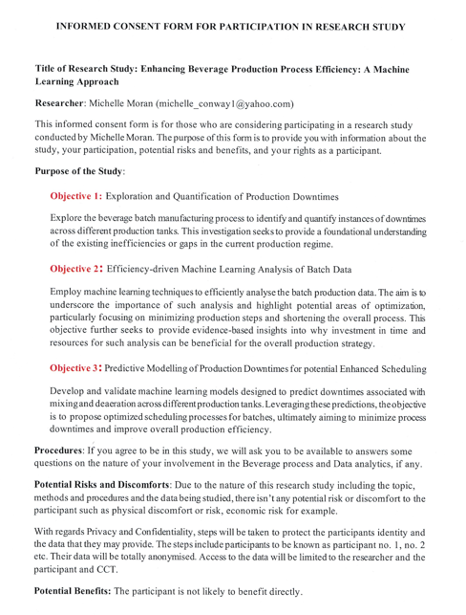



## Machine Learning Models and their Hyperparameters



## All Machine Model Evaluation Results for all Production Tanks Groups

### Tank 22 MT



Table Machine Model Result 22 MT

* **Deaeration Phase**

Table Machine Model Results 22 MT- Deaeration Phase

* **Agitation Phase**

Table Machine Model Results - Agitation Phase

* **Gum Addition Phase**

Table Machine Model Results - Gum Addition

### Tank 23 MT

* **All Phases**



Table Machine Model Results – 23 MT

* **Deaeration Phase**



Table Machine Model Results 23 MT - Deaeration Phase

* **Agitation Phase**



Table Machine Model Results - 23 MT- Agitation Phase

* **Gum Addition Phase**



Table Machine Model Results for 23MT - Gum Addition Phase

### Tank 25MT 4

* All Phases



Table Machine Model Results 25MT 4 - All Phases

* **Deaeration Phase**



Table Machine Model Results 25MT4 - Deaeration Phase

* **Agitation Phase**



Table Machine Model Results 25MT 4 - Agitation Phase

* **Gum Addition Phase**



Table Machine Model Results - 25MT4 - Gum Addition

### Tank 25MT 10

* All Phases



Table Machine Model Results 25MT10 - All Phases

* **Deaeration Phase**



Table Machine Model Results 25MT 10 - Deaeration Phase

* **Agitation Phase**



Table Machine Model Results 25MT10 - Agitation Phase

* **Gum Addition Phase**



Table Machine Model Results 25MT10 - Gum Addition

### Tank 26MT

* **All Phases**



Table Machine Model Results for 26MT - All Phases

* **Deaeration Phase**



Table Machine Model Results 26MT - Deaeration phase

* **Agitation Phase**



Table Machine Model Results 26MT- Agitation Phase

* **Gum Addition**



Table Machine Model Results 26 MT - Gum Addition Phase

## Descriptive Statistics Results for all Production Tanks

Figure Descriptive Statistics Results: 22 MT

Figure Descriptive Statistics Results : 23MT

Figure Descriptive Statistics Results : 25MT 4



Figure Descriptive Statistics Results : 25MT 10

Figure Descriptive Statistic Results : 26MT

## Overview of the Phase Overruns per instruction step for all beverages batches produced.

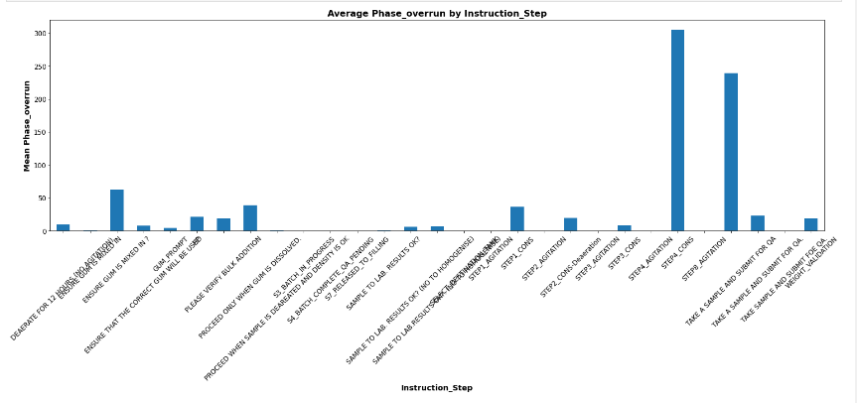

Figure Phase overrun details for each instruction step in the production process.

## Version Control Details

<https://github.com/MichelleMoran431/Capstone---CCT.git>

# Reference List

Agitators: Parts, Types, Flow Patterns, and Configurations [WWW Document], n.d. URL <https://www.iqsdirectory.com/articles/mixer/agitators.html> (accessed 9.15.23).

Agrawal, S., 2021. How to split data into three sets (train, validation, and test) And why? [WWW Document]. Medium. URL <https://towardsdatascience.com/how-to-split-data-into-three-sets-train-validation-and-test-and-why-e50d22d3e54c> (accessed 9.4.23).

Aksa, K., Aitouche, S., Bentoumi, H., Sersa, I., 2021. Developing a Web Platform for the Management of the Predictive Maintenance in Smart Factories. Wireless Personal Communications 119, 1469–1497. <https://doi.org/10.1007/s11277-021-08290-w>

Andriy Burkov, n.d. The Hundred-Page Machine Learning Book. Andriy Burkov (13 Jan. 2019).

Arashpour, Mehrdad, Wakefield, R., Abbasi, B., Arashpour, Mohammadreza, Hosseini, R., 2018. Optimal process integration architectures in off-site construction: Theorizing the use of multi-skilled resources. Architectural engineering and design management 14, 46–59.

Automation, R., 2022. FactoryTalk Batch PhaseManager User Guide.

Backus, P., Janakiram, M., Mowzoon, S., Runger, C., Bhargava, A., 2006. Factory Cycle-Time Prediction With a Data-Mining Approach. Semiconductor Manufacturing, IEEE Transactions on 19, 252–258. <https://doi.org/10.1109/TSM.2006.873400>

Benech, A., 2008. Gum Arabic A functional hydrocolloid for beverages. Agro Food Industry Hi Tech 19, 58–59.

Bhandari, A., 2020. Feature Engineering: Scaling, Normalization, and Standardization (Updated 2023). Analytics Vidhya. URL <https://www.analyticsvidhya.com/blog/2020/04/feature-scaling-machine-learning-normalization-standardization/> (accessed 9.11.23).

Borucka, A., Grzelak, M., 2019. Application of Logistic Regression for Production Machinery Efficiency Evaluation. Applied Sciences 9, 4770. <https://doi.org/10.3390/app9224770>

Çakıt, E., Dağdeviren, M., 2023. Comparative analysis of machine learning algorithms for predicting standard time in a manufacturing environment. AI EDAM 37, e2. <https://doi.org/10.1017/S0890060422000245>

Cavalcante, I.M., Frazzon, E.M., Forcellini, F.A., Ivanov, D., 2019. A supervised machine learning approach to data-driven simulation of resilient supplier selection in digital manufacturing. International Journal of Information Management 49, 86–97. <https://doi.org/10.1016/j.ijinfomgt.2019.03.004>

Choudhary A. K., Harding J. A., Tiwari M. K.,2009, Data mining in manufacturing: a review based on the kind of knowledge, Journal of Intelligent Manufacturing,20, 501-521, https://doi.org/10.1007/s10845-008-0145-x

Chen, B., Chen, X., Li, B., He, Z., Cao, H., Cai, G., 2011. Reliability estimation for cutting tool based on logistic regression model. Mechanical Systems and Signal Processing - MECH SYST SIGNAL PROCESS 25, 2526–2537. <https://doi.org/10.1016/j.ymssp.2011.03.001>

Chung, C., Rojanasasithara, T., Mutilangi, W., Mcclements, D., 2016. Enhancement of colour stability of anthocyanins in model beverages by gum arabic addition. Food Chemistry 201. <https://doi.org/10.1016/j.foodchem.2016.01.051>

Digital Twinning in Food and Beverage Industry: Enhancing Efficiency, Quality and Sustainability through Simulation and Optimization | LinkedIn [WWW Document], n.d. URL <https://www.linkedin.com/pulse/digital-twinning-food-beverage-industry-enhancing-quality-pandey/> (accessed 9.8.23).

Davidovich, O., Ram, P., Wasserkrug, S., Subramaniam, S., Zhou, N., Phan, D., Murali, P., Nguyen, L., 2022. Addressing Solution Quality in Data Generated Optimization Models. Presented at the AAAI Conference on Artificial Intelligence.

Davies, S., 2006. Listening to the factory [Rockwell Automation with its FactoryTalk suite]. Computing & Control Engineering 17, 38–43.

Diez-Olivan, A., Del Ser, J., Galar, D., Sierra, B., 2019. Data fusion and machine learning for industrial prognosis: Trends and perspectives towards Industry 4.0. Information Fusion 50, 92–111. <https://doi.org/10.1016/j.inffus.2018.10.005>

Eddie_4072, 2021. Feature Scaling Techniques in Python - A Complete Guide. Analytics Vidhya. URL <https://www.analyticsvidhya.com/blog/2021/05/feature-scaling-techniques-in-python-a-complete-guide/> (accessed 9.11.23).

Elangovan, M., Sakthivel, N.R., Saravanamurugan, S., Nair, Binoy.B., Sugumaran, V., 2015. Machine Learning Approach to the Prediction of Surface Roughness Using Statistical Features of Vibration Signal Acquired in Turning. Procedia Computer Science 50, 282–288. <https://doi.org/10.1016/j.procs.2015.04.047>

Farahani, S., Xu, B., Filipi, Z., Pilla, S., 2021. A machine learning approach to quality monitoring of injection molding process using regression models. International Journal of Computer Integrated Manufacturing 34, 1223–1236. <https://doi.org/10.1080/0951192X.2021.1963485>

Fayyad, U., Piatetsky-Shapiro, G., Smyth, P., 1996. From data mining to knowledge discovery in databases. AI magazine 17, 37–37.

Felix, E.A., Lee, S.P., 2019. Systematic literature review of preprocessing techniques for imbalanced data. IET Software 13, 479–496. <https://doi.org/10.1049/iet-sen.2018.5193>

Feng, C-X, J., and Wang, X. F.,2004, "Data Mining Technique Applied to Predictive Modelling of the Knurling Process", IIE Transactions, Vol. 36, pp. 253-263.

foodmanufacture.co.uk, n.d. better dispersion of gums in soft drinks [WWW Document]. foodmanufacture.co.uk. URL <https://www.foodmanufacture.co.uk/Article/2005/10/06/Better-dispersion-of-gums-in-soft-drinks> (accessed 9.14.23).

García, V., Sánchez, J.S., Rodríguez-Picón, L.A., Méndez-González, L.C., Ochoa-Domínguez, H.D.J., 2019. Using regression models for predicting the product quality in a tubing extrusion process. J Intell Manuf 30, 2535–2544. <https://doi.org/10.1007/s10845-018-1418-7>

Goli, A., Khademi Zare, H., Tavakkoli-Moghaddam, R., Sadeghieh, A., 2019. Hybrid artificial intelligence and robust optimization for a multi-objective product portfolio problem Case study: The dairy products industry. Computers & Industrial Engineering 137, 106090. <https://doi.org/10.1016/j.cie.2019.106090>

Hassani, I.E., Mazgualdi, C.E., Masrour, T., 2019. Artificial Intelligence and Machine Learning to Predict and Improve Efficiency in Manufacturing Industry.

How do you choose between bagging and boosting for your ML project? [WWW Document], n.d. URL <https://www.linkedin.com/advice/0/how-do-you-choose-between-bagging-boosting-your> (accessed 9.18.23).

https://developer.ibm.com/apis/catalog/ai4industry--regression-optimization-product/Getting%20Started/, n.d.

https://en.wikipedia.org/wiki/SQL_Server_Management_Studio, n.d.

https://literature.rockwellautomation.com/idc/groups/literature/documents/in/batch-in002_-en-d.pdf, n.d.

https://www.linkedin.com/pulse/revolutionizing-food-beverage-industry-ai-ml-supply-chain-pandey, n.d.

https://www.rockwellautomation.com/en-us/capabilities/process-solutions/batch-control.html, n.d.

Ismail, M., Mostafa, N.A., El-assal, A., 2022. Quality monitoring in multistage manufacturing systems by using machine learning techniques. Journal of Intelligent Manufacturing 33, 2471–2486.

Kadam, S., Kadam, A., Sayed, Z., Priya, S., Pardeshi, J., Nemanwar, S., 2023. Factory Downtime Prediction Using Machine Learning Algorithms.

Klein, S., Schorr, S., Bähre, D., 2020. Quality Prediction of Honed Bores with Machine Learning Based on Machining and Quality Data to Improve the Honing Process Control. Procedia CIRP 93, 1322–1327. <https://doi.org/10.1016/j.procir.2020.03.055>

Komorowski, M., Marshall, D., Salciccioli, J., Crutain, Y., 2016. Exploratory Data Analysis, in: Secondary Analysis of Electronic Health Records. pp. 185–203. <https://doi.org/10.1007/978-3-319-43742-2_15>

Krishna Kumar, M., Arvind, P., Dharmendra Singh, R., 2020. Predictive Analytics Using Statistics and Big Data: Concepts and Modeling. Bentham Science Publishers Ltd, Singapore.

Kuhar, Marks., 2015. Information on Demand. Rock Products 13–14.

Kuhn, M., Johnson, K., 2013. Applied Predictive Modeling, Applied Predictive Modeling. <https://doi.org/10.1007/978-1-4614-6849-3>

Kulkarni, V., Han, X., Tjong, J., 2021. Intelligent Detection and Real-time Monitoring of Engine Oil Aeration Using a Machine Learning Model. Applied Artificial Intelligence 35, 1869–1886. <https://doi.org/10.1080/08839514.2021.1995230>

Kusumaningrum, D., Kurniati, N., Santosa, B., 2021. Machine Learning for Predictive Maintenance. Sao Paulo.

Lepenioti, K., Pertselakis, M., Bousdekis, A., Louca, A., Lampathaki, F., Apostolou, D., Mentzas, G., & Anastasiou, S. (2020). Machine Learning for Predictive and Prescriptive Analytics of Operational Data in Smart Manufacturing. Advanced Information Systems Engineering Workshops: CAiSE 2020 International Workshops, Grenoble, France, June 8–12, 2020, Proceedings, 382, 5–16. https://doi.org/10.1007/978-3-030-49165-9_1, n.d.

Lepenioti, K., Pertselakis, M., Bousdekis, A., Louca, A., Lampathaki, F., Apostolou, D., Mentzas, G., Anastasiou, S., 2020. Machine Learning for Predictive and Prescriptive Analytics of Operational Data in Smart Manufacturing, in: Dupuy-Chessa, S., Proper, H.A. (Eds.), Advanced Information Systems Engineering Workshops, Lecture Notes in Business Information Processing. Springer International Publishing, Cham, pp. 5–16. <https://doi.org/10.1007/978-3-030-49165-9_1>

Lieber, D., Stolpe, M., Konrad, B., Deuse, J., Morik, K., 2013. Quality prediction in interlinked manufacturing processes based on supervised & unsupervised machine learning. Procedia Cirp 7, 193–198.

Luger, G.F., 2005. Artificial intelligence: structures and strategies for complex problem solving. Pearson education.

Mark Saunders, Philip Lewis, Adrian Thornhill, 2016. Research Methods for Business Students, Seventh edition. ed. Pearson Education Limited.

McKinney, W., 2012. Python for data analysis: Data wrangling with Pandas, NumPy, and IPython. O’Reilly Media, Inc.

Mckinney, W., 2011. pandas: a Foundational Python Library for Data Analysis and Statistics. Python High Performance Science Computer.

Md, A.Q., Jha, K., Haneef, S., Sivaraman, A.K., Tee, K.F., 2022. A Review on Data-Driven Quality Prediction in the Production Process with Machine Learning for Industry 4.0. Processes 10. <https://doi.org/10.3390/pr10101966>

Millman, K., Aivazis, M., 2011. Python for Scientists and Engineers. Computing in Science & Engineering 13, 9–12. <https://doi.org/10.1109/MCSE.2011.36>

Min, H., 2010. Artificial intelligence in supply chain management: theory and applications. International Journal of Logistics Research and Applications 13, 13–39. <https://doi.org/10.1080/13675560902736537>

Mohri, M., Rostamizadeh, A., Talwalkar, A., 2018. Foundations of Machine Learning, second edition. MIT Press.

Morariu, C., Morariu, O., Răileanu, S., Borangiu, T., 2020. Machine learning for predictive scheduling and resource allocation in large scale manufacturing systems. Computers in Industry 120, 103244. <https://doi.org/10.1016/j.compind.2020.103244>

Nadim, K., Ragab, A., Ouali, M.-S., 2023. Data-driven dynamic causality analysis of industrial systems using interpretable machine learning and process mining. Journal of Intelligent Manufacturing 34, 57–83.

Nighania, K., 2019. Various ways to evaluate a machine learning models performance [WWW Document]. Medium. URL <https://towardsdatascience.com/various-ways-to-evaluate-a-machine-learning-models-performance-230449055f15> (accessed 9.18.23).

Pandian, S., 2020. Feature Engineering (Feature Improvements - Scaling). Analytics Vidhya. URL <https://www.analyticsvidhya.com/blog/2020/12/feature-engineering-feature-improvements-scaling/> (accessed 9.11.23).

Papananias, M., McLeay, T.E., Mahfouf, M., Kadirkamanathan, V., 2019. A Bayesian framework to estimate part quality and associated uncertainties in multistage manufacturing. computers in industry 105, 35–47.

Paturi, U.M.R., Cheruku, S., 2021. Application and performance of machine learning techniques in manufacturing sector from the past two decades: A review. Materials Today: Proceedings 38, 2392–2401. <https://doi.org/10.1016/j.matpr.2020.07.209>

Pavlenko, I., Saga, M., Kuric, I., Kotliar, A., Basova, Y., Trojanowska, J., Ivanov, V., 2020. Parameter identification of cutting forces in crankshaft grinding using artificial neural networks. Materials 13, 5357.

Phan, D.T., Nguyen, L.M., Murali, P., Pham, N.H., Liu, H., Kalagnanam, J.R., 2021. Regression Optimization for System-level Production Control. Presented at the 2021 American Control Conference (ACC), IEEE, pp. 5023–5028.

Ph.D, L.G., 2023. Mastering Data Cleaning with Python: A Step-by-Step Guide to Clean and Preprocess Your Data. Medium. URL <https://medium.com/@lamisghoualmi/mastering-data-cleaning-with-python-a-step-by-step-guide-to-clean-and-preprocess-your-data-a9e62becbb03> (accessed 9.4.23).

Pugliese, R., Regondi, S., Marini, R., 2021. Machine learning-based approach: global trends, research directions, and regulatory standpoints. Data Science and Management 4, 19–29. <https://doi.org/10.1016/j.dsm.2021.12.002>

Rahman, M.A., Saleh, T., Jahan, M.P., McGarry, C., Chaudhari, A., Huang, R., Tauhiduzzaman, M., Ahmed, A., Mahmud, A.A., Bhuiyan, Md.S., Khan, M.F., Alam, Md.S., Shakur, M.S., 2023. Review of Intelligence for Additive and Subtractive Manufacturing: Current Status and Future Prospects. Micromachines 14, 508.

Rajasekaran, S.B., 2003. Applications of machine learning in manufacturing: Benefits, issues, and strategies. Machine learning 77.

Ranjit Kumar - University of Western Australia, Australia, 2019. Research Methodology A Step-by-Step Guide for Beginners, FIFTH EDITION. ed. SAGE Publications Ltd.

Raschka Sebastian, Mirjalili Vahid, - Python Machine Learning: Machine Learning and Deep Learning with Python, Scikit-Learn, and TensorFlow 2, 2019., Third Edition. ed. Packt Publishing Ltd.

Reddy, A.V., 2021. Predictive Modelling - Rain Prediction in Australia With Python. Analytics Vidhya. URL <https://www.analyticsvidhya.com/blog/2021/06/predictive-modelling-rain-prediction-in-australia-with-python/> (accessed 9.11.23).

Santos, M., 2023. A Data Scientist’s Essential Guide to Exploratory Data Analysis [WWW Document]. Medium. URL <https://towardsdatascience.com/a-data-scientists-essential-guide-to-exploratory-data-analysis-25637eee0cf6> (accessed 9.15.23).

Schuh, G., Prote, J.-P., Sauermann, F., Franzkoch, B., 2019a. Databased prediction of order-specific transition times. CIRP Annals 68, 467–470. <https://doi.org/10.1016/j.cirp.2019.03.008>

Schuh, G., Reinhart, G., Prote, J.-P., Sauermann, F., Horsthofer, J., Oppolzer, F., Knoll, D., 2019b. Data Mining Definitions and Applications for the Management of Production Complexity. Procedia CIRP, 52nd CIRP Conference on Manufacturing Systems (CMS), Ljubljana, Slovenia, June 12-14, 2019 81, 874–879. <https://doi.org/10.1016/j.procir.2019.03.217>

Singh, U., Rizwan, M., Alaraj, M., Alsaidan, I., 2021. A Machine Learning-Based Gradient Boosting Regression Approach for Wind Power Production Forecasting: A Step towards Smart Grid Environments. Energies 14, 5196. <https://doi.org/10.3390/en14165196>

Sharma, A, Zhang, Z & Rai, R 2021, ‘The interpretive model of manufacturing: a theoretical framework and research agenda for machine learning in manufacturing’, *International Journal of Production Research*, vol. 59, no. 16, pp. 4960–4994, viewed 21 September 2023, <https://search.ebscohost.com/login.aspx?direct=true&db=bsh&AN=151932920&site=eds-live&scope=site>.

Smola, A.J., Schölkopf, B., 2004. A tutorial on support vector regression. Statistics and Computing 14, 199–222. <https://doi.org/10.1023/B:STCO.0000035301.49549.88>

Steven Hughes, 2020. Hands-On SQL Server 2019 Analysis Services : Design and Query Tabular and Multi-dimensional Models Using Microsoft’s SQL Server Analysis Services. Packt Publishing, Birmingham.

Sun, S., Cao, Z., Zhu, H., Zhao, J., 2019. A survey of optimization methods from a machine learning perspective. IEEE transactions on cybernetics 50, 3668–3681.

Suresh Kumar Mukhiya, Usman Ahmed, 2020. Hands-On Exploratory Data Analysis with Python : Perform EDA Techniques to Understand, Summarize, and Investigate Your Data. Packt Publishing, Birmingham, UK.

Taherdoost, H., 2016. Sampling Methods in Research Methodology; How to Choose a Sampling Technique for Research. International Journal of Academic Research in Management 5, 18–27. <https://doi.org/10.2139/ssrn.3205035>

Tercan, H., Meisen, T., 2022. Machine learning and deep learning based predictive quality in manufacturing: a systematic review. Journal of Intelligent Manufacturing 33, 1879–1905.

Torotwa, I., Ji, C., 2018. A Study of the Mixing Performance of Different Impeller Designs in Stirred Vessels Using Computational Fluid Dynamics. Designs 2, 10. <https://doi.org/10.3390/designs2010010>

Verma, M., 2023. Types of Learning in Machine Learning. Study Trigger. URL <https://www.studytrigger.com/types-of-learning-in-machine-learning/> (accessed 9.15.23).

Wang, J., Ma, Y., Zhang, L., Gao, R.X., Wu, D., 2018. Deep learning for smart manufacturing: Methods and applications. Journal of Manufacturing Systems 48, 144–156. <https://doi.org/10.1016/j.jmsy.2018.01.003>

Weichert, D., Link, P., Stoll, A., Rüping, S., Ihlenfeldt, S., Wrobel, S., 2019. A review of machine learning for the optimization of production processes. The International Journal of Advanced Manufacturing Technology 104, 1889–1902. <https://doi.org/10.1007/s00170-019-03988-5>

Wu, D., Jennings, C., Terpenny, J., Gao, R.X., Kumara, S., 2017. A Comparative Study on Machine Learning Algorithms for Smart Manufacturing: Tool Wear Prediction Using Random Forests. Journal of Manufacturing Science and Engineering 139. <https://doi.org/10.1115/1.4036350>

Xu, S., Lu, B., Baldea, M., Edgar, T., Wojsznis, W., Blevins, T., Nixon, M., 2015. Data cleaning in the process industries. Reviews in Chemical Engineering 31, 453–490. <https://doi.org/10.1515/revce-2015-0022>

Yamak, P.T., Yujian, L., Gadosey, P.K., 2019. A comparison between arima, lstm, and gru for time series forecasting. Presented at the Proceedings of the 2019 2nd International Conference on Algorithms, Computing and Artificial Intelligence, pp. 49–55.

Yang, F., Jin, S., Li, Z., 2017. A comprehensive study of linear variation propagation modelling methods for multistage machining processes. The International Journal of Advanced Manufacturing Technology 90, 2139–2151.

Z. Ge, Z. Song, S. X. Ding, B. Huang, 2017. Data Mining and Analytics in the Process Industry: The Role of Machine Learning. IEEE Access 5, 20590–20616. <https://doi.org/10.1109/ACCESS.2017.2756872>

Zhao, L., Huang, X., Yu, H., 2021. Quality-Analysis-Based Process Monitoring for Multi-Phase Multi-Mode Batch Processes. Processes 9. <https://doi.org/10.3390/pr9081321>

Zheng, A., Shelby, N., & Volckhausen, E. (2019). Evaluating Machine Learning Models. *Machine Learning in the AWS Cloud*.